Mineral Titles Act 2010
NOTICE OF LAND CEASING TO BE A MINERAL TITLE APPLICATION AREA
Title Type and Number: | Exploration Licence 32504
Area Ceased on: | 23 October 2020
Area: | 22 Blocks, 67.47 km²
Locality: | FIELD RIVER
Name of Applicant(s)/Holder(s): | 100% PLUTONIC LIMITED [ACN. 632 991 167]
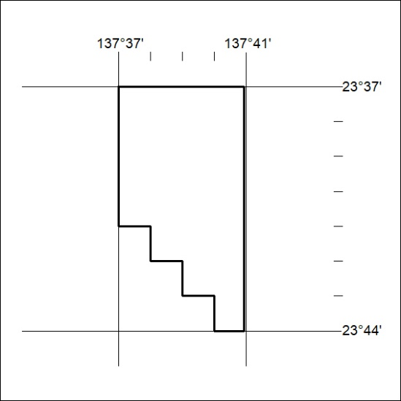

350/20

Mineral Titles Act
NOTICE OF GRANT OF A MINERAL TITLE
Title Type and Number: | Extractive Mineral Exploration Licence 32259
Granted: | 22 October 2020, for a period of 2 Years
Area: | 4 Blocks, 6.76 km²
Locality: | KOOLPINYAH
Name of Holder/s: | 100% SAGE CONSTRUCTIONS PTY. LTD. [ACN. 009 654 648]
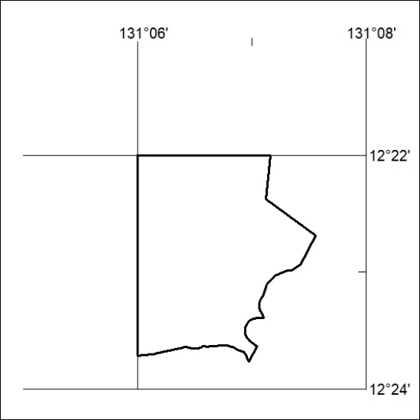
Area granted is indicated above. The titleholder is not permitted to exercise occupational rights on any land that is subject to a development title, or an application for a development title. Any land the subject of a Reserved Land gazettal under the Mineral Titles Act and all land vested in the Commonwealth of Australia is also excluded by description but not excised from the grant area.

351/20

Mineral Titles Act
NOTICE OF GRANT OF A MINERAL TITLE
Title Type and Number: | Extractive Mineral Exploration Licence 32260
Granted: | 22 October 2020, for a period of 2 Years
Area: | 2 Blocks, 2.51 km²
Locality: | KOOLPINYAH
Name of Holder/s: | 100% SAGE CONSTRUCTIONS PTY. LTD. [ACN. 009 654 648]
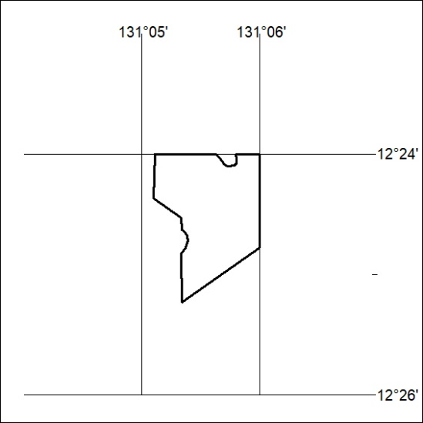
Area granted is indicated above. The titleholder is not permitted to exercise occupational rights on any land that is subject to a development title, or an application for a development title. Any land the subject of a Reserved Land gazettal under the Mineral Titles Act and all land vested in the Commonwealth of Australia is also excluded by description but not excised from the grant area.

352/20

