Mineral Titles Act 2010
NOTICE OF LAND CEASING TO BE A MINERAL TITLE APPLICATION AREA
Title Type and Number: | Extractive Mineral Exploration Licence 32235
Area Ceased on: | 31 July 2020
Area: | 4 Blocks, 13.42 km²
Locality: | KOOLPINYAH
Name of Applicant(s)/Holder(s): | 100% ALLAN KING & SONS CONSTRUCTION PTY LTD [ACN. 068 688 148]
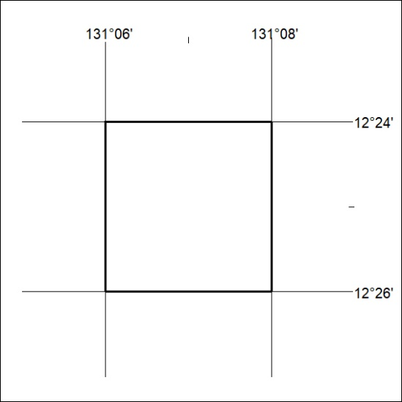

248/20

Mineral Titles Act 2010
NOTICE OF LAND CEASING TO BE A MINERAL TITLE APPLICATION AREA
Title Type and Number: | Extractive Mineral Exploration Licence 32236
Area Ceased on: | 31 July 2020
Area: | 2 Blocks, 6.56 km²
Locality: | KOOLPINYAH
Name of Applicant(s)/Holder(s): | 100% ALLAN KING & SONS CONSTRUCTION PTY LTD [ACN. 068 688 148]
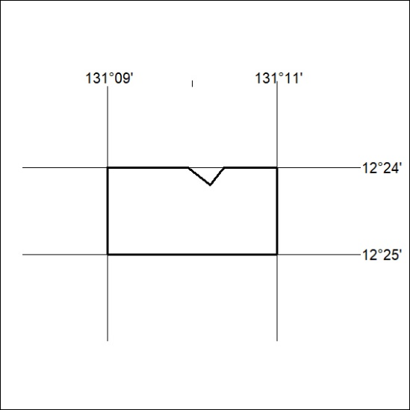

249/20
Mineral Titles Act 2010
NOTICE OF LAND CEASING TO BE A MINERAL TITLE APPLICATION AREA
Title Type and Number: | Extractive Mineral Exploration Licence 32237
Area Ceased on: | 31 July 2020
Area: | 2 Blocks, 5.48 km²
Locality: | KOOLPINYAH
Name of Applicant(s)/Holder(s): | 100% ALLAN KING & SONS CONSTRUCTION PTY LTD [ACN. 068 688 148]
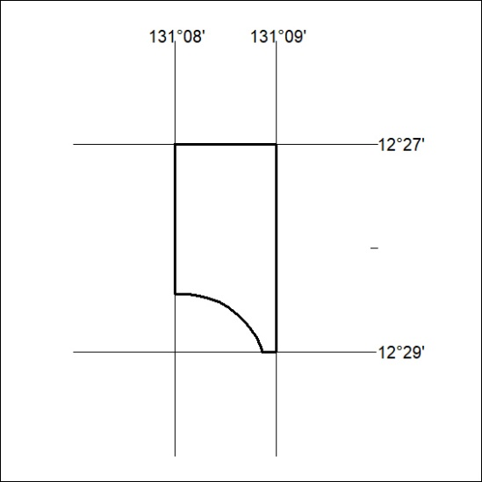

250/20

Mineral Titles Act
NOTICE OF GRANT OF A MINERAL TITLE
Title Type and Number: | Exploration Licence 32205
Granted: | 30 July 2020, for a period of 6 Years
Area: | 2 Blocks, 6.70 km²
Locality: | BYNOE
Name of Holder/s: | 100% LITHIUM DEVELOPMENTS PTY LTD [ACN. 612 245 020]
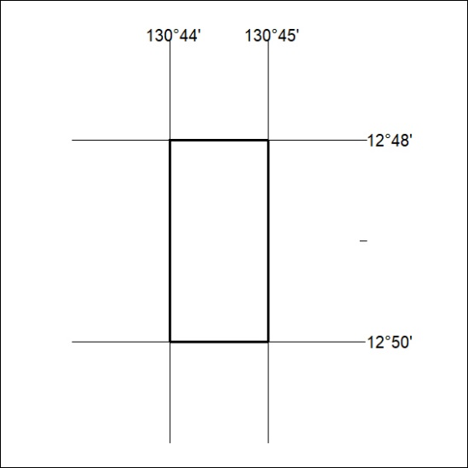
Area granted is indicated above. The titleholder is not permitted to exercise occupational rights on any land that is subject to a development title, or an application for a development title. Any land the subject of a Reserved Land gazettal under the Mineral Titles Act and all land vested in the Commonwealth of Australia is also excluded by description but not excised from the grant area.
251/20

