Mineral Titles Act 2010
NOTICE OF LAND CEASING TO BE A MINERAL TITLE AREA
Title Type and Number: | Exploration Licence 25646
Area Ceased on: | 22 August 2019
Area: | 19 Blocks, 63.00 km²
Locality: | LEGUNE
Name of Applicant(s)/Holder(s): | 100% TODD RIVER METALS PTY LTD [ACN. 600 314 038]
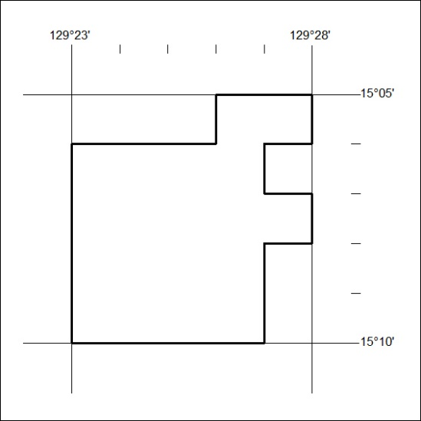

352/19

Mineral Titles Act 2010
NOTICE OF LAND CEASING TO BE A MINERAL TITLE AREA
Title Type and Number: | Mineral Lease 22624
Area ceased on: | 23 August 2019
Area: | 948.00 Hectares
Locality: | RIDDOCH
Name of Applicants(s)Holder(s): | 100% CLARENCE RIVER FINANCE GROUP PTY LTD [ACN. 003 138 930]
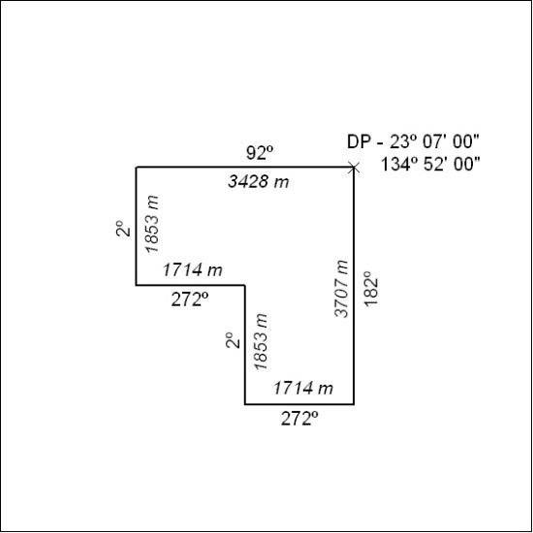

353/19

