Michael Daysh

# Markets and Marketing

Subject to the anticipated production volume and seasonality and variety; initial comments are:

* Australian imports 8,000 – 9,000t of fresh (defined by the moisture content) and dried dates a year,
* First, highest margin/lowest risk opportunity for the grower is probably within their tourism/resort offer, then within NT tourist outlets, etc,
* However, if they don’t want to do the consumer level packing and distribution/marketing, there are opportunities with AU to sell wholesale 5kg packs,
* Packaging and labelling is important in creating value,
* I have not looked at export & market access because I doubt whether the volume and likely prices would justify the grower effort required, but happy to do so if that’s what they have in mind. At quick look at the global trade data; 833,000 tonnes of fresh and dried dates worth US$1.03b exported in 2017. That’s US$0.81/kg, which is probably well below Ross River’s cost of harvesting!

# Import and Export requirements

All import market plant requirements can be found [here](https://micor.agriculture.gov.au/Plants/Pages/default.aspx):

<https://micor.agriculture.gov.au/Plants/Pages/default.aspx>

For dates, just be mindful of the fresh / dried difference. If there is nothing on MICoR then there may be no requirements in the import market, but the prospective exporter should then double check that with their prospective importer. There are Australian export requirements for plant products around documents and labelling including *Product of Australia* on the packaging.

# Import and Export prices

| Australian date (fresh & dried, 080410) imports and exports - 2013/2017 | | | | | |
| --- | --- | --- | --- | --- | --- |
|  | 2013 | 2014 | 2015 | 2016 | 2017 |
| Imports (kgs) | 6,052,974 | 7,605,224 | 8,147,223 | 8,994,469 | 8,073,184 |
| Exports (kgs) | 102,588 | 81,744 | 49,120 | 83,561 | 53,864 |
| Export price (US$/kg) | 5.16 | 2.85 | 2.56 | 1.97 | 2.78 |
| Import price (US$/kg) | 1.76 | 1.81 | 1.83 | 1.54 | 1.97 |
| Major export markets by volume | NZ (58%) | NZ (97%) | NZ (46%) | NZ (47%) | NZ (41%), UAE (33%) |
| Exports to Middle East | - | - | 88 kgs to Qatar @ US$12.27; 3,888kgs to UAE @$US$1.68/kg (re-export?) | 18,590 kgs to Iran(re-export?); 420 kg to Saudi [Arabia @US$8.95/kg](mailto:Arabia@$8.95/kg) | 632kg to Qatar @US $12.04/kg; 140kg to Lebanon @US$10.96/kg; 17,850 kg to UAE @US$0.94/kg (re-export?) |
| Major source of Australian imports by volume | Iran (43%), Turkey (20%) | Iran (49%), Turkey (25%) | Iran (45%), Turkey (23%) | Iran (60%), Turkey (18%) | Iran (68%) |

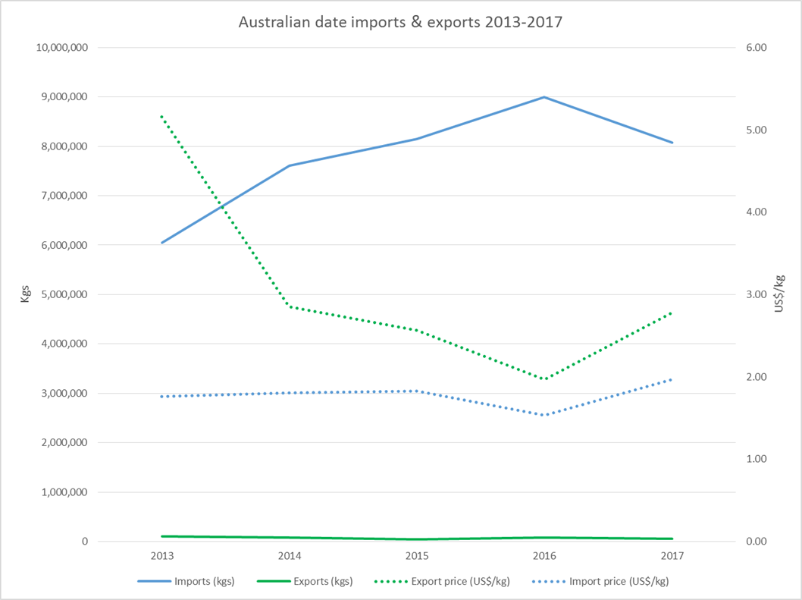

# Varieties by volume, and worldwide consumption

There is no variety / volume data at the moment but there may be some in the Agrifutures publications below.

I gave you a global trade figure of 833,000 tonnes. Wikipedia suggests global production / consumption of 8.5 million tonnes.

Good information sources:

* <https://www.agrifutures.com.au/farm-diversity/dates/>
* <https://www.agrifutures.com.au/product/Towards-an-Australian-Date-Industry-An-overview-of-the-Australian-domestic-and-international-date-industries/>

Dates are not referenced in the Hort Innovation statistics handbook (the industry is too small, there is no peak body, no levy, etc)

# Australian wholesale prices

Monthly wholesale date prices for the last 3 years

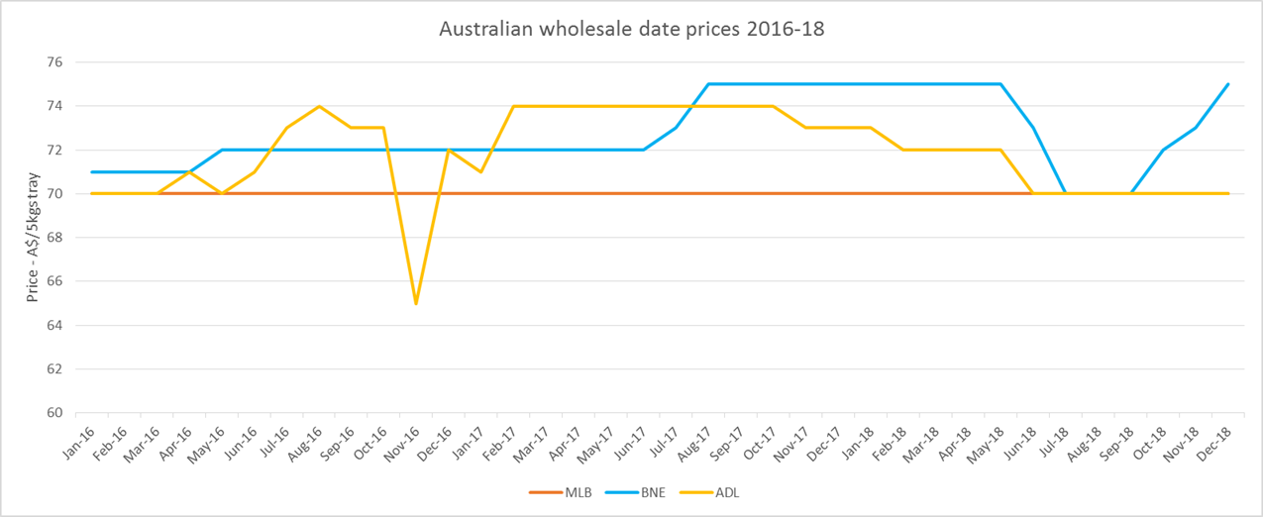

Notes:

* Pricing is very stable; always $14/kg or $70/tray in Melbourne
* Almost all imports, only 1 month with AU fruit, in Brisbane, see below
* Almost no sales reported in Sydney, which I think is something to do with fresh/dried, so did not report Sydney. The few prices reported were high so Sydney is probably an attractive market
* April 2016 – Brisbane:

Screen shot of date price information

Comparison between the import price of US/Mexican dates and the Australian wholesale price

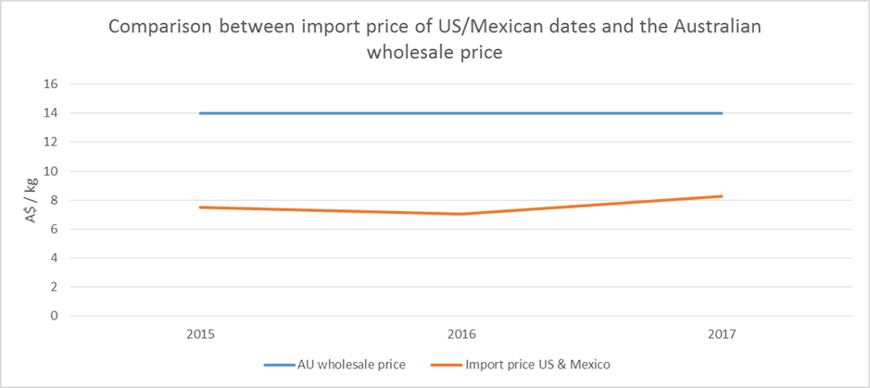

Notes:

* Assumes a standard wholesale price of $14/kg or $70 / 5 kg box
* Assumes that all the dates from US and Mexico are the ‘fresh’ medjool that appear in the wholesale markets and in the produce sections of Australian supermarkets

Suggests a fairly steady import margin of about $6/kg, which is probably quite attractive. On a volume of 217 tonnes of dates from the US in 2017, that’s $1.3m!

# Dates from Egypt into Australia

* Dried Egyptian dates are currently permitted entry to Australia, along with all other countries. There are some standard conditions. Australia imported 2.8t of dates from Egypt in 2017
* The definition of dried is a moisture content of 30% or less
* Fresh dates (*Phoenix dactylifera*) grown and shipped from California are the only fresh dates (moisture more >30%) permitted entry into Australia
* Fresh dates (*Ziziphus jujuba*) are not permitted entry in to Australia
* As discussed, ‘fresh’ medjool dates from Mexico can be purchased in supermarkets in Australia. I assume they are being imported as ‘dried’ (moisture <30%) and presented in the produce departments as ‘fresh’. Occasionally you will see fresh medjool dates from California, but presumably they are more expensive, and the Mexican fruit is meeting a certain price point. The Woolworth online offer below refers to both sources.
* It is potentially possible for the Egyptian’s to offer a <30% moisture medjool which Australian distributors then position as ‘fresh’

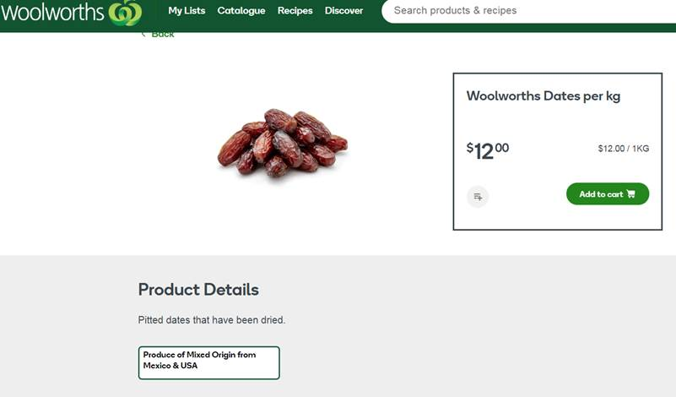

100% U.S.A dates at 3x the price:

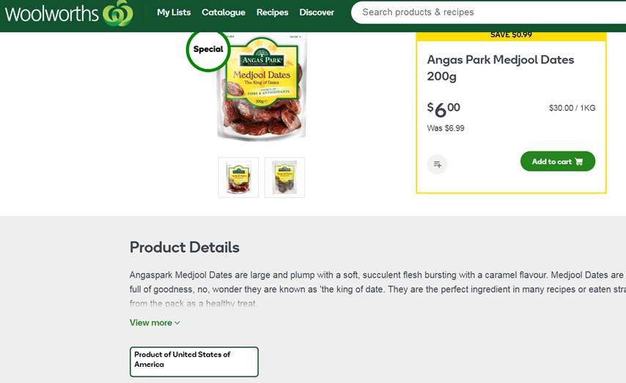

Preserved dates from Turkey:

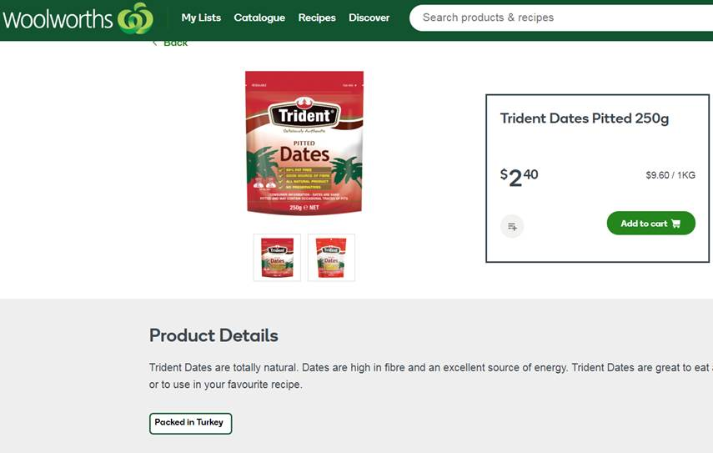

# Marketing, promotion and packaging questions

* Does the NT / Aust date industry have thoughts or a strategy on marketing, promotion and packaging?
* Packaging; 5kg ‘wholesale’ v’s a smaller ‘consumer’ pack?
* Target markets and demographics?
* Distribution; through wholesaler, to retailer, to exporter, direct to consumer (farm gate, retail outlet, e-commerce)?
* Use of social media (Facebook, etc) to engage with customers? There’s some excellent examples of small farm enterprises directly engaging (in the context of their business and their personal interests and strengths) with customers and consumers on Facebook e.g. look for finger limes & The Lime Caviar Company on Facebook.
* For small farm enterprises, there’s often a huge opportunity to value add in the packaging and marketing, particularly if it’s then combined with a direct to consumer distribution strategy.