About the new artificial reefs
Four new artificial reefs are being built in Top End waters to provide the recreational fishing community with great new fishing opportunities. The project, valued at $8.3M, has been awarded to Northern Territory (NT) company Shorecast NT Pty Ltd as part of the Territory Government’s $50 million recreational fishing infrastructure commitment. Shorecast NT has joined forces with Subcon – an Australian company that has designed and built 17 engineered reefs across Australia.

The reef sites
The new artificial reefs will be located in the Greater Darwin region, two will be between North Gutter and Lee Point, one in the Dundee region and one between the Vernon Islands and Cape Hotham.

Reef design
The all-Australian design includes 116 separate concrete ReefPyramids that will be set on the sea floor at the four locations each roughly 2.5 hectares or about the size of TIO stadium at Marrara.
The ReefPyramid modules are the same successful design that has previously been deployed at Port Macquarie, South Sydney, Shoalhaven, Hervey Bay and Port Coogee.

Why engineered reefs?
Purpose built reefs have been shown to be highly productive. When compared with natural reefs and materials of opportunity, engineered reefs deliver significantly improved productivity and fishing opportunities. They are specifically designed to combine the best features of a natural reef while enhancing their qualities for maximum effect. Internal caves, cryptic habitat, vertical relief and upwelling of water flow will create new habitats and provide new fishing areas and reduce pressure on existing natural reef and fish stocks for up to 100 years. A variety of reef associated species will benefit from these new reefs:
- Those that prefer very close contact with reef structures such as black jewfish, cod and coral trout.
- Those that remain adjacent to the structures such as snappers and emperors, and
- Pelagic species that visit occasionally such as mackerel and tuna.

Local content
The reefs are being fabricated locally by Shorecast NT using nearly 3000 tonnes or 180 truck loads of local NT concrete, plus cranes, forklifts, and local labour.
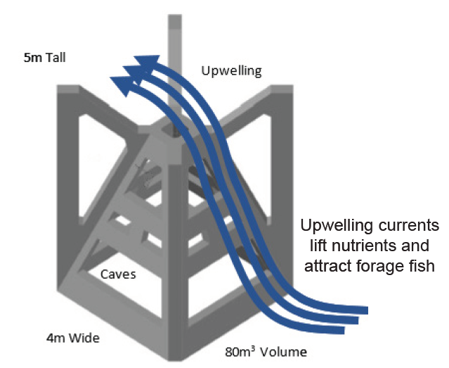
Above: Design of a ReefPyramid module
By the numbers
Number of ReefPyramids | 116
Quantity of locally produced concrete | ~3000 tonnes
ReefPyramid Dimensions | 4m x 4m x 5m
ReefPyramid weight | 24 tonne
Volume of each reef | ~100,000 m³

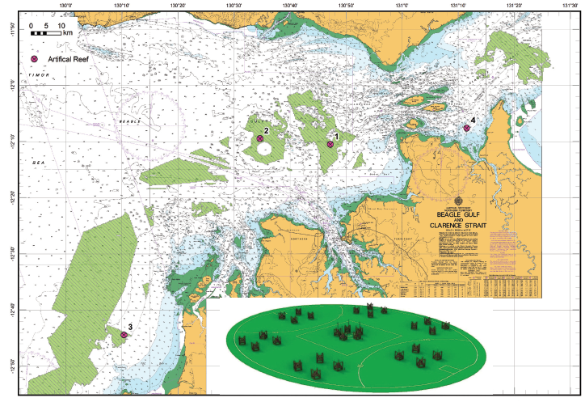
Above: Proposed locations of four new artificial reefs Inset: Reef sizes compared to Marrara Oval

Frequently asked questions

When will the reefs be installed?
All four reefs are due to be completed by October 2019.

When will the reefs be ready for fishing?
The reef ecosystem begins to recruit fish and flora immediately and settles into its sustainable state approximately three years after deployment.

How are the reefs funded?
The reefs are funded through the Northern Territory Government’s $50 million recreational fishing infrastructure fund.

How long will the structures last?
Innovative concrete construction means that the reefs are expected to last up to 100 years

Where can I get project updates?
For more information and updates on the artificial reefs follow the Fisheries NT Facebook page. You can also learn about Department of Primary Industry and Resources’ artificial reef program on the Northern Territory Government website.

