Mineral Titles Act
NOTICE OF LAND CEASING TO BE A MINERAL TITLE AREA
Title Type and Number: | Exploration Licence 3479
Area Ceased on: | 23 January 2019
Area: | 9 Blocks, 12.01 km²
Locality: | CAHILL
Name of Applicant(s)/Holder(s): | 100% KOONGARRA PTY LTD* [ACN. 008 565 508]
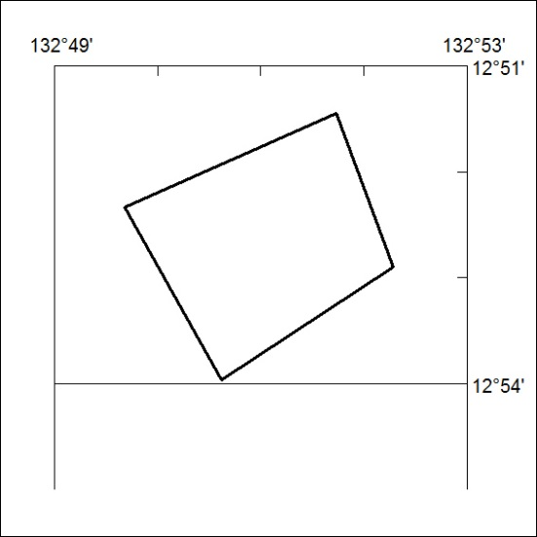

18/19

Mineral Titles Act
NOTICE OF LAND CEASING TO BE A MINERAL TITLE AREA
Title Type and Number: | Exploration Licence 10082
Area Ceased on: | 23 January 2019
Area: | 14 Blocks, 12.58 km²
Locality: | CAHILL
Name of Applicant(s)/Holder(s): | 100% KOONGARRA PTY LTD* [ACN. 008 565 508]
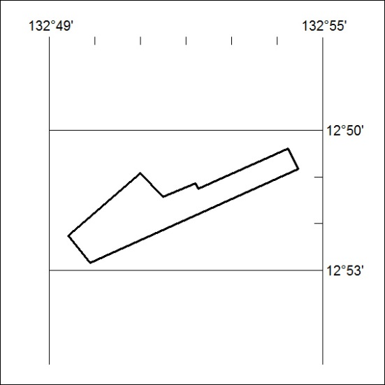

19/19

Mineral Titles Act
NOTICE OF LAND CEASING TO BE A MINERAL TITLE AREA
Title Type and Number: | Exploration Licence 31292
Area Ceased on: | 24 January 2019
Area: | 43 Blocks, 136.92 km²
Locality: | WOODGREEN
Name of Applicant(s)/Holder(s): | 100% BOWGAN MINERALS LTD [ACN. 137 527 336]
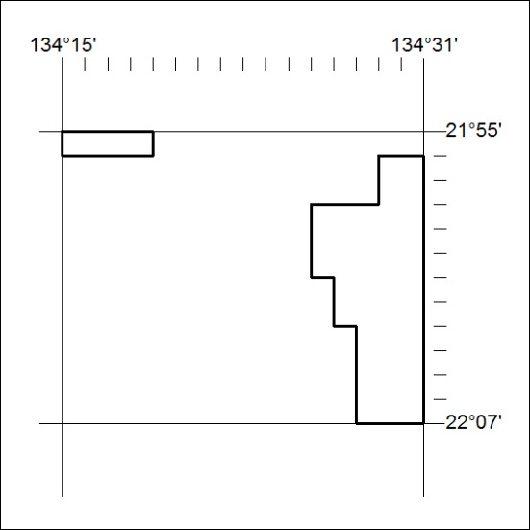

20/19

Mineral Titles Act
NOTICE OF LAND CEASING TO BE A MINERAL TITLE
Title Type and Number: | Mineral Lease (Northern) 1192
Area ceased on: | 23 January 2019
Area: | 16.00 Hectare
Locality: | CAHILL
Name of Applicants(s)Holder(s): | 100% KOONGARRA PTY LTD* [ACN. 008 565 508]
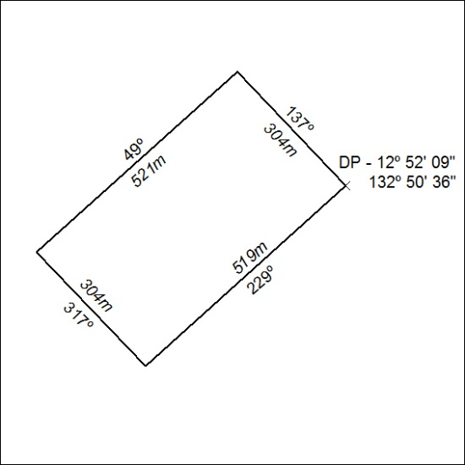

21/19

Mineral Titles Act
NOTICE OF LAND CEASING TO BE A MINERAL TITLE
Title Type and Number: | Mineral Lease (Northern) 1193
Area ceased on: | 23 January 2019
Area: | 15.00 Hectare
Locality: | CAHILL
Name of Applicants(s)Holder(s): | 100% KOONGARRA PTY LTD* [ACN. 008 565 508]
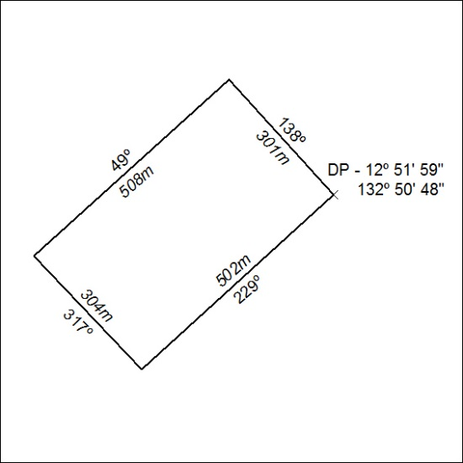

22/19

Mineral Titles Act
NOTICE OF LAND CEASING TO BE A MINERAL TITLE
Title Type and Number: | Mineral Lease (Northern) 1194
Area ceased on: | 23 January 2019
Area: | 13.00 Hectare
Locality: | CAHILL
Name of Applicants(s)Holder(s): | 100% KOONGARRA PTY LTD* [ACN. 008 565 508]
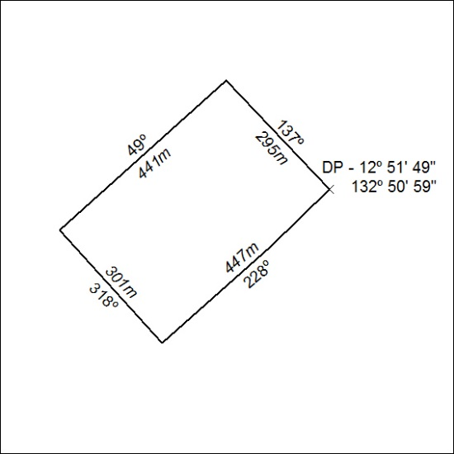

23/19

Mineral Titles Act
NOTICE OF LAND CEASING TO BE A MINERAL TITLE
Title Type and Number: | Mineral Lease (Northern) 1195
Area ceased on: | 23 January 2019
Area: | 14.00 Hectare
Locality: | CAHILL
Name of Applicants(s)Holder(s): | 100% KOONGARRA PTY LTD* [ACN. 008 565 508]
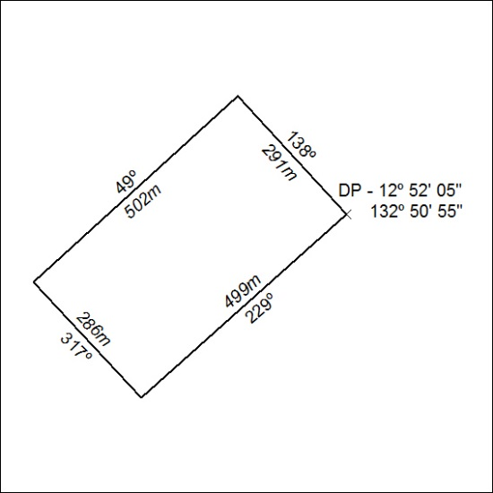

24/19

Mineral Titles Act
NOTICE OF LAND CEASING TO BE A MINERAL TITLE
Title Type and Number: | Mineral Lease (Northern) 1196
Area ceased on: | 23 January 2019
Area: | 15.00 Hectare
Locality: | CAHILL
Name of Applicants(s)Holder(s): | 100% KOONGARRA PTY LTD* [ACN. 008 565 508]
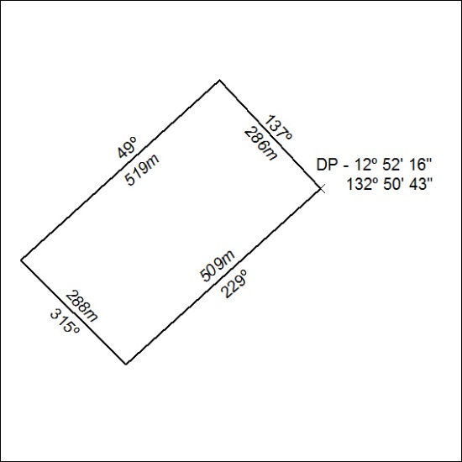

25/19

Mineral Titles Act
NOTICE OF LAND CEASING TO BE A MINERAL TITLE
Title Type and Number: | Mineral Lease (Northern) 1197
Area ceased on: | 23 January 2019
Area: | 16.00 Hectare
Locality: | CAHILL
Name of Applicants(s)Holder(s): | 100% KOONGARRA PTY LTD* [ACN. 008 565 508]
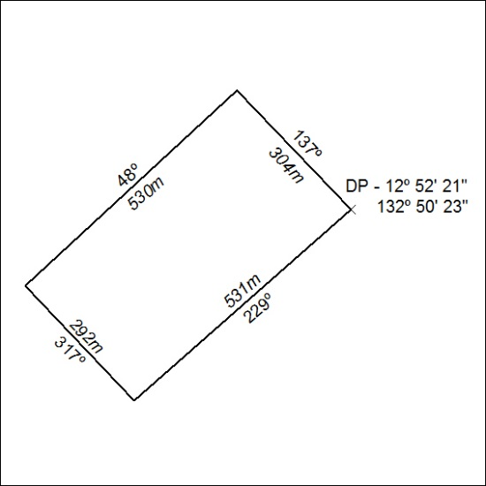

26/19

Mineral Titles Act
NOTICE OF LAND CEASING TO BE A MINERAL TITLE
Title Type and Number: | Mineral Lease (Northern) 1204
Area ceased on: | 23 January 2019
Area: | 16.00 Hectare
Locality: | CAHILL
Name of Applicants(s)Holder(s): | 100% KOONGARRA PTY LTD* [ACN. 008 565 508]
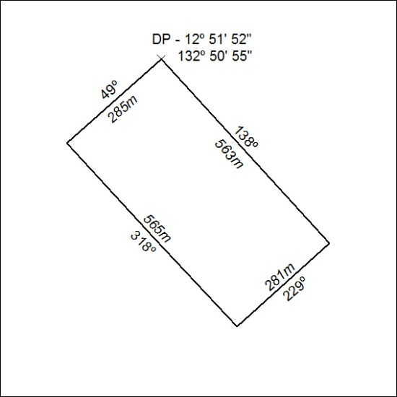

27/19

Mineral Titles Act
NOTICE OF LAND CEASING TO BE A MINERAL TITLE
Title Type and Number: | Mineral Lease (Northern) 1205
Area ceased on: | 23 January 2019
Area: | 14.00 Hectare
Locality: | CAHILL
Name of Applicants(s)Holder(s): | 100% KOONGARRA PTY LTD* [ACN. 008 565 508]
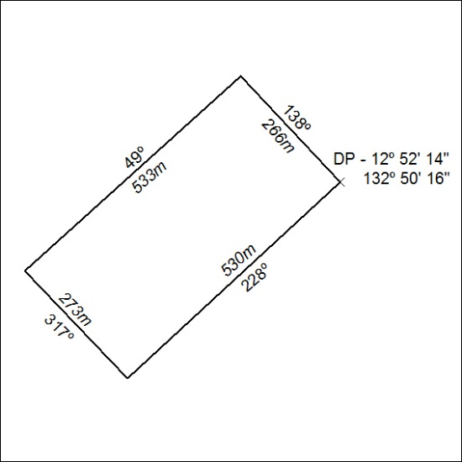

28/19

Mineral Titles Act
NOTICE OF LAND CEASING TO BE A MINERAL TITLE
Title Type and Number: | Mineral Lease (Northern) 1206
Area ceased on: | 23 January 2019
Area: | 14.00 Hectare
Locality: | CAHILL
Name of Applicants(s)Holder(s): | 100% KOONGARRA PTY LTD* [ACN. 008 565 508]
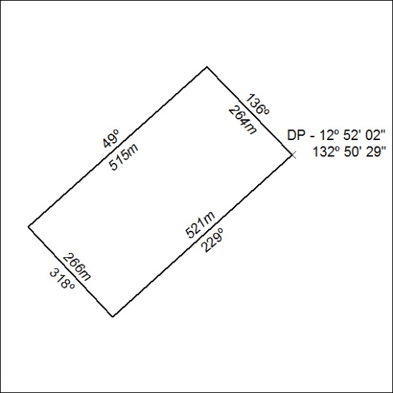

29/19

