Mineral Titles Act 2010
NOTICE OF LAND CEASING TO BE A MINERAL TITLE AREA
Title Type and Number: | Exploration Licence 31665
Area Ceased on: | 26 October 2022
Area: | 15 Blocks, 46.60 km²
Locality: | BRUNCHILLY
Name of Applicant(s)/Holder(s): | 100% OM (MANGANESE) LTD [ACN. 097 091 506]
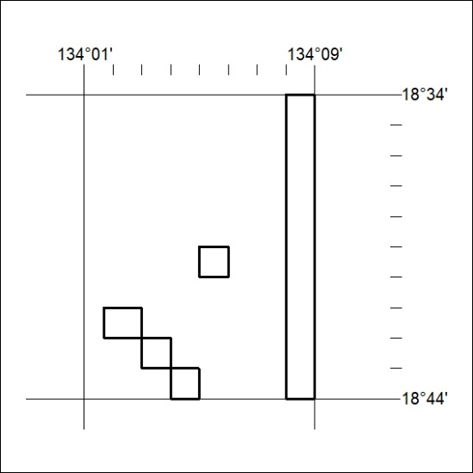

361/22

