Mineral Titles Act 2010
NOTICE OF LAND CEASING TO BE A MINERAL TITLE AREA
Title Type and Number: | Exploration Licence 22957
Area Ceased on: | 16 September 2022
Area: | 5 Blocks, 16.68 km²
Locality: | PINE CREEK
Name of Applicant(s)/Holder(s): | 100% TM GOLD PTY LTD [ACN. 143 126 710]
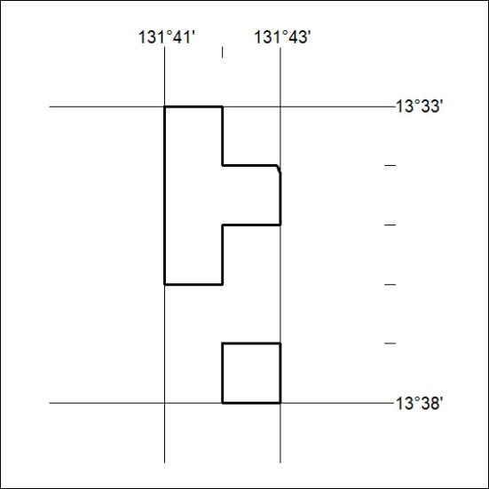
(Area now amalgamated into Exploration Licence 33234 under s102 – EL moratorium period does not apply)

330/22

Mineral Titles Act 2010
NOTICE OF LAND CEASING TO BE A MINERAL TITLE AREA
Title Type and Number: | Exploration Licence 28855
Area Ceased on: | 16 September 2022
Area: | 4 Blocks, 13.21 km²
Locality: | PINE CREEK
Name of Applicant(s)/Holder(s): | 100% TM GOLD PTY LTD [ACN. 143 126 710]
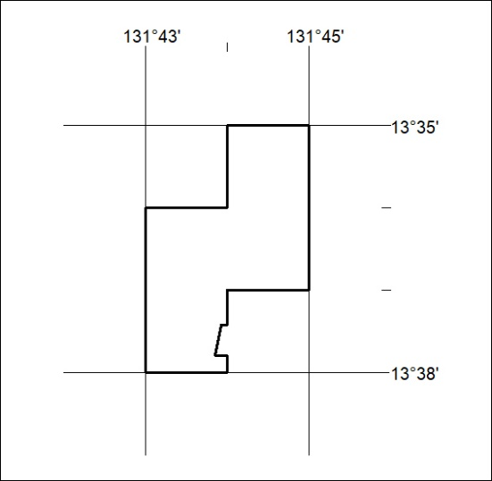
(Area now amalgamated into Exploration Licence 33234 under s102 – EL moratorium period does not apply)

331/22
Mineral Titles Act 2010
NOTICE OF LAND CEASING TO BE A MINERAL TITLE AREA
Title Type and Number: | Exploration Licence 32924
Area Ceased on: | 16 September 2022
Area: | 2 Blocks, 6.68 km²
Locality: | PINE CREEK
Name of Applicant(s)/Holder(s): | 100% TM GOLD PTY LTD [ACN. 143 126 710]
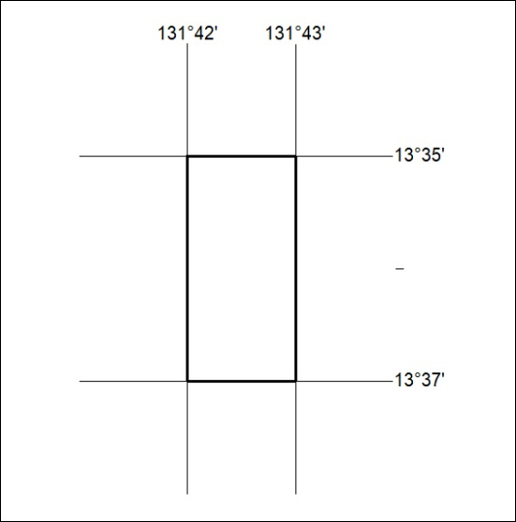
(Area now amalgamated into Exploration Licence 33234 under s102 – EL moratorium period does not apply)

332/22

