Mineral Titles Act
NOTICE OF GRANT OF A MINERAL TITLE
Title Type and Number: | Exploration Licence 33007
Granted: | 05 August 2022, for a period of 6 Years
Area: | 240 Blocks, 734.89 km²
Locality: | MACDONNELL RANGES
Name of Holder/s: | 100% URO CORPORATION PTY LTD [ACN. 653 927 998]
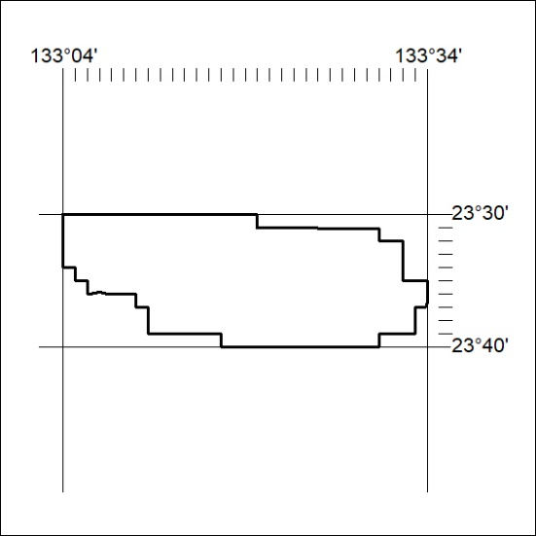
Area granted is indicated above. The titleholder is not permitted to exercise occupational rights on any land that is subject to a development title, or an application for a development title. Any land the subject of a Reserved Land gazettal under the Mineral Titles Act and all land vested in the Commonwealth of Australia is also excluded by description but not excised from the grant area.
273/22

Mineral Titles Act
NOTICE OF GRANT OF A MINERAL TITLE
Title Type and Number: | Exploration Licence 33004
Granted: | 05 August 2022, for a period of 6 Years
Area: | 244 Blocks, 773.20 km²
Locality: | GLEN HELEN
Name of Holder/s: | 100% URO CORPORATION PTY LTD [ACN. 653 927 998]
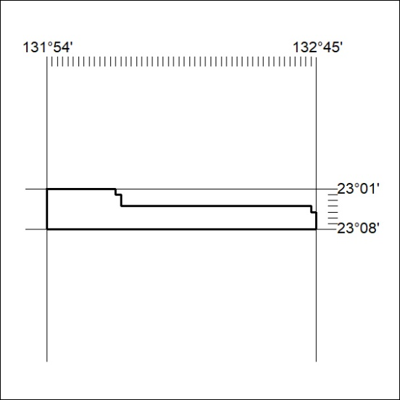
Area granted is indicated above. The titleholder is not permitted to exercise occupational rights on any land that is subject to a development title, or an application for a development title. Any land the subject of a Reserved Land gazettal under the Mineral Titles Act and all land vested in the Commonwealth of Australia is also excluded by description but not excised from the grant area.
274/22

Mineral Titles Act
NOTICE OF GRANT OF A MINERAL TITLE
Title Type and Number: | Exploration Licence 33008
Granted: | 05 August 2022, for a period of 6 Years
Area: | 247 Blocks, 764.83 km²
Locality: | GLEN HELEN
Name of Holder/s: | 100% URO CORPORATION PTY LTD [ACN. 653 927 998]
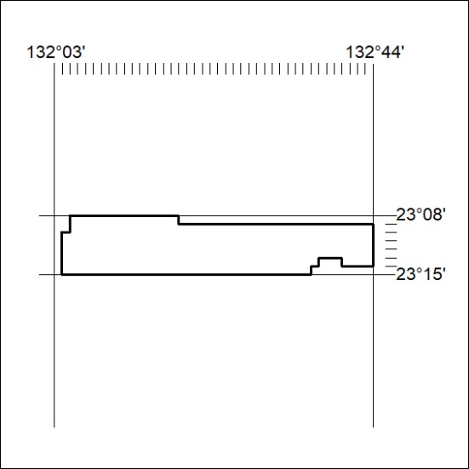
Area granted is indicated above. The titleholder is not permitted to exercise occupational rights on any land that is subject to a development title, or an application for a development title. Any land the subject of a Reserved Land gazettal under the Mineral Titles Act and all land vested in the Commonwealth of Australia is also excluded by description but not excised from the grant area.
275/22

Mineral Titles Act
NOTICE OF GRANT OF A MINERAL TITLE
Title Type and Number: | Exploration Licence 33054
Granted: | 05 August 2022, for a period of 6 Years
Area: | 158 Blocks, 498.14 km²
Locality: | NARWIETOOMA
Name of Holder/s: | 100% URO CORPORATION PTY LTD [ACN. 653 927 998]
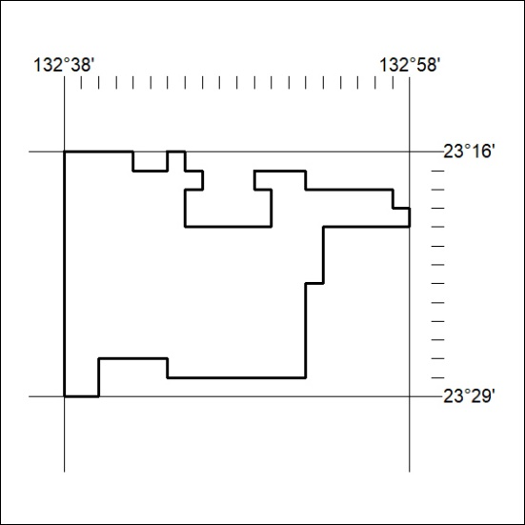
Area granted is indicated above. The titleholder is not permitted to exercise occupational rights on any land that is subject to a development title, or an application for a development title. Any land the subject of a Reserved Land gazettal under the Mineral Titles Act and all land vested in the Commonwealth of Australia is also excluded by description but not excised from the grant area.
276/22

Mineral Titles Act
NOTICE OF GRANT OF A MINERAL TITLE
Title Type and Number: | Exploration Licence 33055
Granted: | 05 August 2022, for a period of 6 Years
Area: | 136 Blocks, 424.43 km²
Locality: | NARWIETOOMA
Name of Holder/s: | 100% URO CORPORATION PTY LTD [ACN. 653 927 998]
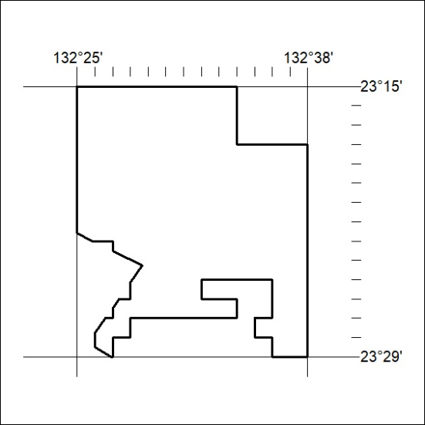
Area granted is indicated above. The titleholder is not permitted to exercise occupational rights on any land that is subject to a development title, or an application for a development title. Any land the subject of a Reserved Land gazettal under the Mineral Titles Act and all land vested in the Commonwealth of Australia is also excluded by description but not excised from the grant area.
277/22

