Overview
Following two years of strong economic outcomes since the beginning of the pandemic, growth in a number of economic indicators for the Northern Territory has slowed in recent quarters. In the March quarter state final demand (SFD) grew by 2.2 per cent, driven entirely by public consumption and investment; both private consumption and investment declined.
Nevertheless, the Territory economy continues to operate at a noticeably higher level than it did pre-pandemic. SFD is now 13.4 per cent higher than it was pre-pandemic – the largest increase of all jurisdictions (Graph 1). Although inflation-adjusted retail sales have declined a little, they remain at a similar level to that seen at the peak of the Inpex-led boom (Graph 2). Looking forward, a strong pipeline of investment projects should ensure that private investment increases over the rest of 2022, and will support overall growth. Goods export volumes dropped in the March quarter, but the value of NT goods exports is already above the total value of exports from FY21 as a result of high prices for gas.
Challenges for the NT economy over the rest of 2022 include broadening price and wage pressures and higher interest rates (Graph 3). The Territory economy is also starting to face constraints. In the residential construction sector timeframes for house construction have lengthened, and across the NT economy as a whole there are now more job vacancies than unemployed persons (Graph 4).
Indicator | Most recent | Level | Period change¹ | Annual change² | Year on Year³ | COVID period change⁴
Economic Growth
State final demand (NT) (sa) | Mar-22 | $6.8 b | 2.2% | 10.8% | 10.1% | 13.4%
Domestic final demand (Aus) (sa) | Mar-22 | $519.8 b | 1.6% | 4.8% | 6.7% | 6.4%
Gross state product (NT) | 2020-21 | $26.2 b | na | na | -0.6% | na
Gross domestic product (Aust) | 2020-21 | $2010.1 b | na | na | 1.5% | na
Partial Indicators
Nominal retail sales (NT) (sa) | Apr-22 | $302.8 m | 0.7% | 0.3% | 1.1% | 16.2%
Nominal retail sales (Aust) (sa) | Apr-22 | $33.9 b | 0.9% | 9.6% | 4.9% | 22.2%
Construction work done (NT) (sa) | Mar-22 | $628.6 m | -19.2% | 31.4% | 21.4% | 32%
Construction work done (Aust) (sa) | Mar-22 | $53.7 b | -0.9% | 1.4% | 2.5% | 1.6%
Residential building activity (NT) | Dec-21 | $82.3 m | -6.8% | -9.9% | 2.8% | 1.4%
Residential building activity (Aust) | Dec-21 | $18.4 b | -4.9% | 0.1% | 4.8% | 0.3%
Goods exports (NT) | Apr-22 | $1.3 b | -11.8% | 132.2% | 54.5% | 18.9%
Goods exports (Aust) (sa) | Apr-22 | $45.1 b | 0% | 26% | 31.9% | 40.4%
Prices
Inflation (Darwin) | Mar-22 | 5.5% | -0.5 ppt | 3.2 ppt | 5.8 ppt | 5.1 ppt
Inflation (8 Capitals) | Mar-22 | 5.1% | 1.6 ppt | 4 ppt | 3.3 ppt | 3.2 ppt
WPI growth (NT) | Mar-22 | 1.9% | -0.2 ppt | 0.1 ppt | 0.2 ppt | -0.6 ppt
WPI growth (Aust) | Mar-22 | 2.4% | 0.1 ppt | 0.9 ppt | 0.7 ppt | 0.1 ppt
Labour Market
Employment (NT) (sa) | Apr-22 | 134040 | 2.2% | 2.4% | 0.5% | 0.1%
Employment (Aus) (sa) | Apr-22 | 13.4 m | 0% | 2.9% | 3.6% | 3.4%
Unemployment rate (NT) (sa) | Apr-22 | 4.1% | 0.1 ppt | 0.3 ppt | -1.4 ppt | -1 ppt
Unemployment rate (Aust) (sa) | Apr-22 | 3.9% | -0.1 ppt | -1.6 ppt | -2.1 ppt | -1.2 ppt
Population
Population (NT) | Sep-21 | 245865 | 0% | -0.2% | 0% | 0.2%
Population (Aust) | Sep-21 | 25.8 m | 0% | 0.3% | 0.3% | 0.8%
Source: ABS
1. Monthly change for retail sales, goods exports, and unemployment; quarterly change for all other variables.
2. Compares the latest month with the same month last year
3. Compares the 12 months up to and including the latest month with the previous 12-month period
4. Growth rate period is December 2019 to most recent for monthly data, and December quarter 2019 to most recent for quarterly data.

Graph 1: State final demand has increased by 13.4 per cent since the December quarter 2019. In mid-2021 growth was driven by private sector investment and consumption, but in the March quarter government consumption drove most of the growth.  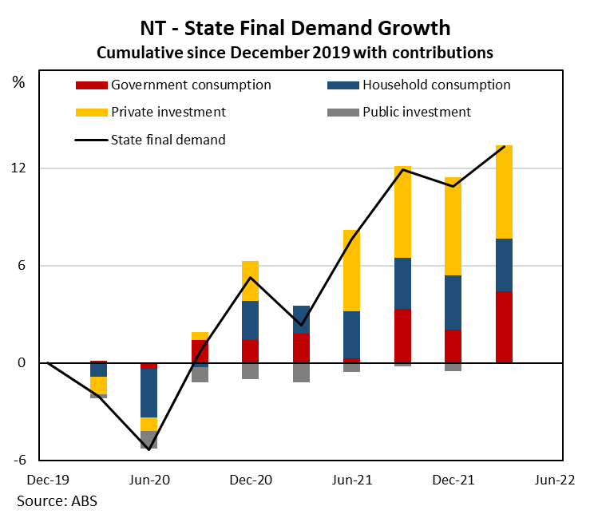 | Graph 2: Growth in retail sales has slowed, but both nominal and inflation-adjusted (real) retail sales are noticeably higher than their pre-pandemic levels. The level of nominal retail sales is being supported by price increases.  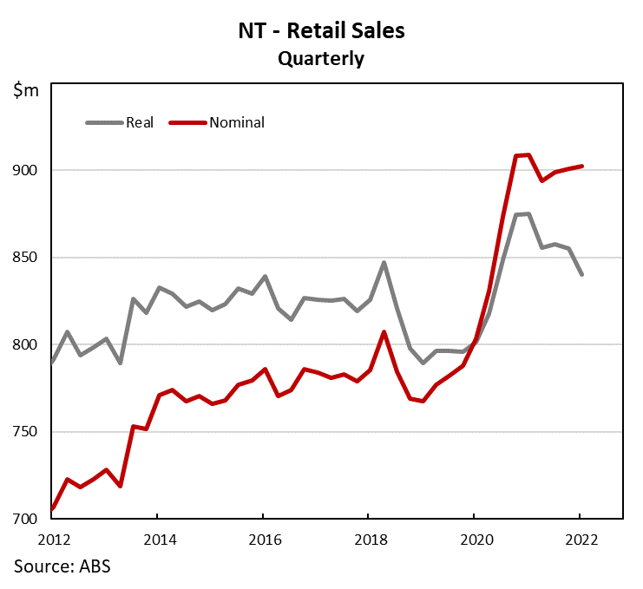
Graph 3: Inflation in Darwin increased sharply in mid-2021 and has remained high since then. Inflationary pressures broadened over recent quarters - around 60 per cent of expenditure classes have recorded price increases of over 2.5 per cent over the year to March.  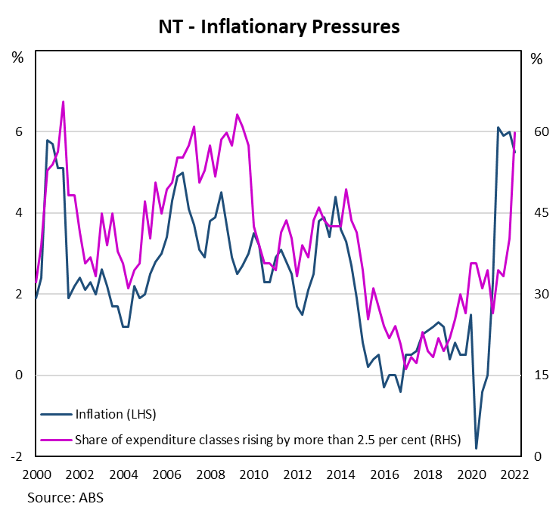 | Graph 4: After spiking at the onset of the pandemic, the ratio of unemployed persons to vacancies in the Territory is now below one, indicating there are currently more job vacancies than unemployed persons in the Territory.  