Mineral Titles Act 2010
NOTICE OF LAND CEASING TO BE A MINERAL TITLE APPLICATION AREA
Title Type and Number: | Exploration Licence 32686
Area Ceased on: | 11 October 2021
Area: | 250 Blocks, 820.30 km²
Locality: | MUNDAH
Name of Applicant(s)/Holder(s): | 100% BAUDIN RESOURCES PTY LTD [ACN. 618 455 593]
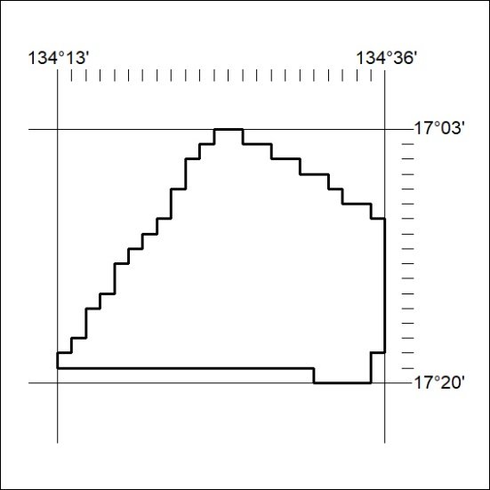

378/21

Mineral Titles Act 2010
NOTICE OF LAND CEASING TO BE A MINERAL TITLE APPLICATION AREA
Title Type and Number: | Exploration Licence 32687
Area Ceased on: | 11 October 2021
Area: | 250 Blocks, 819.11 km²
Locality: | MUNDAH
Name of Applicant(s)/Holder(s): | 100% BAUDIN RESOURCES PTY LTD [ACN. 618 455 593]
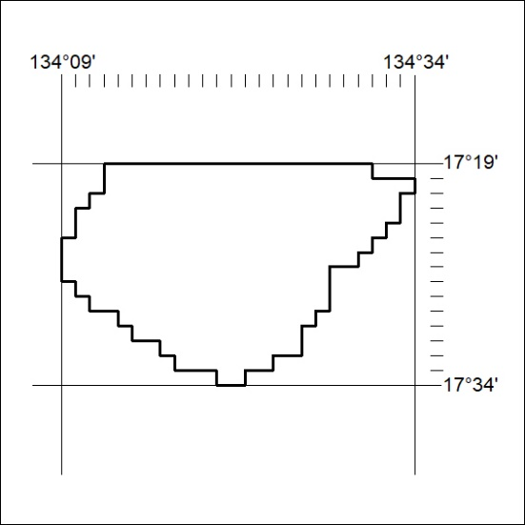

379/21

Mineral Titles Act
NOTICE OF GRANT OF A MINERAL TITLE
Title Type and Number: | Exploration Licence 32518
Granted: | 11 October 2021, for a period of 6 Years
Area: | 242 Blocks, 795.92 km²
Locality: | FLAT TOP HILL
Name of Holder/s: | 100% SANTONIAN RESOURCES PTY LTD [ACN. 627 611 563]
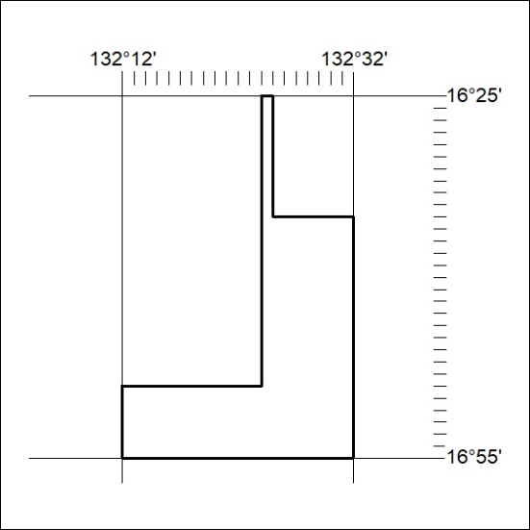
Area granted is indicated above. The titleholder is not permitted to exercise occupational rights on any land that is subject to a development title, or an application for a development title. Any land the subject of a Reserved Land gazettal under the Mineral Titles Act and all land vested in the Commonwealth of Australia is also excluded by description but not excised from the grant area.
380/21

Mineral Titles Act
NOTICE OF GRANT OF A MINERAL TITLE
Title Type and Number: | Exploration Licence 32519
Granted: | 11 October 2021, for a period of 6 Years
Area: | 250 Blocks, 822.21 km²
Locality: | HIDDEN VALLEY
Name of Holder/s: | 100% SANTONIAN RESOURCES PTY LTD [ACN. 627 611 563]
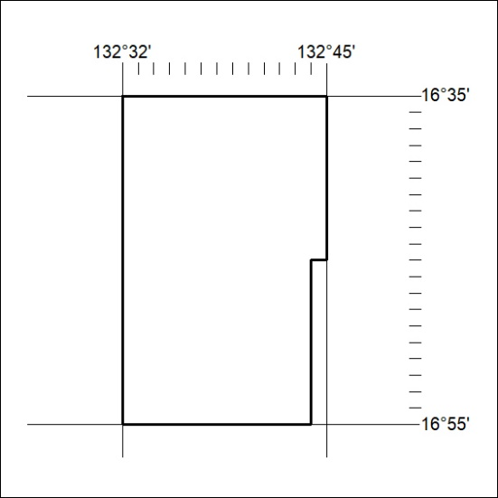
Area granted is indicated above. The titleholder is not permitted to exercise occupational rights on any land that is subject to a development title, or an application for a development title. Any land the subject of a Reserved Land gazettal under the Mineral Titles Act and all land vested in the Commonwealth of Australia is also excluded by description but not excised from the grant area.
381/21

Mineral Titles Act
NOTICE OF GRANT OF A MINERAL TITLE
Title Type and Number: | Exploration Licence 32520
Granted: | 11 October 2021, for a period of 6 Years
Area: | 26 Blocks, 85.54 km²
Locality: | HIDDEN VALLEY
Name of Holder/s: | 100% SANTONIAN RESOURCES PTY LTD [ACN. 627 611 563]
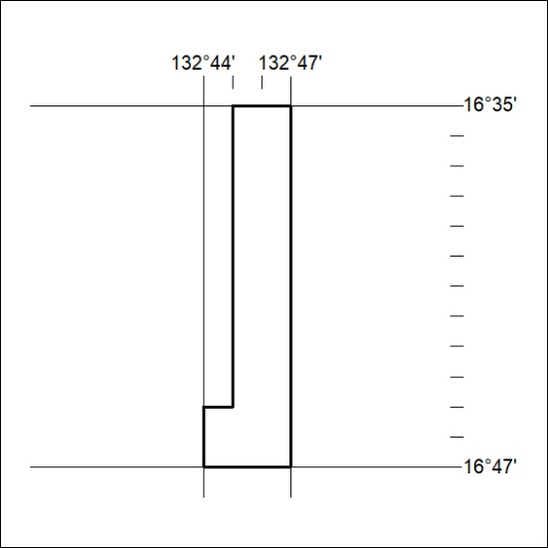
Area granted is indicated above. The titleholder is not permitted to exercise occupational rights on any land that is subject to a development title, or an application for a development title. Any land the subject of a Reserved Land gazettal under the Mineral Titles Act and all land vested in the Commonwealth of Australia is also excluded by description but not excised from the grant area.
382/21

Mineral Titles Act
NOTICE OF GRANT OF A MINERAL TITLE
Title Type and Number: | Exploration Licence 32671
Granted: | 11 October 2021, for a period of 6 Years
Area: | 49 Blocks, 154.55 km²
Locality: | DALY RIVER
Name of Holder/s: | 100% MAY DRILLING PTY LTD [ACN. 123 393 135]
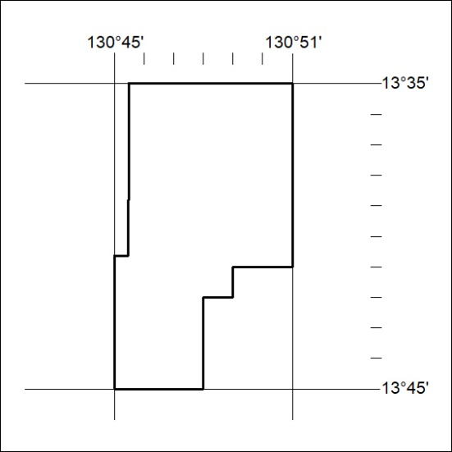
Area granted is indicated above. The titleholder is not permitted to exercise occupational rights on any land that is subject to a development title, or an application for a development title. Any land the subject of a Reserved Land gazettal under the Mineral Titles Act and all land vested in the Commonwealth of Australia is also excluded by description but not excised from the grant area.
383/21

