Mineral Titles Act 2010
NOTICE OF LAND CEASING TO BE A MINERAL TITLE AREA
Title Type and Number: | Exploration Licence 32276
Area Ceased on: | 15 September 2021
Area: | 2 Blocks, 6.68 km²
Locality: | PINE CREEK
Name of Applicant(s)/Holder(s): | 100% HUMPTY DOO PROSPECTING PTY LTD [ACN. 155 321 369]
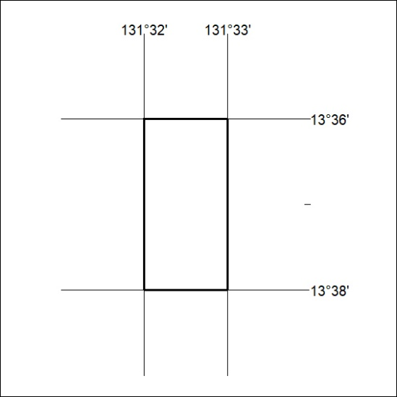

350/21

