Mineral Titles Act 2010
NOTICE OF LAND CEASING TO BE A MINERAL TITLE AREA
Title Type and Number: | Extractive Mineral Permit 31643
Area ceased on: | 09 August 2021
Area: | 27.00 Hectare
Locality: | KOOLPINYAH
Name of Applicants(s)Holder(s): | 100% MOUSELLIS & SONS PTY. LTD. [ACN. 009 654 791]
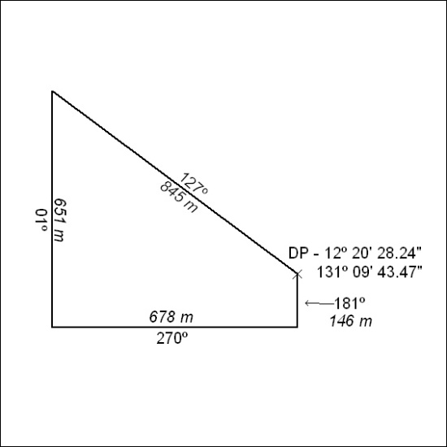

292/21

Mineral Titles Act 2010
NOTICE OF LAND CEASING TO BE A MINERAL TITLE AREA
Title Type and Number: | Extractive Mineral Permit 31662
Area ceased on: | 09 August 2021
Area: | 39.00 Hectare
Locality: | KOOLPINYAH
Name of Applicants(s)Holder(s): | 100% JN. MOUSELLIS CIVIL CONTRACTORS PTY LTD [ACN. 122 603 990]
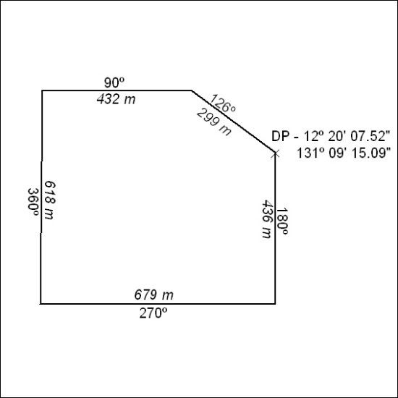

293/21

