Mineral Titles Act 2010
NOTICE OF LAND CEASING TO BE A MINERAL TITLE AREA
Title Type and Number: | Exploration Licence 10335
Area Ceased on: | 18 June 2021
Area: | 215 Blocks, 679.39 km²
Locality: | WOLLOGORANG
Name of Applicant(s)/Holder(s): | 100% REDBANK OPERATIONS PTY LTD* [ACN. 109 362 165]
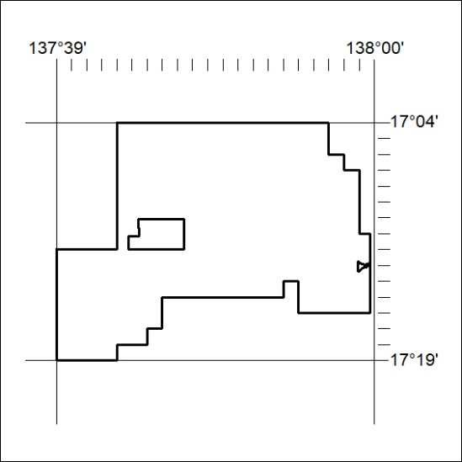
(Area now amalgamated into Exploration Licence 32715 under s102 – EL moratorium period does not apply)

219/21

Mineral Titles Act 2010
NOTICE OF LAND CEASING TO BE A MINERAL TITLE AREA
Title Type and Number: | Exploration Licence 28288
Area Ceased on: | 18 June 2021
Area: | 5 Blocks, 16.40 km²
Locality: | WOLLOGORANG
Name of Applicant(s)/Holder(s): | 100% REDBANK OPERATIONS PTY LTD* [ACN. 109 362 165]
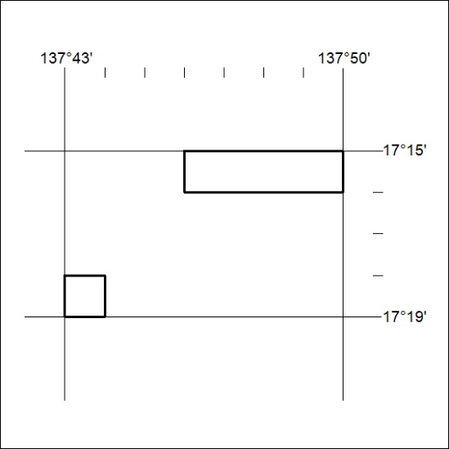
(Area now amalgamated into Exploration Licence 32715 under s102 – EL moratorium period does not apply)

220/21
Mineral Titles Act 2010
NOTICE OF LAND CEASING TO BE A MINERAL TITLE AREA
Title Type and Number: | Exploration Licence 28289
Area Ceased on: | 18 June 2021
Area: | 4 Blocks, 10.16 km²
Locality: | WOLLOGORANG
Name of Applicant(s)/Holder(s): | 100% REDBANK OPERATIONS PTY LTD* [ACN. 109 362 165]
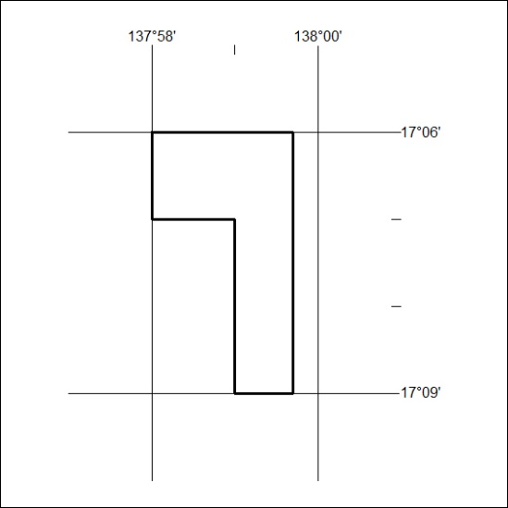
(Area now amalgamated into Exploration Licence 32715 under s102 – EL moratorium period does not apply)

221/21

Mineral Titles Act 2010
NOTICE OF LAND CEASING TO BE A MINERAL TITLE AREA
Title Type and Number: | Exploration Licence 28290
Area Ceased on: | 18 June 2021
Area: | 3 Blocks, 9.84 km²
Locality: | WOLLOGORANG
Name of Applicant(s)/Holder(s): | 100% REDBANK OPERATIONS PTY LTD* [ACN. 109 362 165]
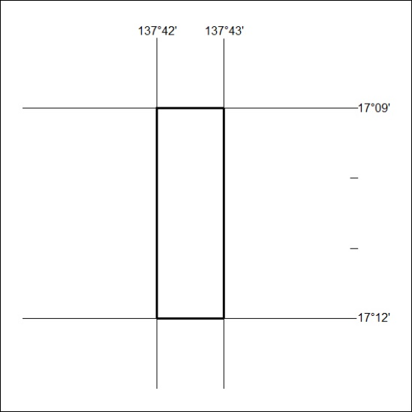
(Area now amalgamated into Exploration Licence 32715 under s102 – EL moratorium period does not apply)

222/21

Mineral Titles Act 2010
NOTICE OF LAND CEASING TO BE A MINERAL TITLE AREA
Title Type and Number: | Extractive Mineral Permit 31661
Area ceased on: | 21 June 2021
Area: | 25.87 Hectare
Locality: | KOOLPINYAH
Name of Applicants(s)Holder(s): | 100% MOUSELLIS & SONS PTY. LTD. [ACN. 009 654 791]
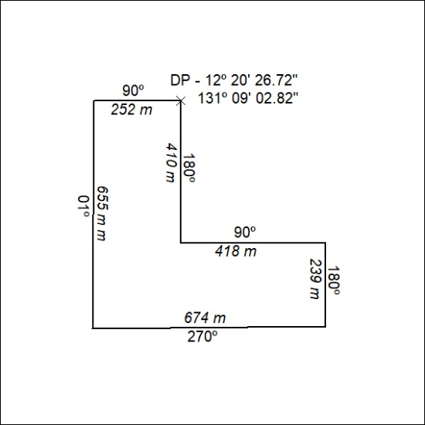

223/21

