Mineral Titles Act
NOTICE OF GRANT OF A MINERAL TITLE
Title Type and Number: | Exploration Licence 32495
Granted: | 27 May 2021, for a period of 6 Years
Area: | 135 Blocks, 423.96 km²
Locality: | EPENARRA
Name of Holder/s: | 100% BREMA RESOURCES PTY LTD [ACN. 643 480 693]
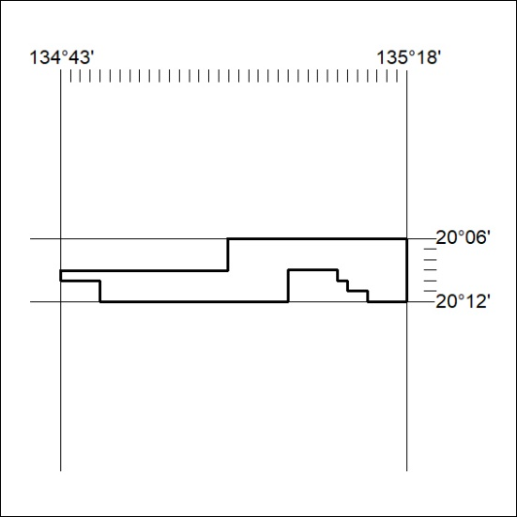
Area granted is indicated above. The titleholder is not permitted to exercise occupational rights on any land that is subject to a development title, or an application for a development title. Any land the subject of a Reserved Land gazettal under the Mineral Titles Act and all land vested in the Commonwealth of Australia is also excluded by description but not excised from the grant area.
187/21

Mineral Titles Act
NOTICE OF GRANT OF A MINERAL TITLE
Title Type and Number: | Exploration Licence 32496
Granted: | 27 May 2021, for a period of 6 Years
Area: | 196 Blocks, 635.12 km²
Locality: | LULU
Name of Holder/s: | 100% BREMA RESOURCES PTY LTD [ACN. 643 480 693]
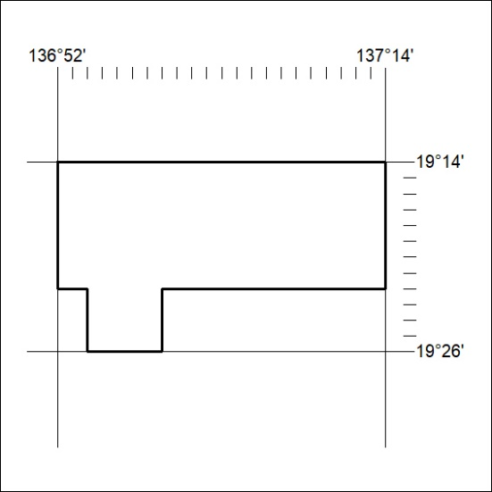
Area granted is indicated above. The titleholder is not permitted to exercise occupational rights on any land that is subject to a development title, or an application for a development title. Any land the subject of a Reserved Land gazettal under the Mineral Titles Act and all land vested in the Commonwealth of Australia is also excluded by description but not excised from the grant area.
188/21

Mineral Titles Act
NOTICE OF GRANT OF A MINERAL TITLE
Title Type and Number: | Exploration Licence 32497
Granted: | 27 May 2021, for a period of 6 Years
Area: | 233 Blocks, 755.10 km²
Locality: | ALEXANDRIA
Name of Holder/s: | 100% BREMA RESOURCES PTY LTD [ACN. 643 480 693]
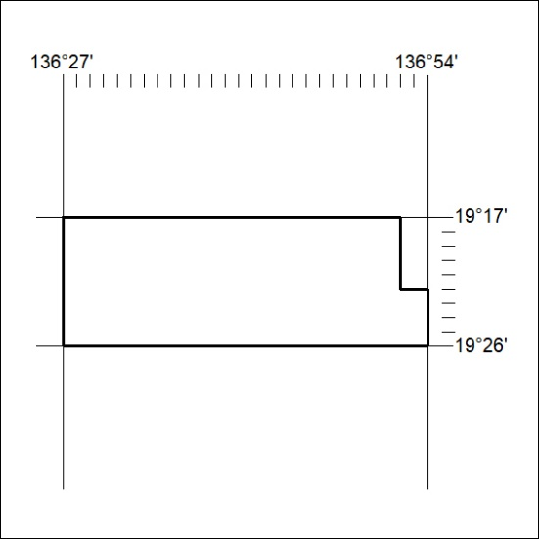
Area granted is indicated above. The titleholder is not permitted to exercise occupational rights on any land that is subject to a development title, or an application for a development title. Any land the subject of a Reserved Land gazettal under the Mineral Titles Act and all land vested in the Commonwealth of Australia is also excluded by description but not excised from the grant area.
189/21

Mineral Titles Act
NOTICE OF GRANT OF A MINERAL TITLE
Title Type and Number: | Exploration Licence 32500
Granted: | 27 May 2021, for a period of 6 Years
Area: | 250 Blocks, 796.54 km²
Locality: | PLAYFORD
Name of Holder/s: | 100% BREMA RESOURCES PTY LTD [ACN. 643 480 693]
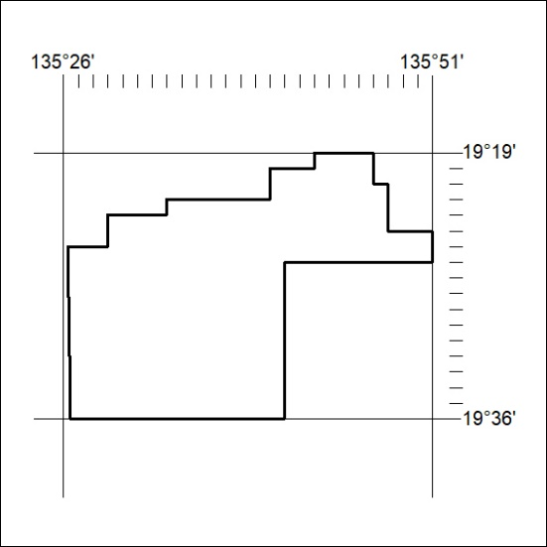
Area granted is indicated above. The titleholder is not permitted to exercise occupational rights on any land that is subject to a development title, or an application for a development title. Any land the subject of a Reserved Land gazettal under the Mineral Titles Act and all land vested in the Commonwealth of Australia is also excluded by description but not excised from the grant area.
190/21

