Mineral Titles Act 2010
NOTICE OF LAND CEASING TO BE A MINERAL TITLE AREA
Title Type and Number: | Exploration Licence 25146
Area Ceased on: | 17 October 2019
Area: | 174 Blocks, 550.72 km²
Locality: | EGERTON
Name of Applicant(s)/Holder(s): | 100% PRODIGY GOLD NL* [ACN. 009 127 020]
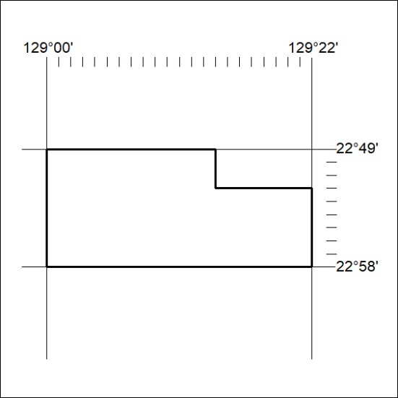

432/19

Mineral Titles Act 2010
NOTICE OF LAND CEASING TO BE A MINERAL TITLE AREA
Title Type and Number: | Exploration Licence 30730
Area Ceased on: | 17 October 2019
Area: | 61 Blocks, 192.98 km²
Locality: | CAREY
Name of Applicant(s)/Holder(s): | 100% PRODIGY GOLD NL* [ACN. 009 127 020]
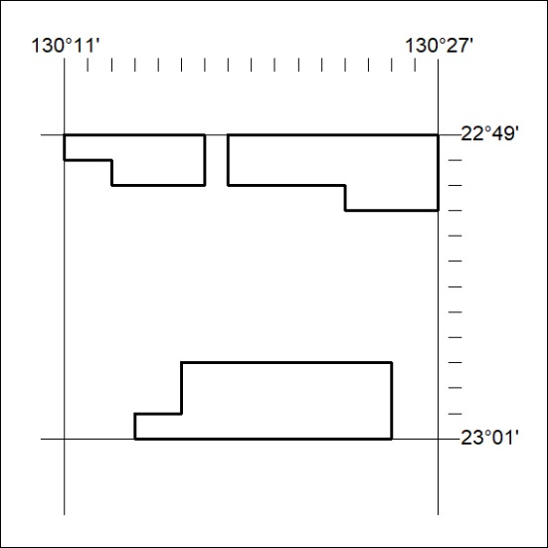

433/19
Mineral Titles Act 2010
NOTICE OF LAND CEASING TO BE A MINERAL TITLE AREA
Title Type and Number: | Exploration Licence 30732
Area Ceased on: | 17 October 2019
Area: | 118 Blocks, 372.89 km²
Locality: | KUTA KUTA
Name of Applicant(s)/Holder(s): | 100% PRODIGY GOLD NL* [ACN. 009 127 020]
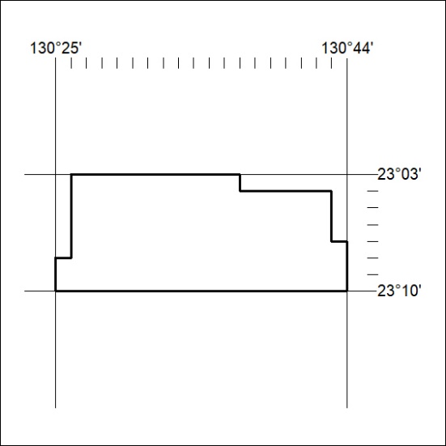

434/19

Mineral Titles Act 2010
NOTICE OF LAND CEASING TO BE A MINERAL TITLE AREA
Title Type and Number: | Exploration Licence 30733
Area Ceased on: | 17 October 2019
Area: | 112 Blocks, 353.97 km²
Locality: | KUTA KUTA
Name of Applicant(s)/Holder(s): | 100% PRODIGY GOLD NL* [ACN. 009 127 020]
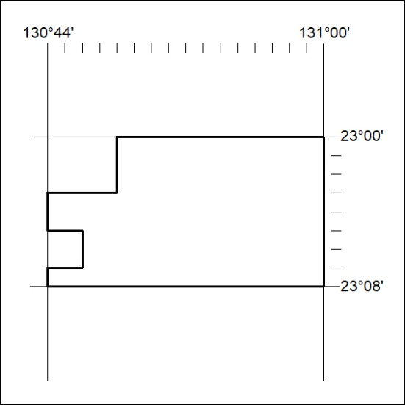

435/19
Mineral Titles Act 2010
NOTICE OF LAND CEASING TO BE A MINERAL TITLE AREA
Title Type and Number: | Exploration Licence 30740
Area Ceased on: | 17 October 2019
Area: | 96 Blocks, 288.54 km²
Locality: | LIEBIG
Name of Applicant(s)/Holder(s): | 100% PRODIGY GOLD NL* [ACN. 009 127 020]
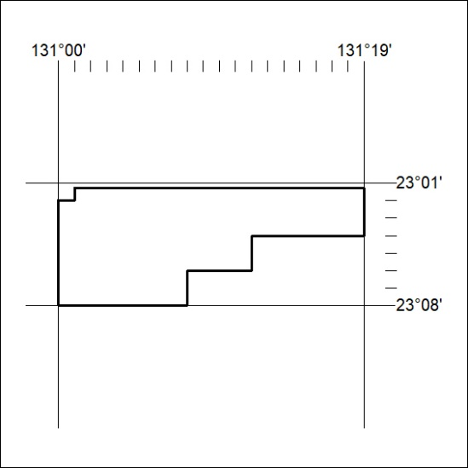

436/19

Mineral Titles Act 2010
NOTICE OF LAND CEASING TO BE A MINERAL TITLE AREA
Title Type and Number: | Exploration Licence 31234
Area Ceased on: | 17 October 2019
Area: | 66 Blocks, 208.46 km²
Locality: | LEISLER
Name of Applicant(s)/Holder(s): | 100% INDEPENDENCE GROUP NL* [ACN. 092 786 304]
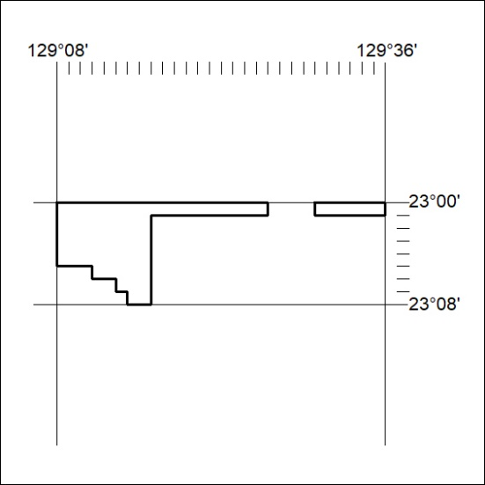

437/19
Mineral Titles Act 2010
NOTICE OF LAND CEASING TO BE A MINERAL TITLE AREA
Title Type and Number: | Exploration Licence 31451
Area Ceased on: | 17 October 2019
Area: | 109 Blocks, 351.05 km²
Locality: | McKINLAY RIVER
Name of Applicant(s)/Holder(s): | 100% ML GLOBAL PTY LTD [ACN. 150 097 242]
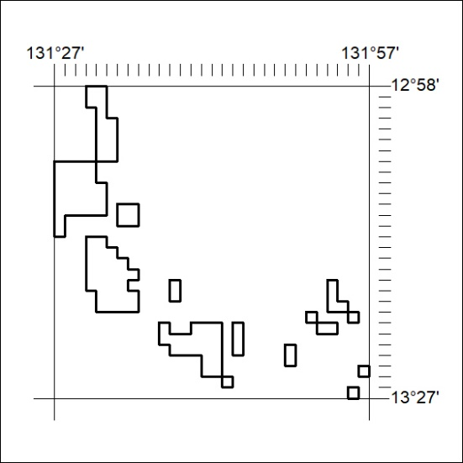

438/19

