Mineral Titles Act 2010
NOTICE OF LAND CEASING TO BE A MINERAL TITLE AREA
Title Type and Number: | Extractive Mineral Permit 22637
Area ceased on: | 04 July 2019
Area: | 20.00 Hectare
Locality: | NOONAMAH
Name of Applicants(s)Holder(s): | 100% A AND SF MADDALOZZO PTY. LIMITED [ACN. 009 624 015]
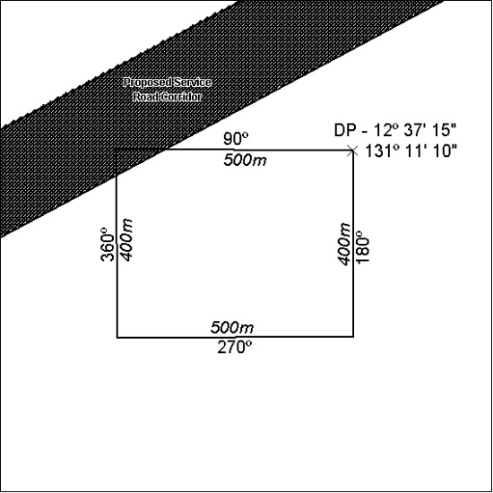

286/19

