Mineral Titles Act 2010
NOTICE OF LAND CEASING TO BE A MINERAL TITLE AREA
Title Type and Number: | Exploration Licence 30897
Area Ceased on: | 25 June 2019
Area: | 3 Blocks, 10.05 km²
Locality: | BYNOE
Name of Applicant(s)/Holder(s): | 100% LITHIUM AUSTRALIA NL [ACN. 126 129 413]
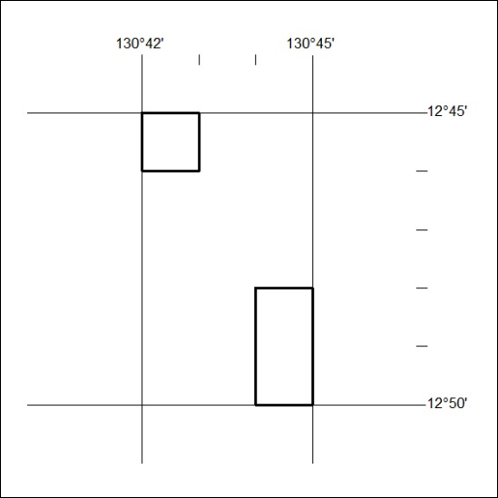

264/19

Mineral Titles Act 2010
NOTICE OF LAND CEASING TO BE A MINERAL TITLE AREA
Title Type and Number: | Exploration Licence 31305
Area Ceased on: | 20 June 2019
Area: | 100 Blocks, 318.08 km²
Locality: | DOREEN
Name of Applicant(s)/Holder(s): | 100% LITCHFIELD MINERALS PTY LTD [ACN. 612 660 429]
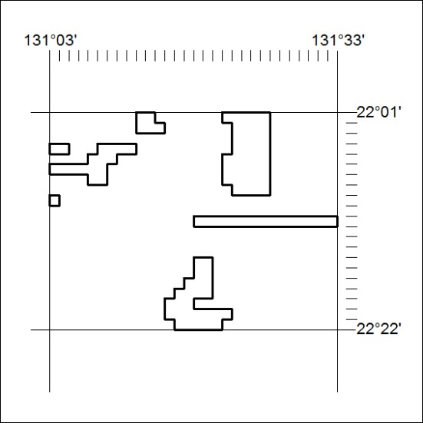

265/19
Mineral Titles Act 2010
NOTICE OF LAND CEASING TO BE A MINERAL TITLE AREA
Title Type and Number: | Exploration Licence 31753
Area Ceased on: | 21 June 2019
Area: | 72 Blocks, 215.25 km²
Locality: | NICHOLSON RIVER
Name of Applicant(s)/Holder(s): | 100% TM RESOURCES PTY LTD [ACN. 601 076 091]
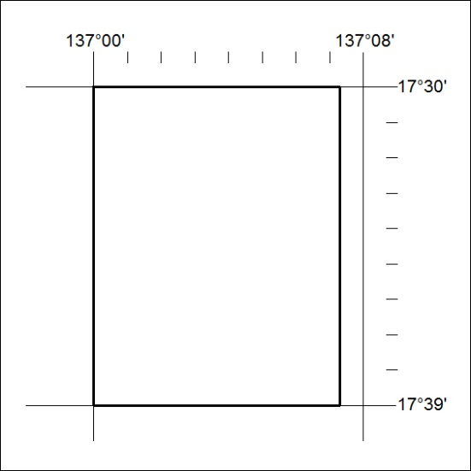

266/19

Mineral Titles Act 2010
NOTICE OF LAND CEASING TO BE A MINERAL TITLE AREA
Title Type and Number: | Extractive Mineral Exploration Licence 31450
Area Ceased on: | 19 June 2019
Area: | 4 Blocks, 12.16 km²
Locality: | KOOLPINYAH
Name of Applicant(s)/Holder(s): | 100% MOUSELLIS John
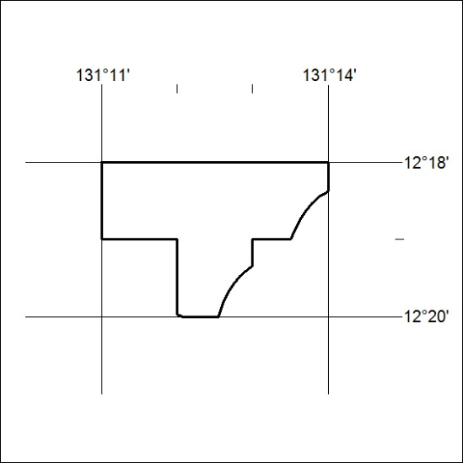

267/19

