Key points
- Territory-wide business confidence was +62% in the December quarter 2023, up from +57% in the September quarter 2023, and down from +73% in the December quarter 2022.
- The increase in the quarter was driven by greater confidence in Katherine region, retracing from the drop in the June quarter.
- The most commonly cited reasons for confidence this quarter were ‘strong customer relations’, ‘business opportunity’ and ‘been in business a long time’.
- The most commonly cited reasons for concern were ‘increasing business costs’, ‘lack of suitably skilled workers’ and ‘decrease in business/sales’.

Territory business confidence increased in the quarter
Territory-wide business confidence was +62% for the December quarter 2023 in response to the question ‘How confident are you about your business prospects over the next 12 months?’. This is a 5 percentage point (ppt) increase in the quarter and a decrease of 11 ppt annually (Table 1).
Table 1: Business confidence index
 | Dec qtr 2023 | Quarterly change | Annual change*
Confident | 71% | +4ppt |  | -8ppt
Worried | 9% | -1ppt |  | +3ppt
Net Balance | 62% | +5ppt |  | -11ppt
*Current quarter compared with the same quarter in the previous year.
Figure 1: Responses to the business confidence question & change from previous quarter
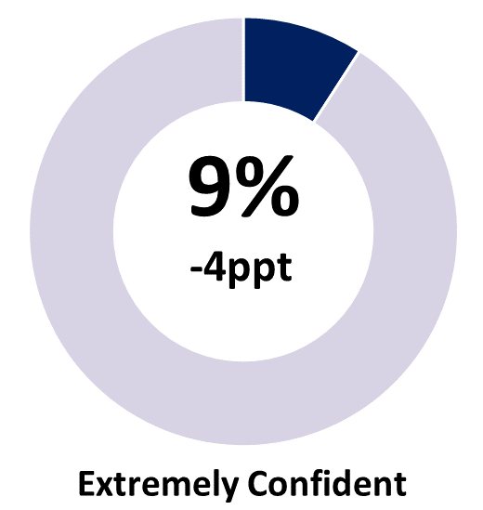 | 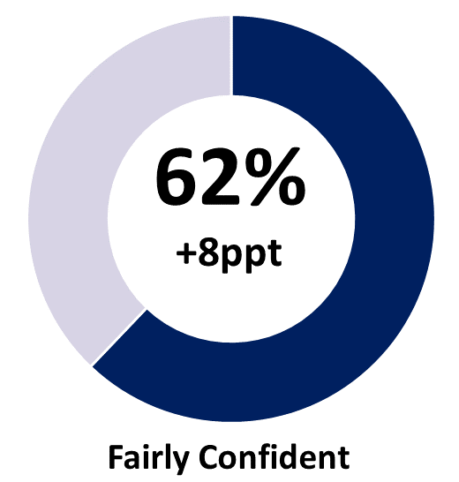 | 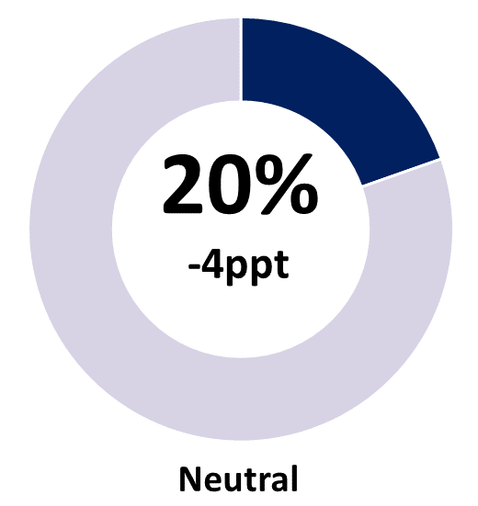
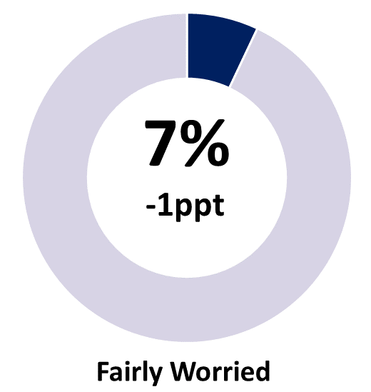 | 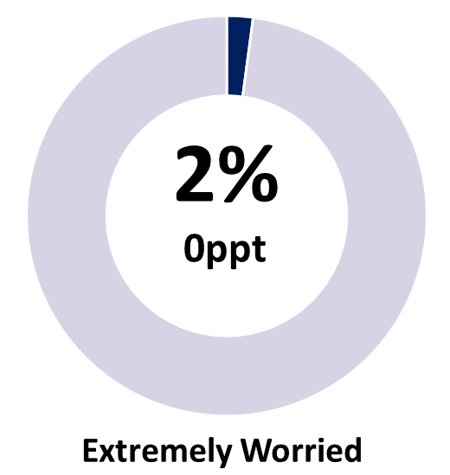 | 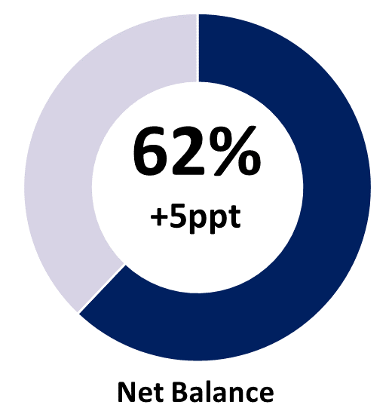
Note: Individual categories may not add to the net balance figure due to rounding.

Business confidence remains well-above pre-pandemic levels
The proportion of confident businesses increased by 4 ppt this quarter, largely attributed to increase in fairly confident businesses, picking up shares from neutral (-4) and worried businesses (-1). Recovering from the dip in the June quarter, business confidence this quarter returned to well above pre-pandemic levels (Chart 1). In calendar year terms, confidence in 2023 is well above pre-pandemic levels, but below the peak reported in 2022 (Chart 2).
Chart 1
Business confidence by quarter (%)
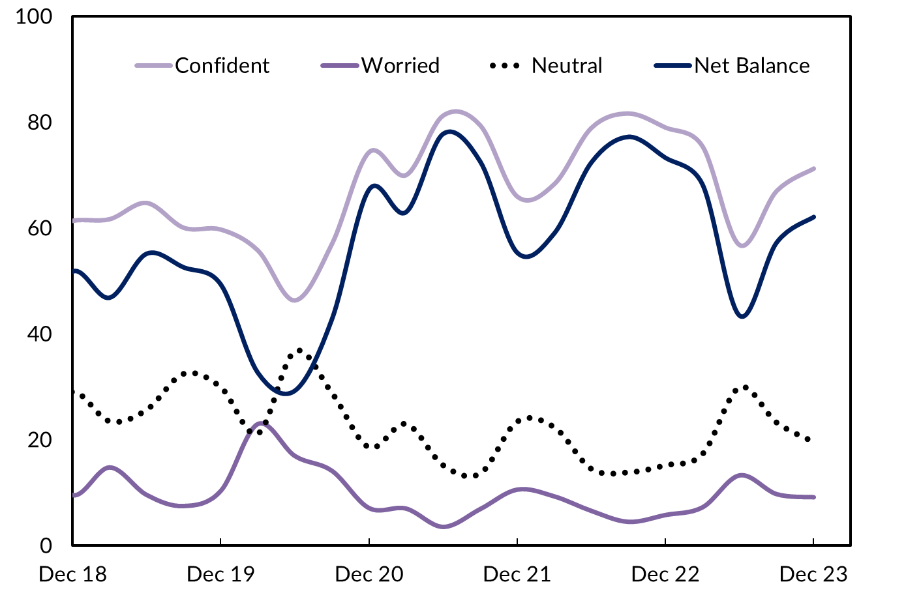
Chart 2
Average business confidence by calendar year (%)
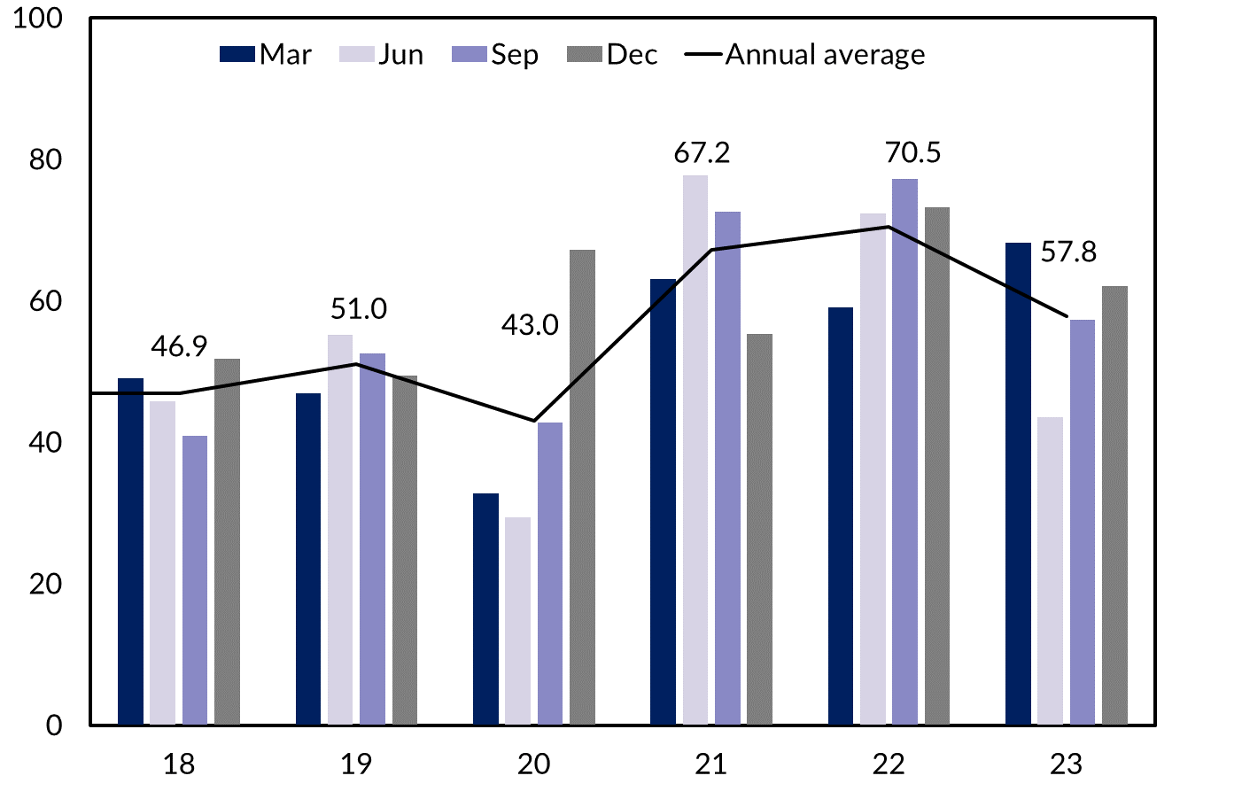

Business performance decreased in the quarter
When asked ‘How is your business performing this year compared to last year?’, 47% of businesses responded with ‘better’, representing a 1ppt increase from the September quarter 2023 and a 19ppt decrease from December quarter 2022 (Table 2).
Table 2: Business performance compared to last year
 | Dec qtr 2023 | Quarterly change | Annual change*
Better | 47% | +1ppt | -19ppt
Same | 36% | +3ppt | +8ppt
Worse | 17% | -3ppt | +11ppt
*Current quarter compared with the same quarter in the previous year.
Figure 2: Responses to the business performance question & quarterly change
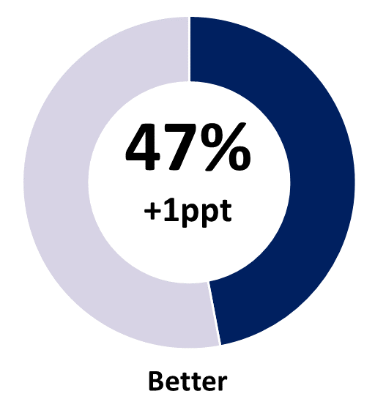 | 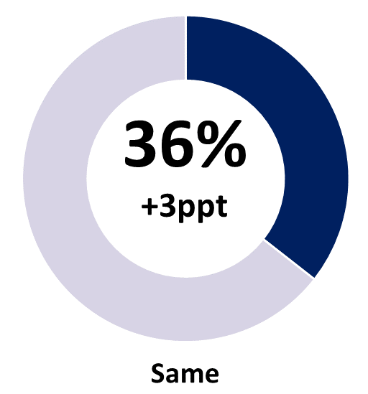 | 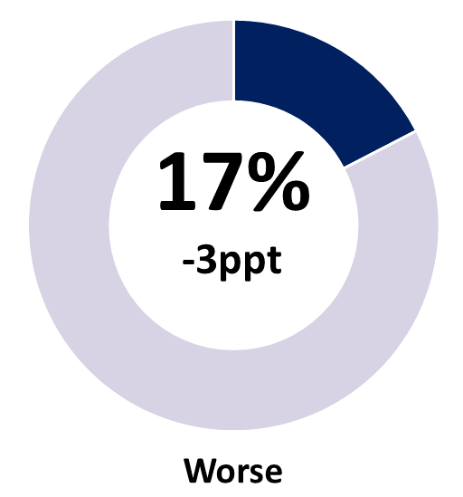
Note: Individual categories may not sum to 100 due to rounding.
The number of businesses stating performance this year is worse than last year was at 17% in the December quarter 2023, down by 3 ppt in quarterly terms and up by 11 ppt in annual terms (Chart 3).
Chart 3
Business performance – comparing this year to last – by quarter (%)
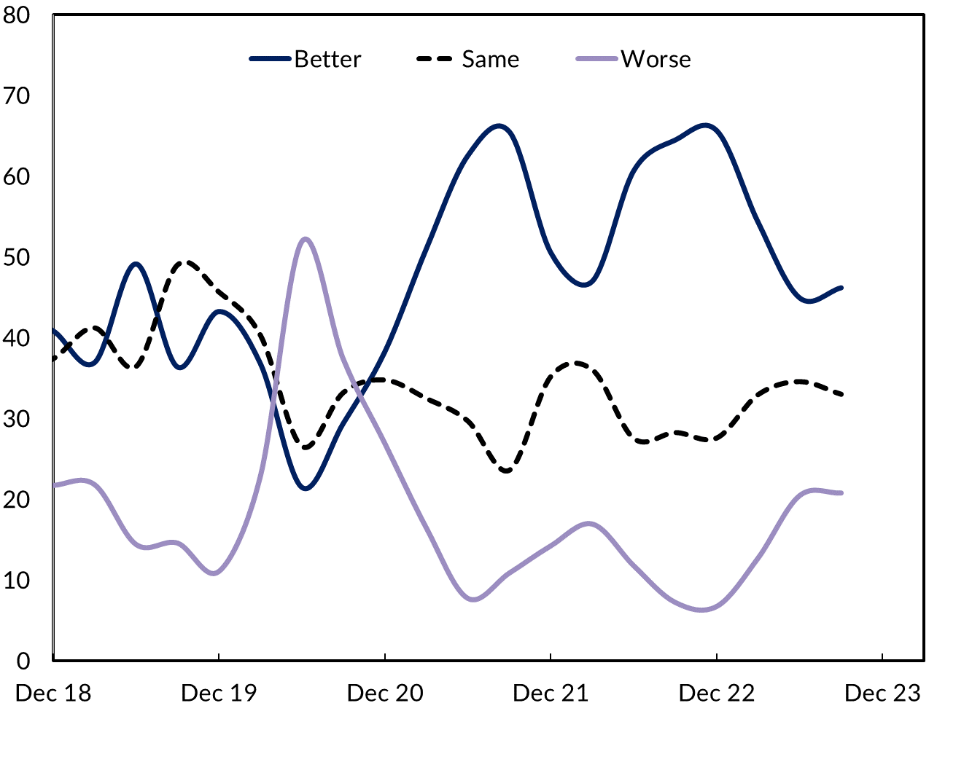

Customer relations & business opportunity drive confidence
The most commonly cited reasons for business confidence in the December quarter 2023 were ‘strong customer relations’, ‘business opportunity’ and ‘been in business a long time’ (Chart 4). Compared with the previous quarter, the proportion of businesses that reported ‘business opportunity’ as a reason for confidence increased by 10 ppt to 39%.
Following two years of strong COVID-related business confidence, over the course of 2023 confidence – at the aggregate level – returned to be slightly above the long term trend level, though there is considerable variation by industry (Chart 10). Business investment remains at high levels, though the rate of growth has tailed-off in recent quarters (Chart 5), impacted by the timing of investment for the Barossa project. That said, ‘increased public works’ continues to support confidence in the construction industry, as does falls in input prices as supply chain issues abate (Chart 6).
Chart 4
Reasons for confidence cited, share of businesses (%)
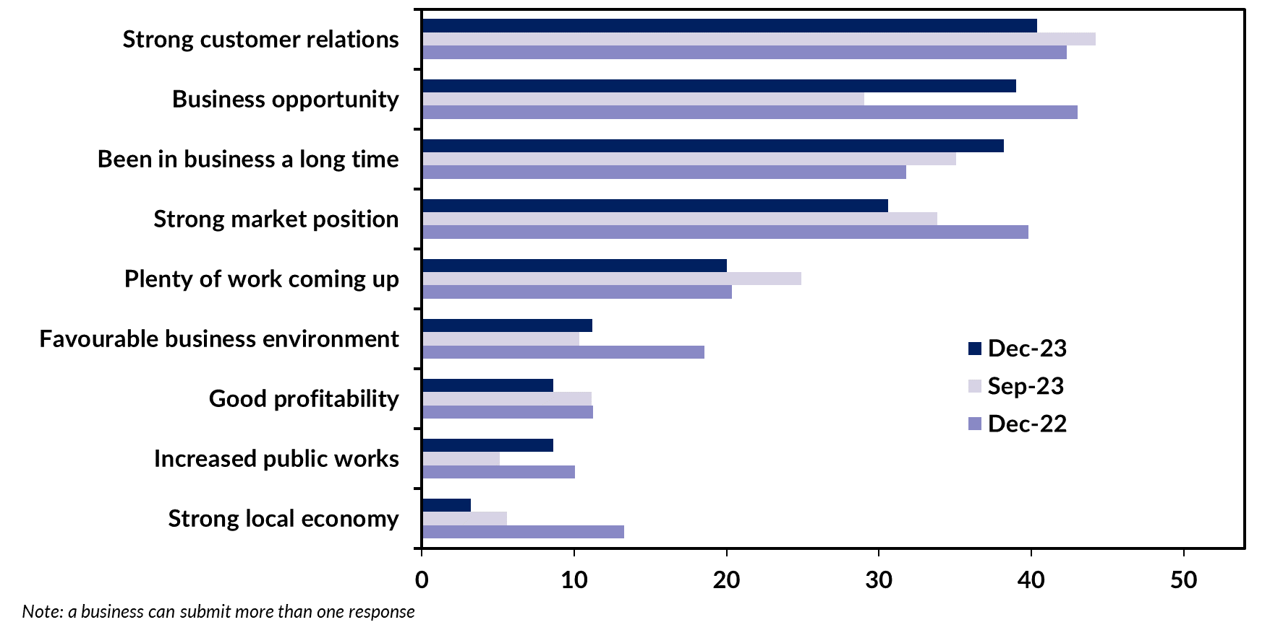
Chart 5 | Chart 6
Territory state final demand component contribution  Year-on-year growth (%) | Building construction price index – NT  Annual growth (%)
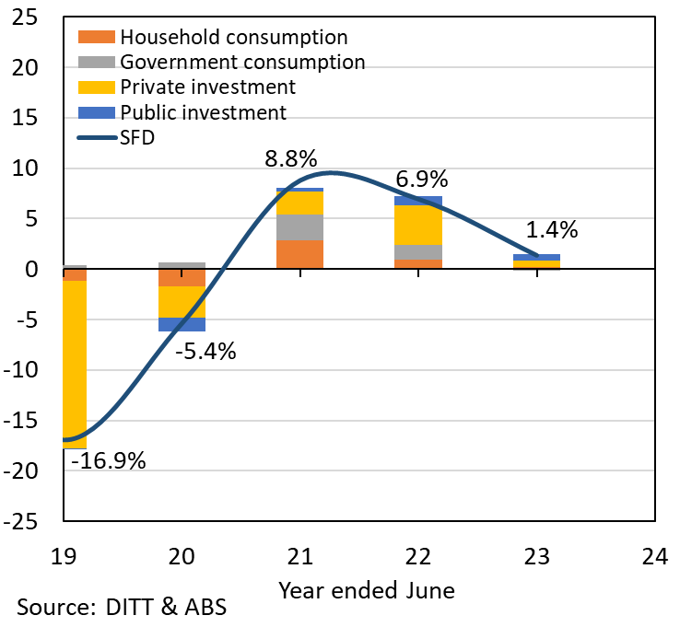 | 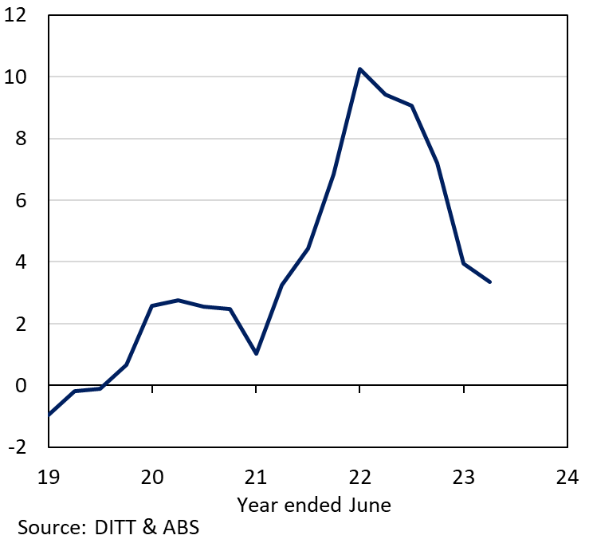

Rising business costs & skilled labour shortages are a concern
Businesses cited ‘increasing business costs’ and ‘decrease in business/sales’ as major concerns in the quarter (Chart 7). Businesses citing ‘decrease in business/sales’ increased to 9%, up by 6 ppt from last year. Higher interest rates and cost of living pressures are impacting consumer sentiment and household spending (which is around 35% of demand in the Territory), and reduced demand is particularly noticeable for non-discretionary goods and services (Chart 8). The impacts of reduced demand are being felt through the supply chain, including with respect to the demand for labour.
Since mid-2020, ‘lack of suitably skilled workers’ has consistently been in the Top 2 business concerns in the Territory (and #1 in 9 out of 15 quarters). It was #2 in the December quarter, and reported a dramatic decrease from the September quarter. Chart 9 suggests the Territory’s labour market is currently more balanced than at any time in the past three years, supported by stronger population growth – notably from overseas migration – supporting supply, and weaker household consumption impacting labour demand.

Chart 7
Reasons for worry cited, share of businesses (%)
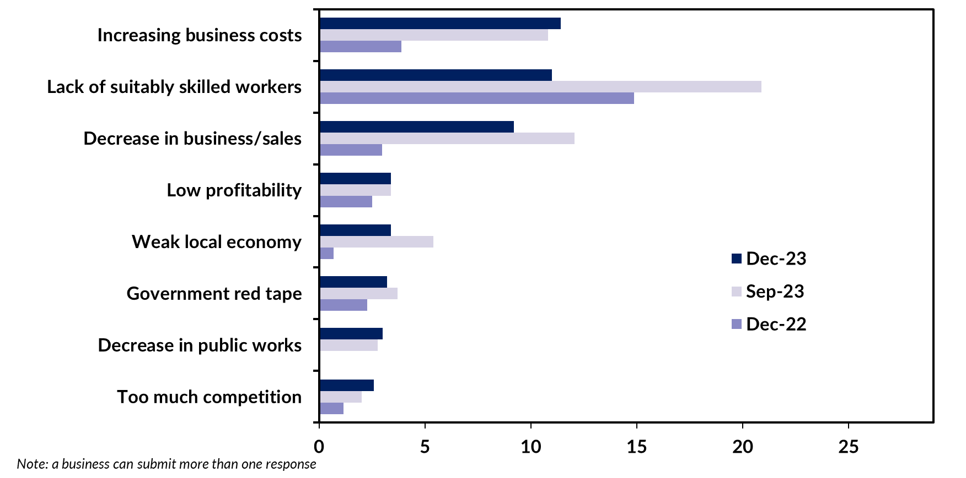
Chart 8 | Chart 9
Discretionary & non-discretionary retail sales  Year-on-year growth (%), Seasonally Adjusted | Vacancy & unemployment rate  Quarterly (%), Original
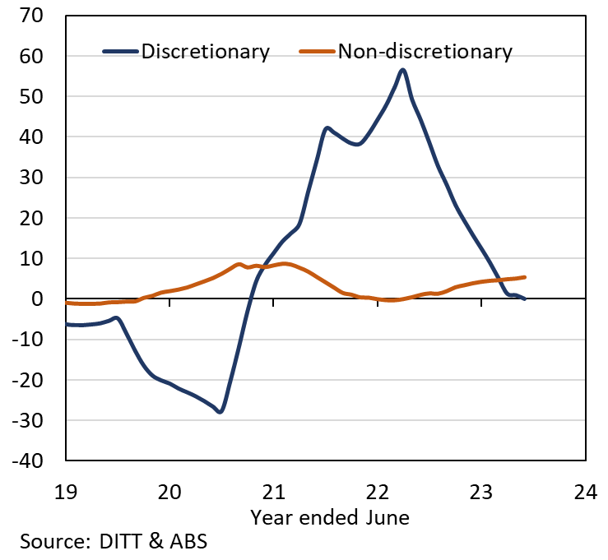 | 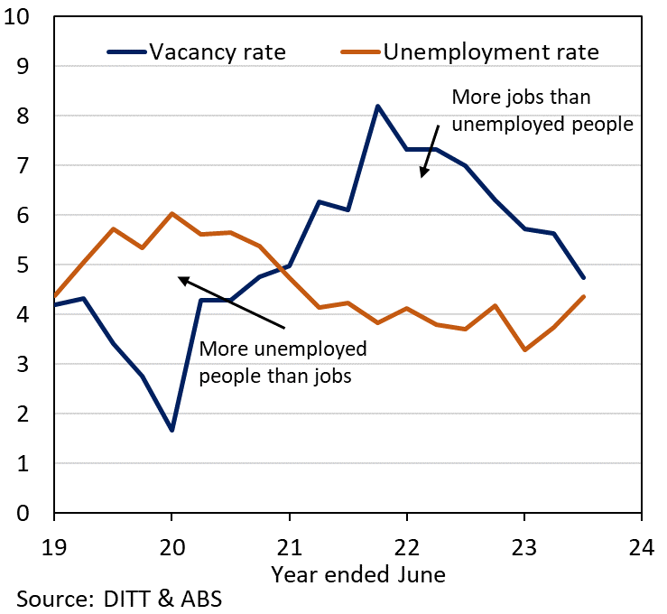

Business confidence & performance vary among the regions
Business confidence and performance varies by region (Table 3). Business confidence was highest in the Daly-Tiwi-West Arnhem region in the December quarter with a net balance of +81. Katherine region recorded a net balance of +71%, an increase of 24 ppt in a quarter, highest among the regions. Please note that a small sample size in some regions can contribute to large quarterly movements.
Business confidence in Greater Darwin increased by 3 ppt in the quarter to a net balance of +60%, rebounding from the 21ppt decline in the June quarter and comfortably back above pre-pandemic levels. Business confidence in Alice Springs increased by 10 ppt this quarter to a net balance of +62% and down by 32 ppt annually, continuing to decline from its record high observed in the second half of 2022.
Table 3: Business confidence & performance by region
Business Confidence |  |  |  |  | Business Performance
 | Dec qtr 2023 | Quarterly change | Annual change |  |  | Dec qtr 2023 | Quarterly change | Annual change
Territory-wide (n=500) |  |  |  |  | Territory-wide (n=500)
Confident | 71% | +4ppt | -8ppt |  | Better | 47% | +1ppt | -19ppt
Worried | 9% | -1ppt | +3ppt |  | Same | 36% | +3ppt | +8ppt
Net Balance | 62% | +5ppt | -11ppt |  | Worse | 17% | -3ppt | +11ppt
Greater Darwin (n=217) |  |  |  |  | Greater Darwin (n=217)
Confident | 71% | +4ppt | -5ppt |  | Better | 50% | +2ppt | -17ppt
Worried | 10% | +1ppt | +4ppt |  | Same | 33% | +2ppt | +6ppt
Net Balance | 60% | +3ppt | -8ppt |  | Worse | 17% | -4ppt | +11ppt
Daly-Tiwi-West Arnhem (n=43) |  |  |  |  | Daly-Tiwi-West Arnhem (n=43)
Confident | 81% | -3ppt | +13ppt |  | Better | 42% | -13ppt | -17ppt
Worried | 0% | -6ppt | -18ppt |  | Same | 47% | +13ppt | +19ppt
Net Balance | 81% | +3ppt | +31ppt |  | Worse | 12% | 0ppt | -2ppt
East Arnhem (n=39) |  |  |  |  | East Arnhem (n=39)
Confident | 79% | -17ppt | -1ppt |  | Better | 44% | +6ppt | -16ppt
Worried | 5% | +1ppt | 0ppt |  | Same | 36% | -14ppt | +11ppt
Net Balance | 74% | -18ppt | -1ppt |  | Worse | 21% | +8ppt | +6ppt
Katherine (n=35) |  |  |  |  | Katherine (n=35)
Confident | 74% | +9ppt | -10ppt |  | Better | 43% | +3ppt | -15ppt
Worried | 3% | -15ppt | -1ppt |  | Same | 31% | +7ppt | +1ppt
Net Balance | 71% | +24ppt | -9ppt |  | Worse | 26% | -10ppt | +14ppt
Barkly (n=21) |  |  |  |  | Barkly (n=21)
Confident | 76% | +3ppt | -24ppt |  | Better | 38% | -1ppt | -62ppt
Worried | 5% | -11ppt | +5ppt |  | Same | 38% | -1ppt | +38ppt
Net Balance | 71% | +14ppt | -29ppt |  | Worse | 24% | +2ppt | +24ppt
Alice Springs (n=145) |  |  |  |  | Alice Springs (n=145)
Confident | 70% | +9ppt | -24ppt |  | Better | 35% | -4ppt | -27ppt
Worried | 8% | -1ppt | +8ppt |  | Same | 50% | +6ppt | +17ppt
Net Balance | 62% | +10ppt | -32ppt |  | Worse | 14% | -2ppt | +10ppt
Note: Caution should be taken when interpreting these results as the sample size in some regions may be relatively small.

Business confidence varies across industries
Business confidence varies among the 10 industries with the largest number of respondents, ranging from Construction reporting a net balance of +78% to Accommodation & Food Services with a net balance of +48% (and reflecting seasonal impacts) (Chart 10).
Confidence in the Territory’s Arts & Recreation Services industry increased for the third consecutive quarter, and reports a solid net balance of +74% in the quarter. This coincides with the industry’s highest recorded employment level of 5,343 persons in the November quarter 2023. In 2022-23, the Territory recorded the highest entry rate of new businesses in the Arts & Recreation Services industry at 23%, higher than the national entry rate of 18%.
Consumer-facing industries such as Retail Trade & Accommodation & Food Services reported the lowest confidence levels in the quarter, as inflation and cost of living pressures impact household confidence, budgets and consumption.
Chart 10
Business confidence responses by industry (%)
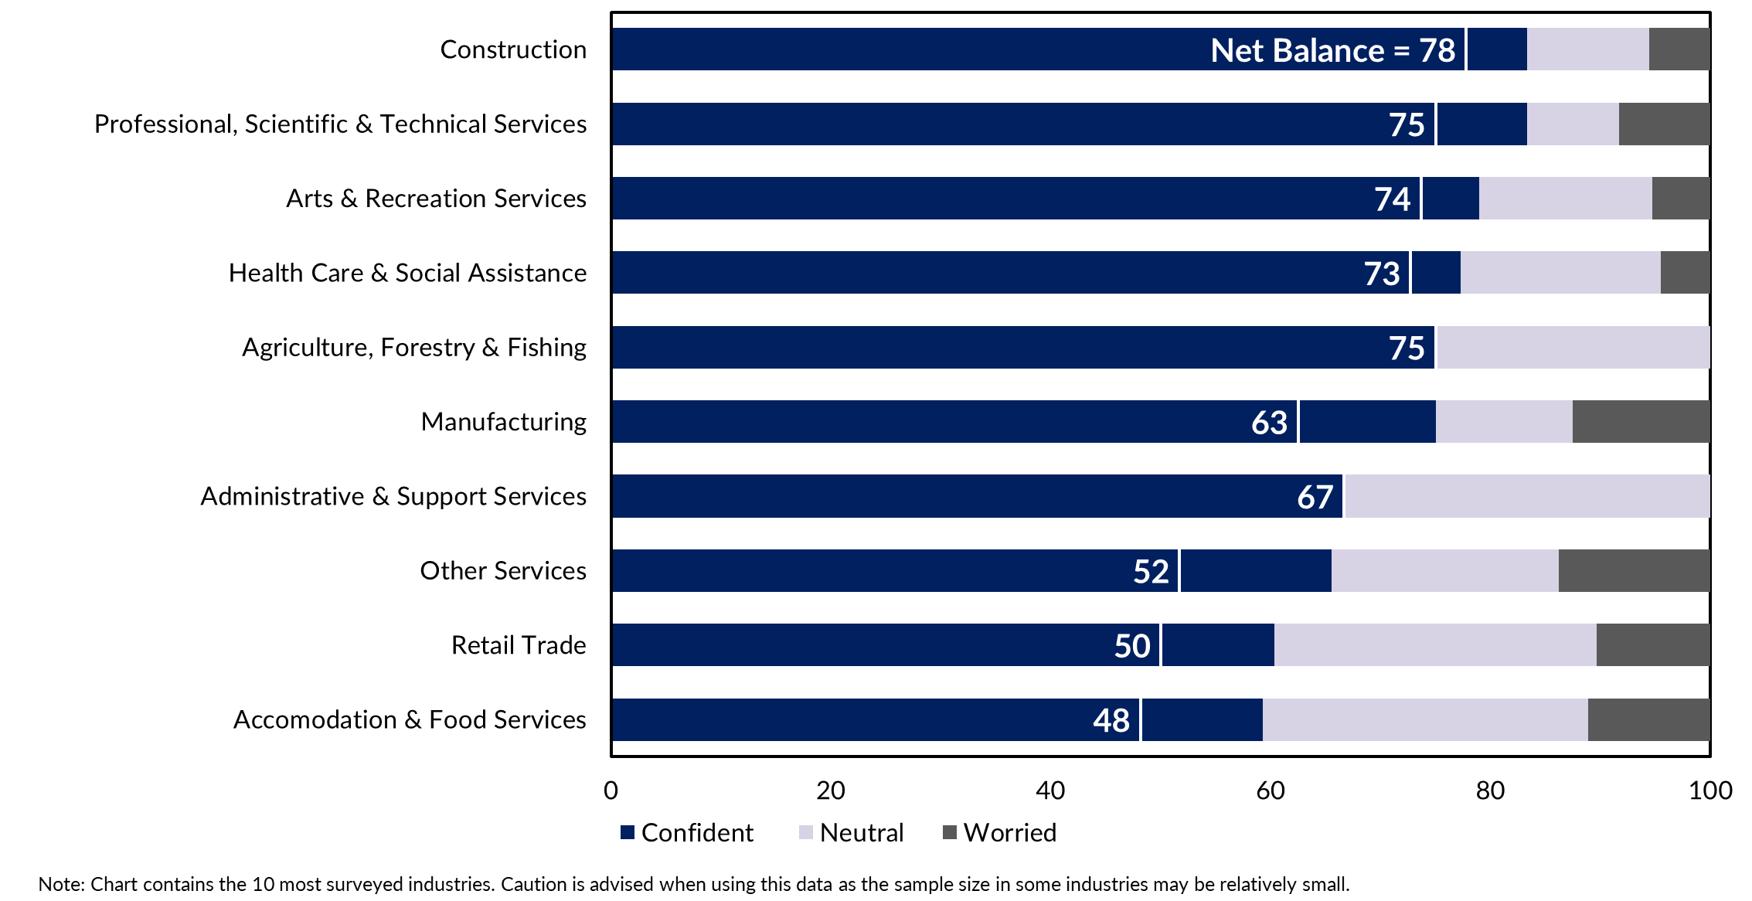

Appendix

Methodology
The Department of Industry, Tourism and Trade conducts a survey of businesses operating in the Territory on a quarterly basis. The results have been used to construct a business confidence index.
The business confidence index is calculated as the difference between the proportion of businesses that are ‘confident about their business prospects for the next 12 months' and the proportion of businesses that are ‘worried about their business prospects for the next 12 months’ (net balance approach).
The Territory-wide confidence index is weighted to account for the number of businesses in each region. The weighted result provides a more balanced reflection of overall business confidence. Business confidence results are also presented by region and industry.
500 businesses were surveyed this quarter out of 16,103 operating businesses in the Territory (Table 4). For the sample survey to achieve a 95% confidence level with a margin of error of 5%, 376 survey responses are required.
Table 4: Survey Numbers
Region | Total number of businesses | Businesses surveyed | Proportion of total
Greater Darwin | 11,907 | 217 | 1.8%
Daly-Tiwi-West Arnhem | 389 | 43 | 11.1%
East Arnhem | 275 | 39 | 14.2%
Katherine | 1,036 | 35 | 3.4%
Barkly | 182 | 21 | 11.5%
Alice Springs | 2,020 | 145 | 7.2%
Total | 16,103 | 500 | 3.1%
Note: Total number of businesses do not add up to individuals due to some businesses missing location information.

