Mineral Titles Act 2010
NOTICE OF LAND CEASING TO BE A MINERAL TITLE AREA
Title Type and Number: | Exploration Licence 30739
Area Ceased on: | 23 September 2022
Area: | 40 Blocks, 121.42 km²
Locality: | GURNER
Name of Applicant(s)/Holder(s): | 100% PRODIGY GOLD NL* [ACN. 009 127 020]
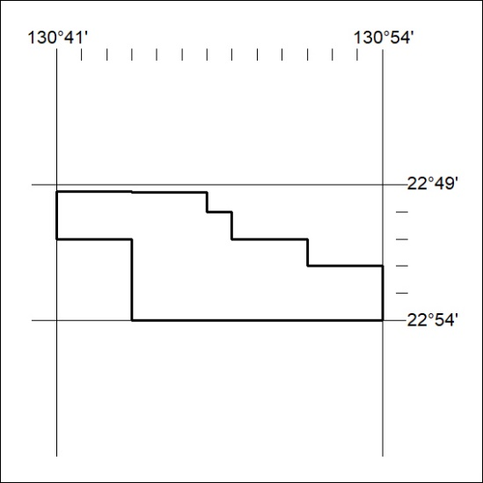

334/22

Mineral Titles Act 2010
NOTICE OF LAND CEASING TO BE A MINERAL TITLE AREA
Title Type and Number: | Exploration Licence 31685
Area Ceased on: | 23 September 2022
Area: | 22 Blocks, 72.21 km²
Locality: | LANCEWOOD
Name of Applicant(s)/Holder(s): | 100% SCRIVEN EXPLORATION PTY LTD [ACN. 006 264 615]
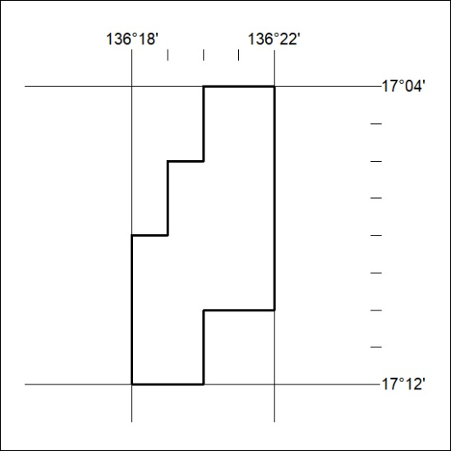

335/22

Mineral Titles Act
NOTICE OF GRANT OF A MINERAL TITLE
Title Type and Number: | Exploration Licence 33069
Granted: | 21 September 2022, for a period of 6 Years
Area: | 222 Blocks, 736.88 km²
Locality: | MANBULLOO
Name of Holder/s: | 100% FIDDLER'S CREEK MINING COMPANY PTY LTD * [ACN. 099 215 648]
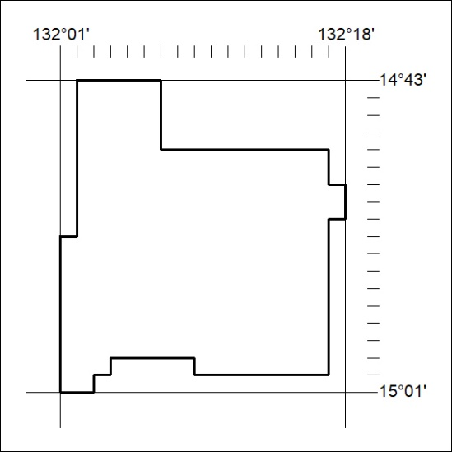
Area granted is indicated above. The titleholder is not permitted to exercise occupational rights on any land that is subject to a development title, or an application for a development title. Any land the subject of a Reserved Land gazettal under the Mineral Titles Act and all land vested in the Commonwealth of Australia is also excluded by description but not excised from the grant area.
336/22

Mineral Titles Act
NOTICE OF GRANT OF A MINERAL TITLE
Title Type and Number: | Exploration Licence 33071
Granted: | 21 September 2022, for a period of 6 Years
Area: | 148 Blocks, 490.35 km²
Locality: | ELSEY
Name of Holder/s: | 100% FIDDLER'S CREEK MINING COMPANY PTY LTD * [ACN. 099 215 648]
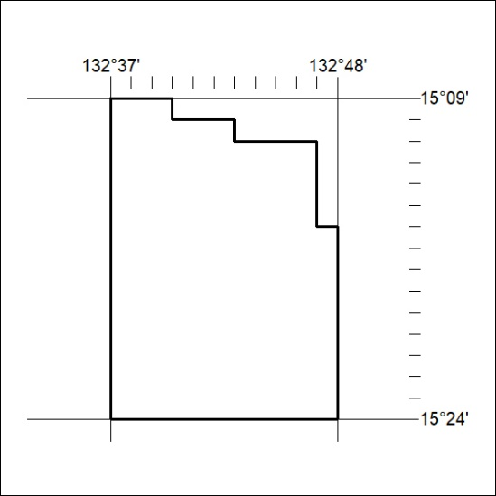
Area granted is indicated above. The titleholder is not permitted to exercise occupational rights on any land that is subject to a development title, or an application for a development title. Any land the subject of a Reserved Land gazettal under the Mineral Titles Act and all land vested in the Commonwealth of Australia is also excluded by description but not excised from the grant area.
337/22

Mineral Titles Act
NOTICE OF GRANT OF A MINERAL TITLE
Title Type and Number: | Exploration Licence 33072
Granted: | 21 September 2022, for a period of 6 Years
Area: | 57 Blocks, 137.49 km²
Locality: | GORRIE
Name of Holder/s: | 100% FIDDLER'S CREEK MINING COMPANY PTY LTD * [ACN. 099 215 648]
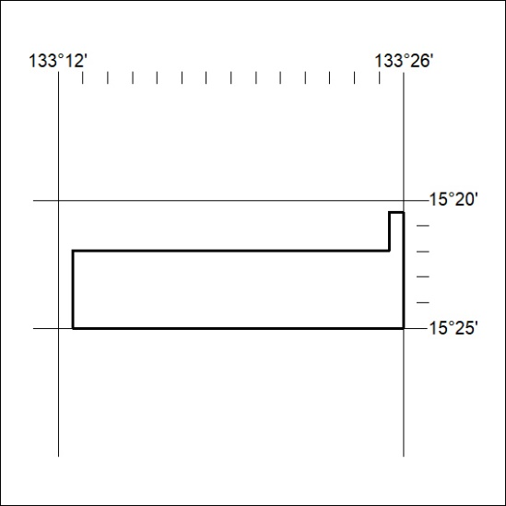
Area granted is indicated above. The titleholder is not permitted to exercise occupational rights on any land that is subject to a development title, or an application for a development title. Any land the subject of a Reserved Land gazettal under the Mineral Titles Act and all land vested in the Commonwealth of Australia is also excluded by description but not excised from the grant area.
338/22

Mineral Titles Act
NOTICE OF GRANT OF A MINERAL TITLE
Title Type and Number: | Exploration Licence 33074
Granted: | 21 September 2022, for a period of 6 Years
Area: | 222 Blocks, 736.17 km²
Locality: | MANBULLOO
Name of Holder/s: | 100% FIDDLER'S CREEK MINING COMPANY PTY LTD * [ACN. 099 215 648]
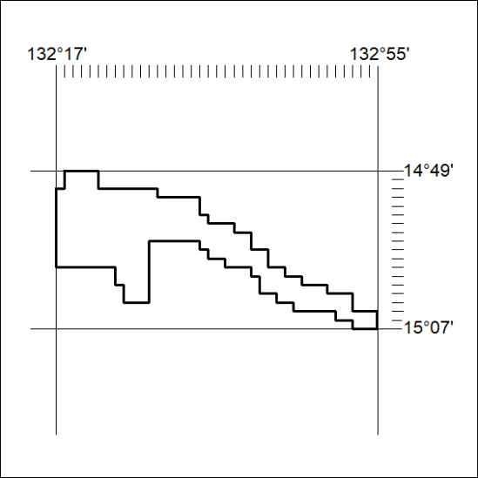
Area granted is indicated above. The titleholder is not permitted to exercise occupational rights on any land that is subject to a development title, or an application for a development title. Any land the subject of a Reserved Land gazettal under the Mineral Titles Act and all land vested in the Commonwealth of Australia is also excluded by description but not excised from the grant area.
339/22

Mineral Titles Act
NOTICE OF GRANT OF A MINERAL TITLE
Title Type and Number: | Extractive Mineral Exploration Licence 33146
Granted: | 21 September 2022, for a period of 2 Years
Area: | 3 Blocks, 2.91 km²
Locality: | NOONAMAH
Name of Holder/s: | 50% ALDEBARAN CONTRACTING PTY LTD [ACN. 128 020 299], 50% SKEWES Daniel Joseph
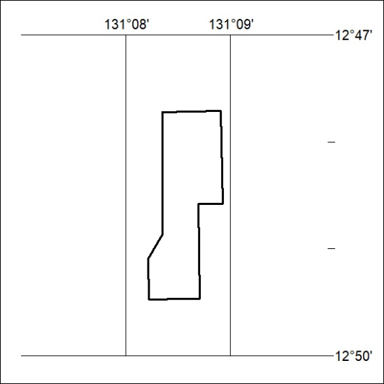
Area granted is indicated above. The titleholder is not permitted to exercise occupational rights on any land that is subject to a development title, or an application for a development title. Any land the subject of a Reserved Land gazettal under the Mineral Titles Act and all land vested in the Commonwealth of Australia is also excluded by description but not excised from the grant area.
340/22

