Mineral Titles Act 2010
NOTICE OF LAND CEASING TO BE A MINERAL TITLE AREA
Title Type and Number: | Exploration Licence 31684
Area Ceased on: | 19 September 2022
Area: | 7 Blocks, 22.97 km²
Locality: | LANCEWOOD
Name of Applicant(s)/Holder(s): | 100% SCRIVEN EXPLORATION PTY LTD [ACN. 006 264 615]
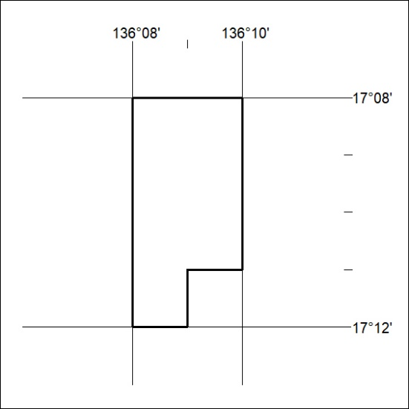

333/22

