Mineral Titles Act 2010
NOTICE OF LAND CEASING TO BE A MINERAL TITLE AREA
Title Type and Number: | Exploration Licence 31623
Area Ceased on: | 19 August 2022
Area: | 13 Blocks, 40.80 km²
Locality: | OORADIDGEE
Name of Applicant(s)/Holder(s): | 100% TREASURE CREEK PTY LTD [ACN. 619 057 644]
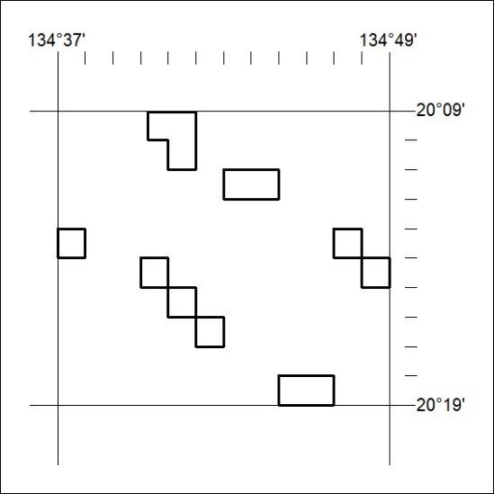

308/22

Mineral Titles Act 2010
NOTICE OF LAND CEASING TO BE A MINERAL TITLE AREA
Title Type and Number: | Exploration Licence 31625
Area Ceased on: | 19 August 2022
Area: | 20 Blocks, 64.45 km²
Locality: | EPENARRA
Name of Applicant(s)/Holder(s): | 100% TREASURE CREEK PTY LTD [ACN. 619 057 644]
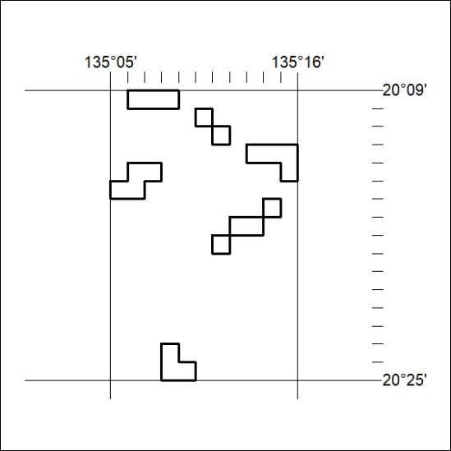

309/22
Mineral Titles Act 2010
NOTICE OF LAND CEASING TO BE A MINERAL TITLE AREA
Title Type and Number: | Exploration Licence 31627
Area Ceased on: | 19 August 2022
Area: | 8 Blocks, 24.37 km²
Locality: | EPENARRA
Name of Applicant(s)/Holder(s): | 100% TREASURE CREEK PTY LTD [ACN. 619 057 644]
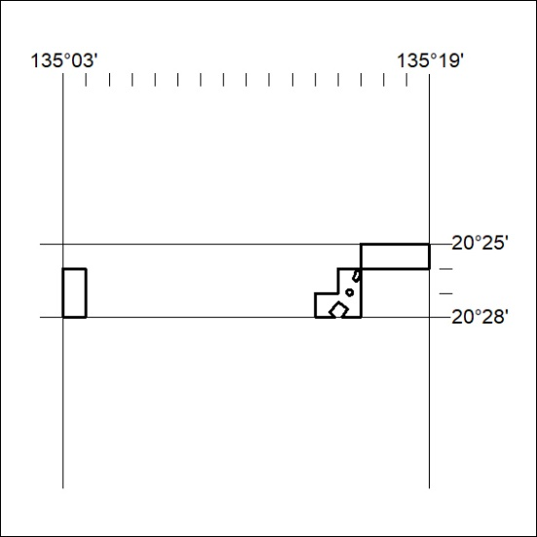

310/22

Mineral Titles Act 2010
NOTICE OF LAND CEASING TO BE A MINERAL TITLE AREA
Title Type and Number: | Exploration Licence 31628
Area Ceased on: | 19 August 2022
Area: | 3 Blocks, 9.65 km²
Locality: | HATCHES
Name of Applicant(s)/Holder(s): | 100% TREASURE CREEK PTY LTD [ACN. 619 057 644]
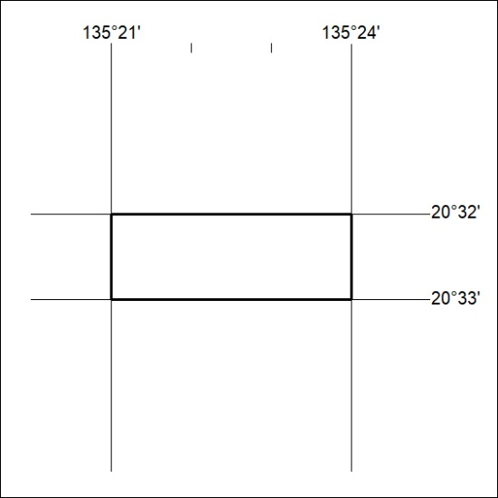

311/22

Mineral Titles Act
NOTICE OF GRANT OF A MINERAL TITLE
Title Type and Number: | Extractive Mineral Exploration Licence 33153
Granted: | 29 August 2022, for a period of 2 Years
Area: | 2 Blocks, 3.63 km²
Locality: | NOONAMAH
Name of Holder/s: | 100% OSTOJIC GROUP PTY LTD* [ACN. 009 629 805]
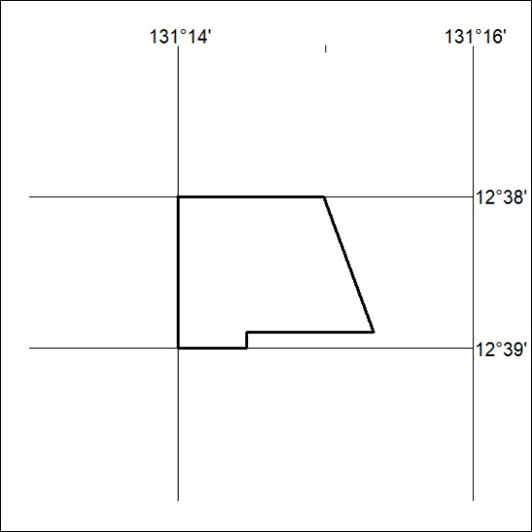
Area granted is indicated above. The titleholder is not permitted to exercise occupational rights on any land that is subject to a development title, or an application for a development title. Any land the subject of a Reserved Land gazettal under the Mineral Titles Act and all land vested in the Commonwealth of Australia is also excluded by description but not excised from the grant area.
312/22

Mineral Titles Act
NOTICE OF GRANT OF A MINERAL TITLE
Title Type and Number: | Extractive Mineral Exploration Licence 33154
Granted: | 29 August 2022, for a period of 2 Years
Area: | 4 Blocks, 7.63 km²
Locality: | NOONAMAH
Name of Holder/s: | 100% OSTOJIC GROUP PTY LTD* [ACN. 009 629 805]
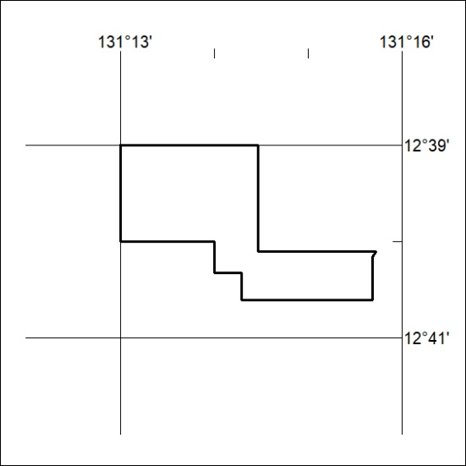
Area granted is indicated above. The titleholder is not permitted to exercise occupational rights on any land that is subject to a development title, or an application for a development title. Any land the subject of a Reserved Land gazettal under the Mineral Titles Act and all land vested in the Commonwealth of Australia is also excluded by description but not excised from the grant area.
313/22

