Mineral Titles Act
NOTICE OF GRANT OF A MINERAL TITLE
Title Type and Number: | Exploration Licence 33125
Granted: | 25 August 2022, for a period of 6 Years
Area: | 6 Blocks, 18.95 km²
Locality: | QUARTZ
Name of Holder/s: | 100% PEREGIAN MINERALS PTY LTD [ACN. 656 661 586]
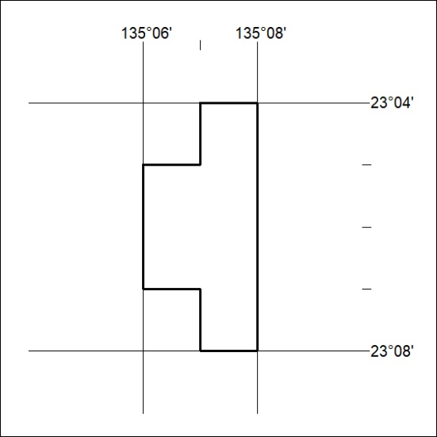
Area granted is indicated above. The titleholder is not permitted to exercise occupational rights on any land that is subject to a development title, or an application for a development title. Any land the subject of a Reserved Land gazettal under the Mineral Titles Act and all land vested in the Commonwealth of Australia is also excluded by description but not excised from the grant area.
303/22

Mineral Titles Act
NOTICE OF GRANT OF A MINERAL TITLE
Title Type and Number: | Exploration Licence 33126
Granted: | 25 August 2022, for a period of 6 Years
Area: | 15 Blocks, 47.34 km²
Locality: | QUARTZ
Name of Holder/s: | 100% PEREGIAN MINERALS PTY LTD [ACN. 656 661 586]
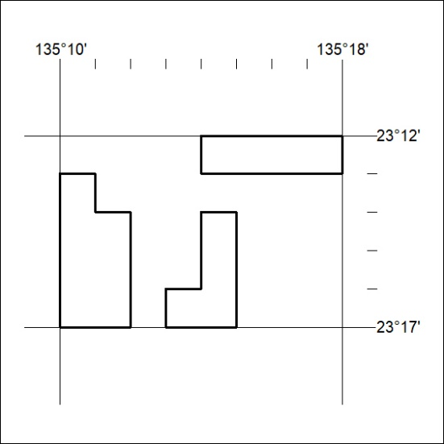
Area granted is indicated above. The titleholder is not permitted to exercise occupational rights on any land that is subject to a development title, or an application for a development title. Any land the subject of a Reserved Land gazettal under the Mineral Titles Act and all land vested in the Commonwealth of Australia is also excluded by description but not excised from the grant area.
304/22

