Mineral Titles Act
NOTICE OF GRANT OF A MINERAL TITLE
Title Type and Number: | Exploration Licence 32991
Granted: | 29 July 2022, for a period of 6 Years
Area: | 249 Blocks, 828.70 km²
Locality: | FLYING FOX
Name of Holder/s: | 100% DALY TENEMENTS PTY LTD [ACN. 658 845 786]
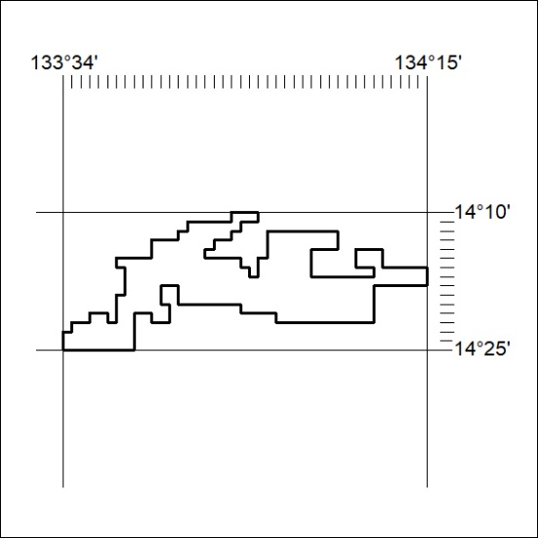
Area granted is indicated above. The titleholder is not permitted to exercise occupational rights on any land that is subject to a development title, or an application for a development title. Any land the subject of a Reserved Land gazettal under the Mineral Titles Act and all land vested in the Commonwealth of Australia is also excluded by description but not excised from the grant area.
269/22

Mineral Titles Act
NOTICE OF GRANT OF A MINERAL TITLE
Title Type and Number: | Exploration Licence 32992
Granted: | 29 July 2022, for a period of 6 Years
Area: | 250 Blocks, 833.10 km²
Locality: | MAINORU
Name of Holder/s: | 100% DALY TENEMENTS PTY LTD [ACN. 658 845 786]
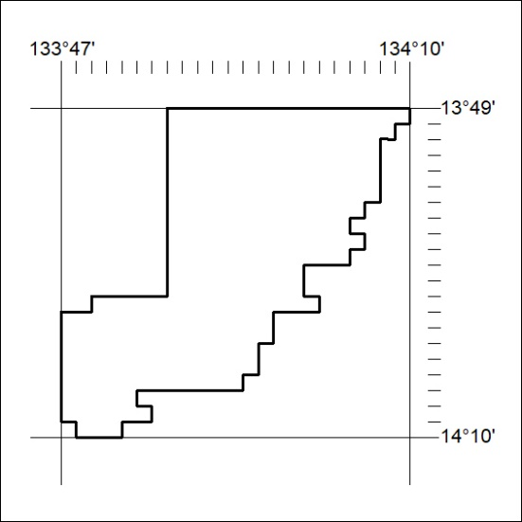
Area granted is indicated above. The titleholder is not permitted to exercise occupational rights on any land that is subject to a development title, or an application for a development title. Any land the subject of a Reserved Land gazettal under the Mineral Titles Act and all land vested in the Commonwealth of Australia is also excluded by description but not excised from the grant area.
270/22

Mineral Titles Act
NOTICE OF GRANT OF A MINERAL TITLE
Title Type and Number: | Exploration Licence 32993
Granted: | 29 July 2022, for a period of 6 Years
Area: | 250 Blocks, 832.70 km²
Locality: | FLYING FOX
Name of Holder/s: | 100% DALY TENEMENTS PTY LTD [ACN. 658 845 786]
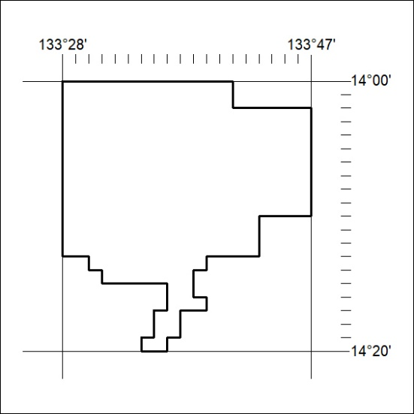
Area granted is indicated above. The titleholder is not permitted to exercise occupational rights on any land that is subject to a development title, or an application for a development title. Any land the subject of a Reserved Land gazettal under the Mineral Titles Act and all land vested in the Commonwealth of Australia is also excluded by description but not excised from the grant area.
271/22

