Northern Territory
Business Confidence survey
June Quarter 2022

Northern Territory Business Confidence Survey
June Quarter 2022

Summary
- The Territory-wide business confidence level was +74% in the June quarter 2022, up 24 percentage points from the March quarter 2022, and close to the peak reached in the June quarter 2021.
- Of those Territory businesses confident about their business prospects for the next 12 months, 'strong local economy' was more likely to be cited as a reason to be confident in the June quarter 2022 than in recent quarters.
- Of those Territory businesses worried about their business prospects for the next 12 months, 'lack of suitably skilled workers' was more likely to be cited as a reason to be worried in the June quarter 2022 than in recent quarters.
- Between 1 April and 30 June 2022, 360 businesses were surveyed across Territory regions and industry sectors.
- 59% of Territory businesses noted their business performance is better this year compared to last year, representing a 15 percentage point increase from the previous quarter.

Introduction
Northern Territory Business Confidence is a quarterly publication which highlights confidence levels of Territory-wide businesses.
The survey covers urban and regional areas of the Territory and captures different industry sectors and business sizes (small, medium and large).
Monitoring business confidence levels is important as it is a key barometer and a leading indicator of business conditions and the overall health of the economy. Business confidence drives business growth and investment, supports employment opportunities and attracts people to the region.
Information about the survey methodology is included at the end of the report.

Number of businesses surveyed by regions
(ABS statistical area 3 – sa3 levels)

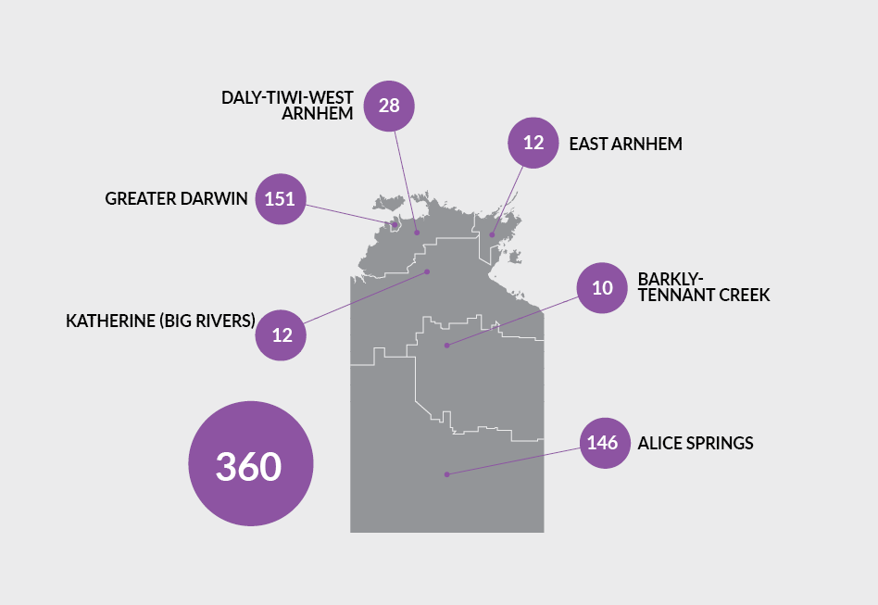

Region | Total no of businesses | Businesses surveyed | Proportional of total
Greater Darwin | 10 959 | 151 | 1.4%
Daly-Tiwi-West Arnhem | 361 | 28 | 7.7%
East Arnhem | 253 | 12 | 4.7%
Katherine (Big Rivers) | 956 | 12 | 1.2%
Barkly-Tennant Creek | 198 | 10 | 5.0%
Alice Springs | 2092 | 150 | 6.9%
TOTAL | 14 973 | 360 | 2.4%
Source: ABS Cat. No. 8165.0

Business confidence
Q. How confident are you about your business prospects for the next 12 months?

Territory wide
In the June quarter 2022, the Territory-wide business confidence index was +74%. The sentiment of some businesses appears to have changed from feeling neutral to feeling fairly confident. The response rate for this question was 98.4%.

Overall business confidence index
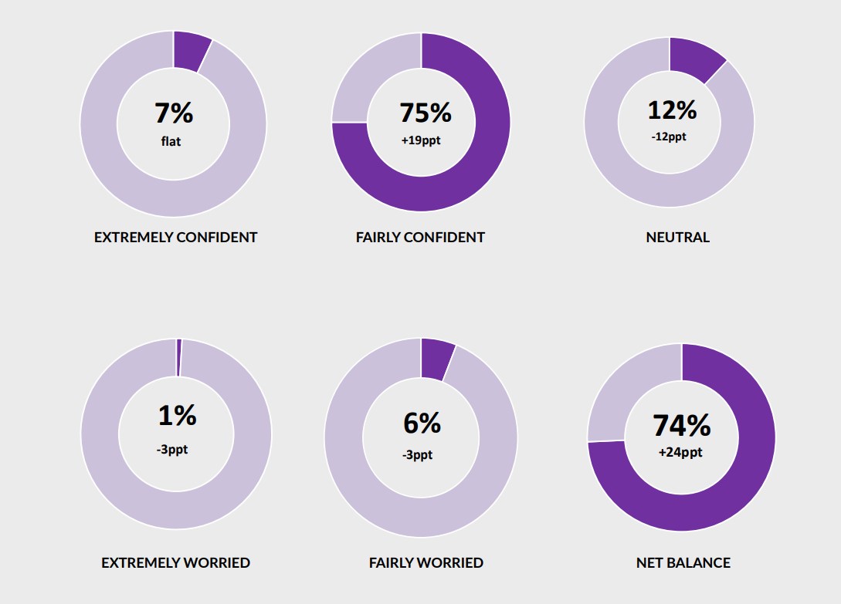
Note: Individual confidence categories may not add up to the net balance figure due to rounding.

REGIONAL SUMMARY
Business confidence varied among Territory regions, ranging from +90% in the Barkly-Tennant Creek region to +67% in the Katherine region.
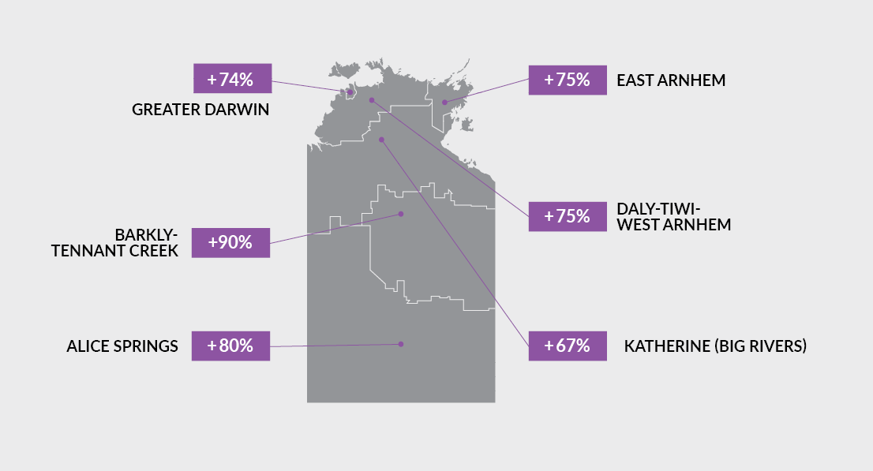

Confidence trends

Territory wide
 | Jun Qtr  2021 | Sep Qtr  2021 | Dec Qtr  2021 | Mar Qtr  2022 | Jun Qtr  2022
Confident | 86% | 77% | 68% | 63% | 81%
Worried | 2% | 7% | 10% | 13% | 7%
Net balance | 84% | 70% | 58% | 50% | 74%

In the June quarter 2022, business confidence increased 24 percentage points to +74% from the previous quarter, approaching the record highs reached in June 2021.

The chart below shows that business confidence in the Territory is above longer term trend levels, and significantly stronger than two years ago.
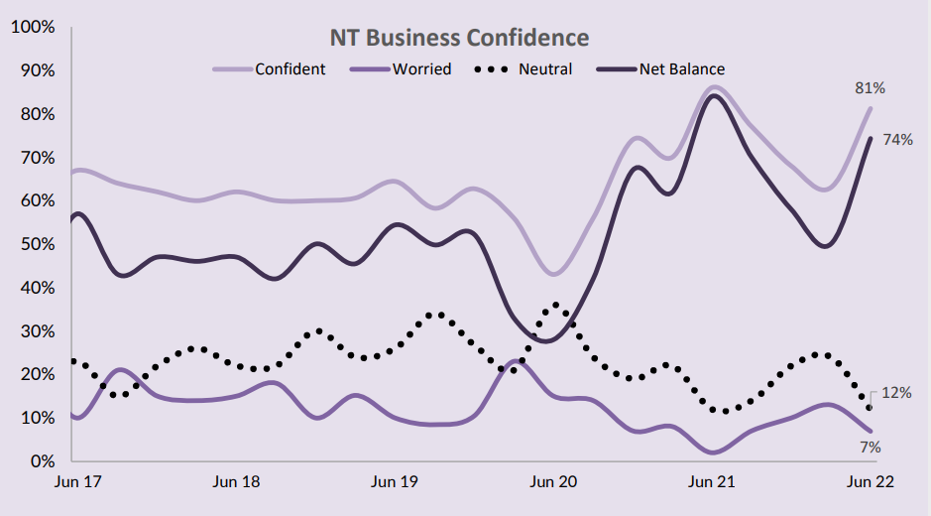

ANNUAL AVERAGE BUSINESS CONFIDENCE
Yearly average business confidence in 2021-22 was +63%, compared to +64% in 2020-21.

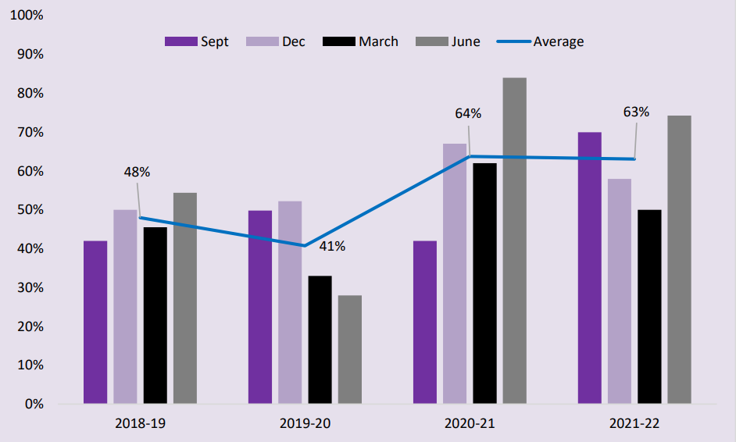

Business confidence by region
In the June quarter 2022, business confidence increased in all regions except East Arnhem and Katherine, where confidence decreased.
Region | Jun Qtr  2021 | Sep Qtr  2021 | Dec Qtr  2021 | Mar Qtr  2022 | Jun Qtr  2022
Greater Darwin
Confident | 83% | 81% | 70% | 62% | 81%
Worried | 1% | 5% | 8% | 14% | 7%
Net balance | 83% | 76% | 62% | 48% | 74%
Daly-Tiwi-West Arnhem
Confident | 73% | 100% | 72% | 73% | 86%
Worried | 7% | 0% | 28% | 14% | 11%
Net balance | 67% | 100% | 44% | 59% | 75%
East Arnhem
Confident | 84% | 86% | 93% | 100% | 83%
Worried | 5% | 3% | 0% | 0% | 8%
Net balance | 79% | 83% | 93% | 100% | 75%
Katherine (Big Rivers)
Confident | 75% | 65% | 81% | 76% | 75%
Worried | 13% | 29% | 8% | 8% | 8%
Net balance | 63% | 35% | 73% | 68% | 67%
Barkly-Tennant Creek
Confident | 100% | 0% | 52% | 72% | 90%
Worried | 0% | 0% | 29% | 17% | 0%
Net balance | 100% | 0% | 23% | 56% | 90%
Alice Springs
Confident | 73% | 70% | 41% | 63% | 84%
Worried | 8% | 9% | 22% | 13% | 4%
Net balance | 65% | 61% | 19% | 51% | 80%

Business confidence by industry
In the June quarter 2022, the industries that reported largest increases in business confidence were: Education and Training; Transport, Postal and warehousing; and Manufacturing. The table below displays the top 10 most surveyed industries.
Sector | Confident | Worried | Net balance
 | Jun Qtr  2022 | Jun Qtr 2022 | Jun Qtr 2022 | Mar Qtr 2022 | Jun Qtr 2021
Health Care and Social  Assistance | 92% | 8% | 85% | 33% | 74%
Manufacturing | 93% | 0% | 93% | 27% | 71%
Accommodation and Food Services | 83% | 7% | 76% | 42% | 54%
Education and Training | 100% | 0% | 100% | 14% | 63%
Other Services | 63% | 13% | 50% | 58% | 86%
Arts and Recreation Services | 82% | 14% | 68% | 52% | 73%
Construction | 76% | 0% | 76% | 46% | 75%
Retail Trade | 76% | 12% | 65% | 59% | 80%
Professional, Scientific and Technical Services | 80% | 0% | 80% | 62% | 86%
Administrative and Support Services | 80% | 0% | 80% | 67% | 50%
Note: Caution is advised when using this data as the sample size in some sectors may be relatively small.

Industry expectations

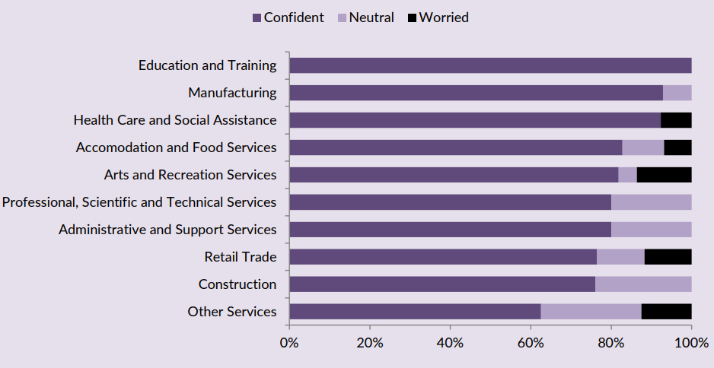

Key business insights

Confident
Of the Territory businesses confident about their business prospects for the next 12 months, key reasons cited are: 'strong customer relations'; 'business opportunity'; and 'been in business a long time'. There was a significant increase in the number of businesses that reported 'strong local economy' as a reason for confidence in the June quarter 2022. The graph below shows the relative importance of the key reasons for confidence.
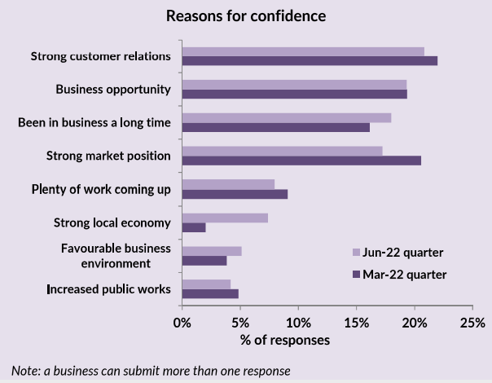

Worried
Of those Territory businesses worried about their business prospects for the next 12 months, the main reasons cited for being worried are: 'lack of suitably skilled workers' and 'increasing business costs'. There was a significant increase in the number of businesses reporting 'lack of suitably skilled workers' as a reason for being worried in the June quarter 2022, while the number of businesses reporting 'decrease in business sales' and 'government red tape' as reasons to be worried fell significantly. The graph below shows the relative importance of the key reasons for being worried.
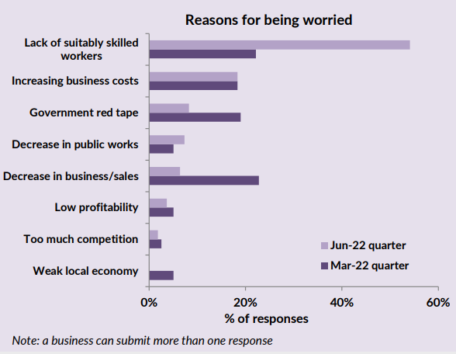

Business performance
Q. How’s your business performing this year compared to last year?
59% of Territory businesses noted that their business performance is better this year compared to last year, while 28% of the businesses stated that business performance is the same as last year, and 13% of businesses stated their business performance is worse than last year.
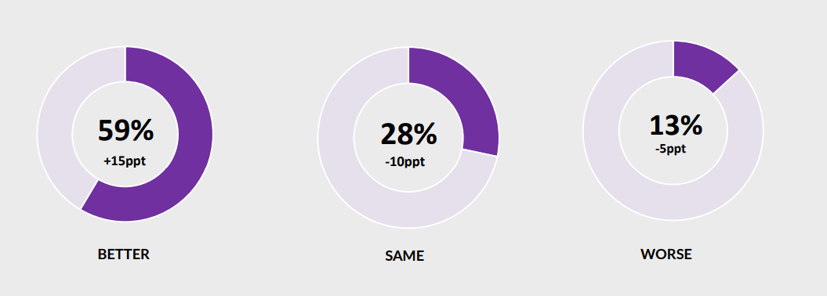

Trend in Business performance
The proportion of businesses that reported performance is better this year increased in the June quarter 2022, to be around long term levels. Similarly, the proportion of businesses that reported that their performance was worse remains around long term levels, after slightly decreasing in the June quarter 2022.
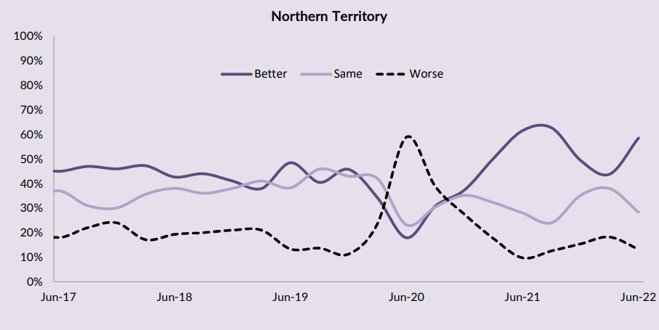

Business performance by region
The table and graphs below report that business performance compared to last year varied across the regions. Compared to the previous quarter, perceptions of business performance have improved in Greater Darwin, Daly-Tiwi-West Arnhem, Barkly-Tennant Creek, and Alice Springs, and decreased in the other regions.
Statistical area level 3 (sa3) regions | Business performance
 | Better | Same | Worse
Greater Darwin | 62% | 25% | 13%
Katherine (Big Rivers) | 17% | 67% | 17%
East Arnhem | 31% | 31% | 38%
Daly-Tiwi-West Arnhem | 50% | 36% | 14%
Barkly-Tennant Creek | 64% | 27% | 9%
Alice Springs | 62% | 27% | 11%
Territory-wide | 59% | 28% | 13%

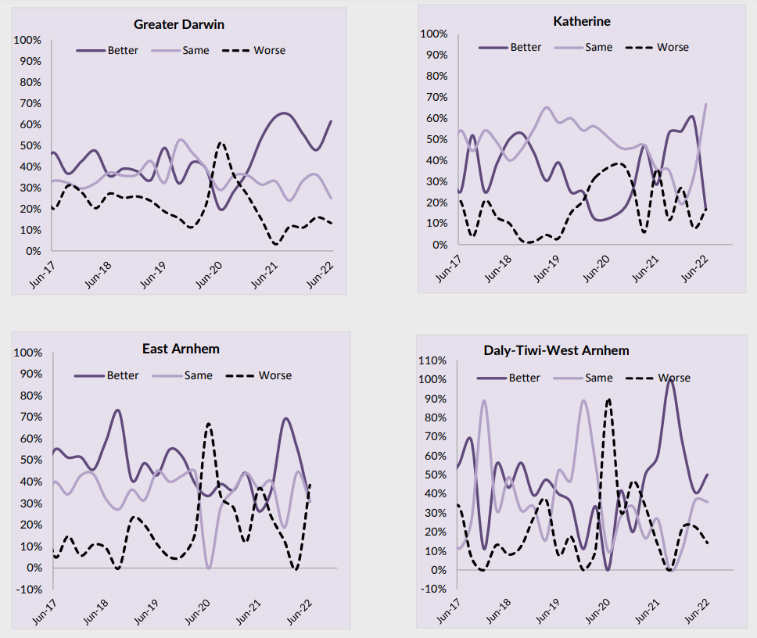

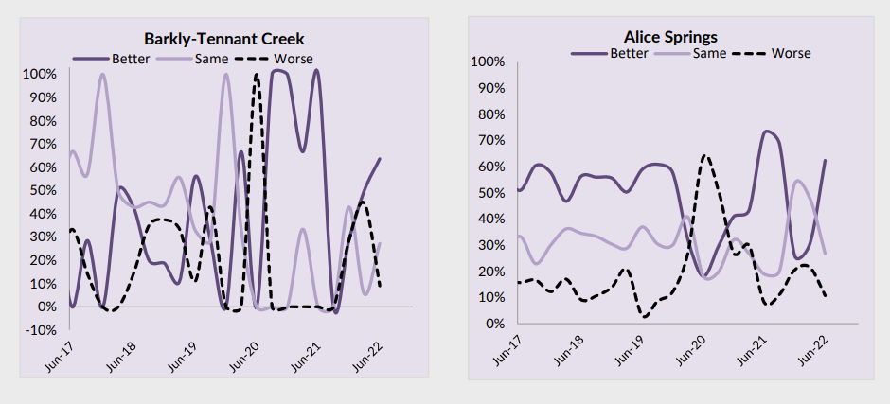

Survey methodology
A face-to-face survey of businesses operating in the Territory is conducted by the Department of Industry, Tourism and Trade on a quarterly basis. Business confidence is estimated using the business confidence index.
There are approximately 15 000 operating businesses in the Territory. Therefore, for the sample survey to achieve a 95% confidence level with a margin of error of 5%, 375 survey responses are required.
The business confidence index is calculated as the difference between the proportion of businesses that are ‘confident about their business prospects for the next 12 months' minus the proportion of businesses that are ‘worried about their business prospects for the next 12 months’ (net balance approach).
The higher the net balance the greater the level of business confidence. For example, if 60% of businesses are confident and 40% of businesses are worried, the net balance is +20%. Survey responses are also analysed by region and industry sector of businesses.
The business confidence results are presented for overall Northern Territory, Greater Darwin (Darwin City, Darwin suburbs, Palmerston and Litchfield) and for individual regions.
The overall Territory-wide confidence index is weighted to account for the number of businesses in each of the regions. The weights are based on the proportion of total Territory businesses in each region. The weighted result provides a more balanced reflection of overall business confidence.

business.nt.gov.au

