Mineral Titles Act 2010
NOTICE OF LAND CEASING TO BE A MINERAL TITLE AREA
Title Type and Number: | Extractive Mineral Permit 30367
Area ceased on: | 14 July 2022
Area: | 99.00 Hectare
Locality: | NOONAMAH
Name of Applicants(s)Holder(s): | 100% EAST ARM CIVIL PTY LTD [ACN. 073 382 251]
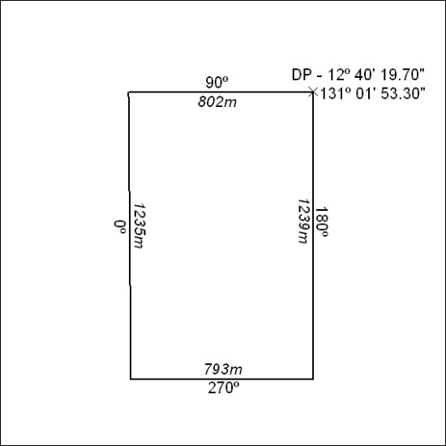

239/22

Mineral Titles Act 2010
NOTICE OF LAND CEASING TO BE A MINERAL TITLE AREA
Title Type and Number: | Extractive Mineral Permit 30370
Area ceased on: | 14 July 2022
Area: | 98.00 Hectare
Locality: | NOONAMAH
Name of Applicants(s)Holder(s): | 100% EAST ARM CIVIL PTY LTD [ACN. 073 382 251]
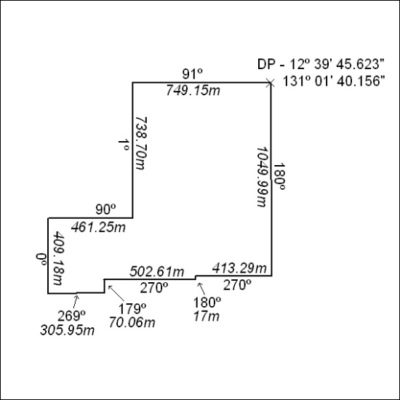

240/22

Mineral Titles Act
NOTICE OF GRANT OF A MINERAL TITLE
Title Type and Number: | Exploration Licence 32809
Granted: | 15 July 2022, for a period of 6 Years
Area: | 4 Blocks, 12.95 km²
Locality: | WONARAH
Name of Holder/s: | 100% STRATEGIC ENERGY RESOURCES LIMITED* [ACN. 051 212 429]
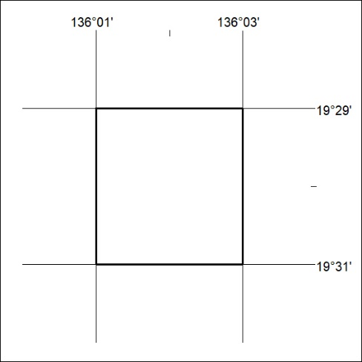
Area granted is indicated above. The titleholder is not permitted to exercise occupational rights on any land that is subject to a development title, or an application for a development title. Any land the subject of a Reserved Land gazettal under the Mineral Titles Act and all land vested in the Commonwealth of Australia is also excluded by description but not excised from the grant area.

241/22

Mineral Titles Act
NOTICE OF GRANT OF A MINERAL TITLE
Title Type and Number: | Exploration Licence 32962
Granted: | 14 July 2022, for a period of 6 Years
Area: | 182 Blocks, 586.34 km²
Locality: | DALY RIVER
Name of Holder/s: | 100% ALTAN NEVADA MINERALS (AUST) PTY LTD [ACN. 632 387 878]
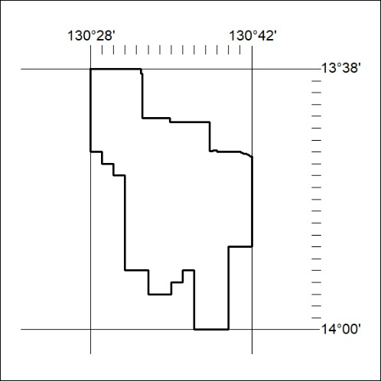
Area granted is indicated above. The titleholder is not permitted to exercise occupational rights on any land that is subject to a development title, or an application for a development title. Any land the subject of a Reserved Land gazettal under the Mineral Titles Act and all land vested in the Commonwealth of Australia is also excluded by description but not excised from the grant area.

242/22

Mineral Titles Act
NOTICE OF GRANT OF A MINERAL TITLE
Title Type and Number: | Exploration Licence 32963
Granted: | 14 July 2022, for a period of 6 Years
Area: | 115 Blocks, 383.43 km²
Locality: | DALY RIVER
Name of Holder/s: | 100% ALTAN NEVADA MINERALS (AUST) PTY LTD [ACN. 632 387 878]
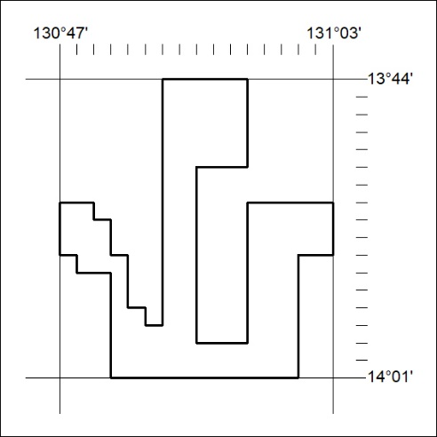
Area granted is indicated above. The titleholder is not permitted to exercise occupational rights on any land that is subject to a development title, or an application for a development title. Any land the subject of a Reserved Land gazettal under the Mineral Titles Act and all land vested in the Commonwealth of Australia is also excluded by description but not excised from the grant area.

243/22

