Mineral Titles Act
NOTICE OF GRANT OF A MINERAL TITLE
Title Type and Number: | Exploration Licence 32945
Granted: | 10 June 2022, for a period of 6 Years
Area: | 46 Blocks, 127.31 km²
Locality: | VAUGHAN
Name of Holder/s: | 100% JALEIN PTY LTD [ACN. 124 331 157]
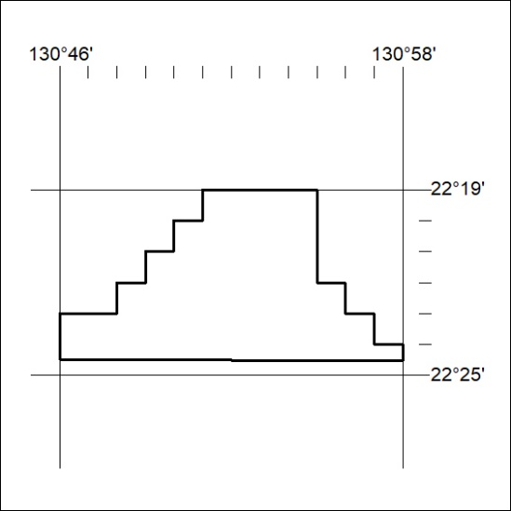
Area granted is indicated above. The titleholder is not permitted to exercise occupational rights on any land that is subject to a development title, or an application for a development title. Any land the subject of a Reserved Land gazettal under the Mineral Titles Act and all land vested in the Commonwealth of Australia is also excluded by description but not excised from the grant area.
193/22

Mineral Titles Act
NOTICE OF GRANT OF A MINERAL TITLE
Title Type and Number: | Exploration Licence 32946
Granted: | 10 June 2022, for a period of 6 Years
Area: | 102 Blocks, 324.35 km²
Locality: | DOREEN
Name of Holder/s: | 100% JALEIN PTY LTD [ACN. 124 331 157]
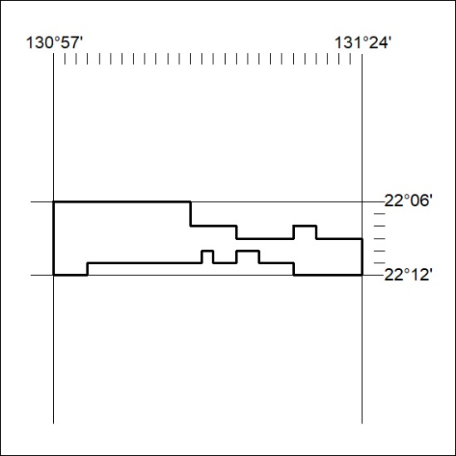
Area granted is indicated above. The titleholder is not permitted to exercise occupational rights on any land that is subject to a development title, or an application for a development title. Any land the subject of a Reserved Land gazettal under the Mineral Titles Act and all land vested in the Commonwealth of Australia is also excluded by description but not excised from the grant area.
194/22

Mineral Titles Act
NOTICE OF GRANT OF A MINERAL TITLE
Title Type and Number: | Exploration Licence 32948
Granted: | 10 June 2022, for a period of 6 Years
Area: | 54 Blocks, 171.20 km²
Locality: | NAPPERBY
Name of Holder/s: | 100% JALEIN PTY LTD [ACN. 124 331 157]
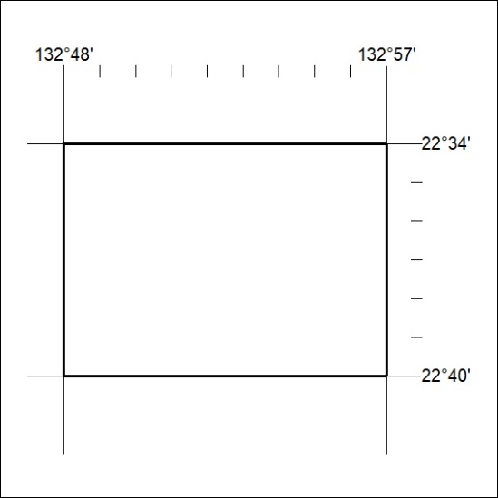
Area granted is indicated above. The titleholder is not permitted to exercise occupational rights on any land that is subject to a development title, or an application for a development title. Any land the subject of a Reserved Land gazettal under the Mineral Titles Act and all land vested in the Commonwealth of Australia is also excluded by description but not excised from the grant area.
195/22

