Mineral Titles Act 2010
NOTICE OF LAND CEASING TO BE A MINERAL TITLE AREA
Title Type and Number: | Exploration Licence in Retention 146
Area ceased on: | 19 September 2021
Area: | 16.00 Hectare
Locality: | NOONAMAH
Name of Applicants(s)Holder(s): | 100% NORTHERN TERRITORIES RESOURCES PTY LTD* [ACN. 124 647 829]
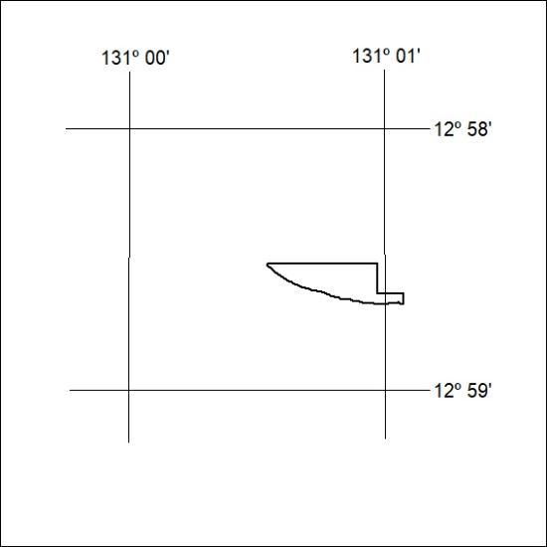

49/22

Mineral Titles Act
NOTICE OF GRANT OF A MINERAL TITLE
Title Type and Number: | Exploration Licence 32794
Granted: | 16 February 2022, for a period of 6 Years
Area: | 115 Blocks, 348.43 km²
Locality: | NAPIER
Name of Holder/s: | 100% OMNIA PANTON PTY LTD [ACN. 648 190 934]
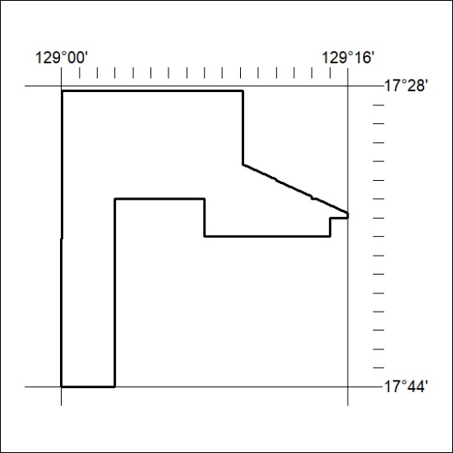
Area granted is indicated above. The titleholder is not permitted to exercise occupational rights on any land that is subject to a development title, or an application for a development title. Any land the subject of a Reserved Land gazettal under the Mineral Titles Act and all land vested in the Commonwealth of Australia is also excluded by description but not excised from the grant area.

50/22

