Mineral Titles Act 2010
NOTICE OF LAND CEASING TO BE A MINERAL TITLE AREA
Title Type and Number: | Exploration Licence 30730
Area Ceased on: | 21 October 2021
Area: | 87 Blocks, 275.22 km²
Locality: | CAREY
Name of Applicant(s)/Holder(s): | 100% PRODIGY GOLD NL* [ACN. 009 127 020]
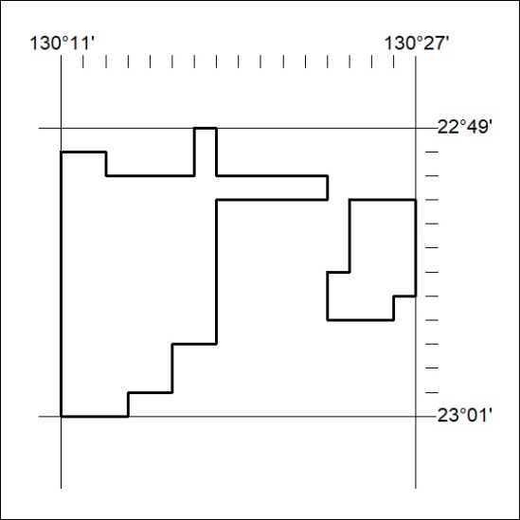

398/21

Mineral Titles Act 2010
NOTICE OF LAND CEASING TO BE A MINERAL TITLE AREA
Title Type and Number: | Exploration Licence 30739
Area Ceased on: | 21 October 2021
Area: | 42 Blocks, 132.83 km²
Locality: | GURNER
Name of Applicant(s)/Holder(s): | 100% PRODIGY GOLD NL* [ACN. 009 127 020]
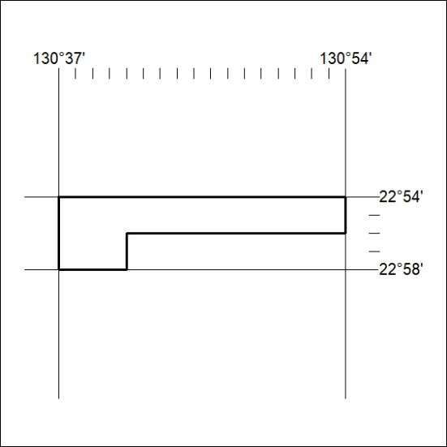

399/21
Mineral Titles Act 2010
NOTICE OF LAND CEASING TO BE A MINERAL TITLE APPLICATION AREA
Title Type and Number: | Exploration Licence 30924
Area Ceased on: | 21 October 2021
Area: | 4 Blocks, 11.11 km²
Locality: | BATHURST ISLAND
Name of Applicant(s)/Holder(s): | 100% TIWI RESOURCES PTY LTD [ACN. 054 667 051]
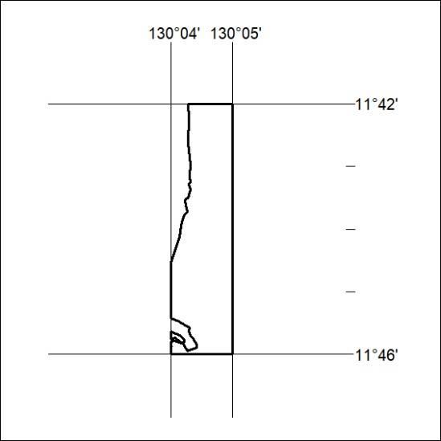

400/21

