Mineral Titles Act 2010
NOTICE OF LAND CEASING TO BE A MINERAL TITLE APPLICATION AREA
Title Type and Number: | Exploration Licence 25147
Area Ceased on: | 07 October 2021
Area: | 499 Blocks, 1579.77 km²
Locality: | REDVERS
Name of Applicant(s)/Holder(s): | 100% PRODIGY GOLD NL* [ACN. 009 127 020]
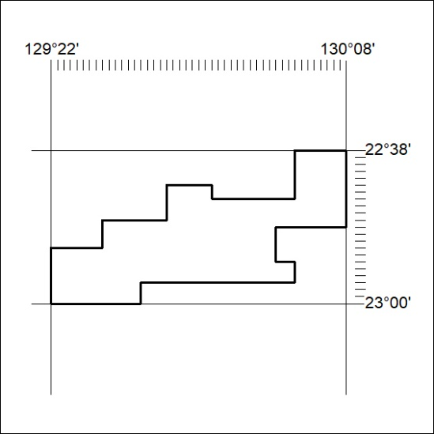

372/21

Mineral Titles Act 2010
NOTICE OF LAND CEASING TO BE A MINERAL TITLE APPLICATION AREA
Title Type and Number: | Exploration Licence 31718
Area Ceased on: | 07 October 2021
Area: | 203 Blocks, 623.07 km²
Locality: | CAREY
Name of Applicant(s)/Holder(s): | 100% IGO LIMITED* [ACN. 092 786 304]
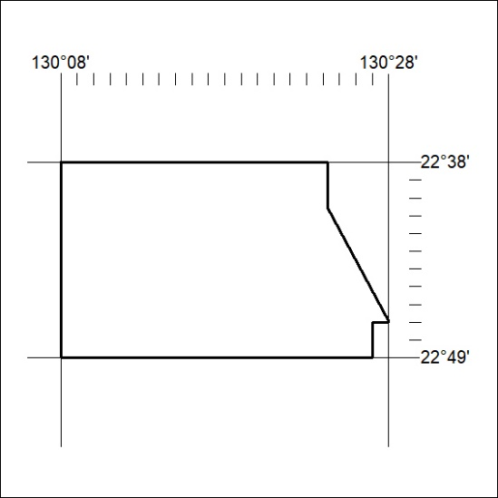

373/21
Mineral Titles Act 2010
NOTICE OF LAND CEASING TO BE A MINERAL TITLE APPLICATION AREA
Title Type and Number: | Exploration Licence 31719
Area Ceased on: | 07 October 2021
Area: | 126 Blocks, 360.57 km²
Locality: | GURNER
Name of Applicant(s)/Holder(s): | 100% IGO LIMITED* [ACN. 092 786 304]
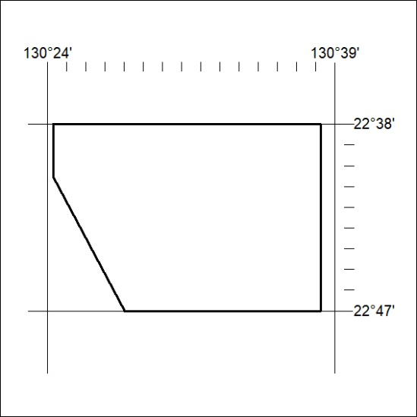

374/21

