Mineral Titles Act 2010
NOTICE OF LAND CEASING TO BE A MINERAL TITLE AREA
Title Type and Number: | Exploration Licence 26619
Area Ceased on: | 06 September 2021
Area: | 12 Blocks, 38.74 km²
Locality: | TANAMI
Name of Applicant(s)/Holder(s): | 100% PRODIGY GOLD NL* [ACN. 009 127 020]
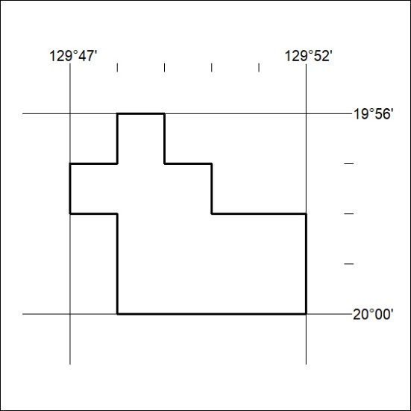

344/21

