Corrigendum
Notice Number 320/21 appearing in MN78/21 on 25 August 2021 is hereby cancelled and replaced by the following:

Mineral Titles Act 2010
NOTICE OF LAND CEASING TO BE A MINERAL TITLE AREA
Title Type and Number: | Exploration Licence 5889
Area Ceased on: | 24 August 2021
Area: | 27 Blocks, 87.80 km²
Locality: | WARE
Name of Applicant(s)/Holder(s): | 100% PRODIGY GOLD NL* [ACN. 009 127 020]
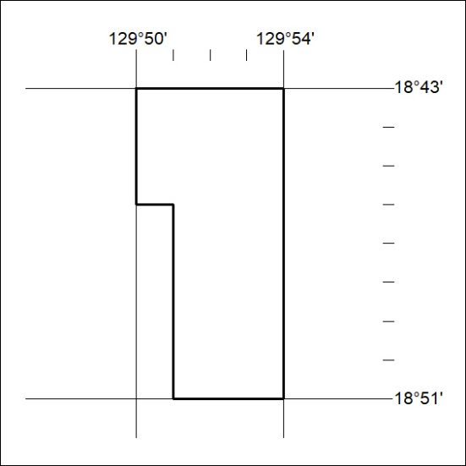

336/21

