Mineral Titles Act 2010
NOTICE OF LAND CEASING TO BE A MINERAL TITLE AREA
Title Type and Number: | Exploration Licence 30131
Area Ceased on: | 12 August 2021
Area: | 16 Blocks, 50.42 km²
Locality: | GLEN HELEN
Name of Applicant(s)/Holder(s): | 100% TODD RIVER METALS PTY LTD [ACN. 600 314 038]
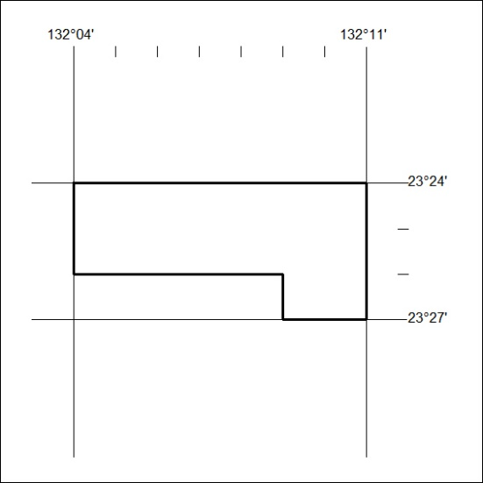

296/21

