Mineral Titles Act 2010
NOTICE OF LAND CEASING TO BE A MINERAL TITLE AREA
Title Type and Number: | Exploration Licence 29723
Area Ceased on: | 17 May 2021
Area: | 32 Blocks, 102.55 km²
Locality: | CRAWFORD
Name of Applicant(s)/Holder(s): | 100% PRODIGY GOLD NL* [ACN. 009 127 020]
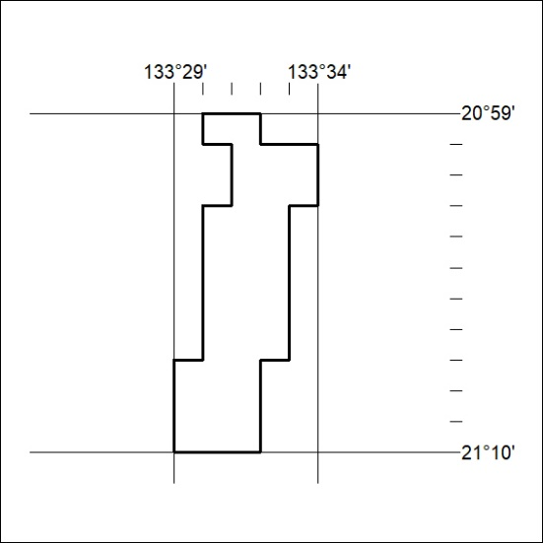

166/21

Mineral Titles Act 2010
NOTICE OF LAND CEASING TO BE A MINERAL TITLE APPLICATION AREA
Title Type and Number: | Exploration Licence 31333
Area Ceased on: | 14 May 2021
Area: | 247 Blocks, 768.56 km²
Locality: | LIMBLA
Name of Applicant(s)/Holder(s): | 100% LITCHFIELD MINERALS PTY LTD [ACN. 612 660 429]
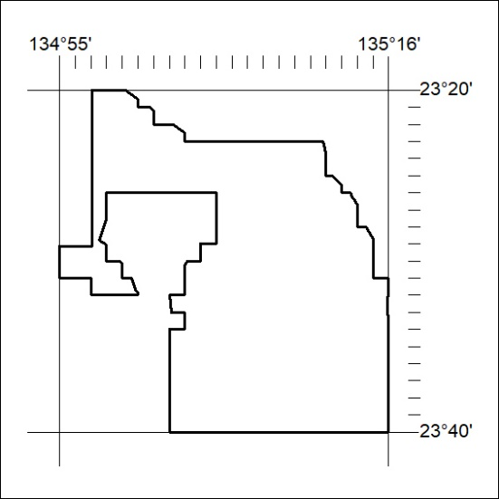

167/21

