Mineral Titles Act
NOTICE OF GRANT OF A MINERAL TITLE
Title Type and Number: | Mineral Lease 27938
Granted: | 19 August 2020, for a period of 25 Years
Area: | 33.94 Hectares
Locality: | TIPPERARY
Name of Holder/s: | 100% KIRKLAND LAKE GOLD AUSTRALIA PTY LTD* [ACN. 136 505 587]
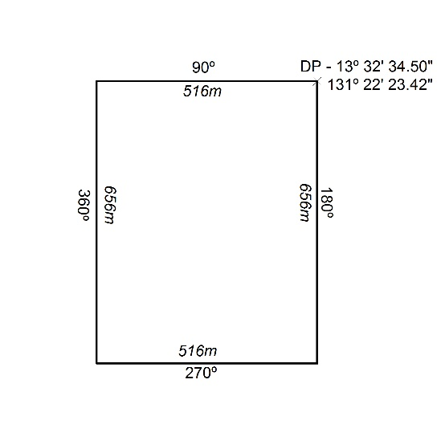
293/20

Mineral Titles Act
NOTICE OF GRANT OF A MINERAL TITLE
Title Type and Number: | Mineral Lease (Northern) 1129
Granted: | 19 August 2020, for a period of 25 Years
Area: | 324.70 Hectares
Locality: | BATCHELOR
Name of Holder/s: | 100% KIRKLAND LAKE GOLD AUSTRALIA PTY LTD* [ACN. 136 505 587]
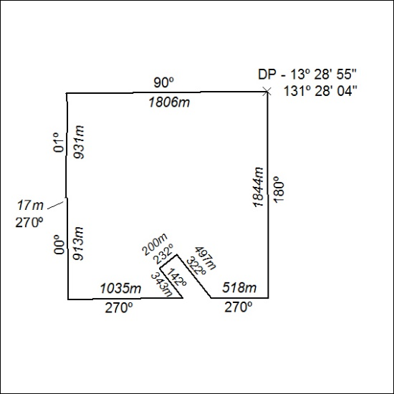
294/20

Mineral Titles Act
NOTICE OF GRANT OF A MINERAL TITLE
Title Type and Number: | Mineral Lease (Northern) 1135
Granted: | 19 August 2020, for a period of 20 Years
Area: | 239.40 Hectares
Locality: | BATCHELOR
Name of Holder/s: | 100% KIRKLAND LAKE GOLD AUSTRALIA PTY LTD* [ACN. 136 505 587]
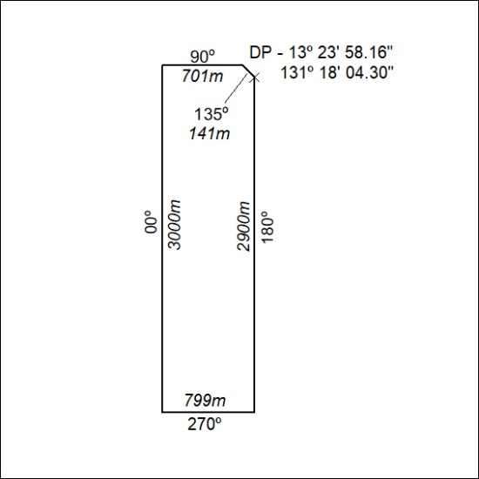
295/20

Mineral Titles Act
NOTICE OF GRANT OF A MINERAL TITLE
Title Type and Number: | Mineral Lease (Northern) 1144
Granted: | 19 August 2020, for a period of 20 Years
Area: | 189.40 Hectares
Locality: | BATCHELOR
Name of Holder/s: | 100% KIRKLAND LAKE GOLD AUSTRALIA PTY LTD* [ACN. 136 505 587]
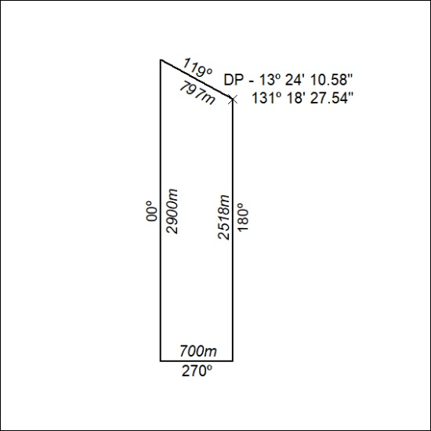
296/20

