Mineral Titles Act 2010
NOTICE OF LAND CEASING TO BE A MINERAL TITLE AREA
Title Type and Number: | Extractive Mineral Permit 30667
Area ceased on: | 15 August 2019
Area: | 16.00 Hectare
Locality: | KOOLPINYAH
Name of Applicants(s)Holder(s): | 100% A AND SF MADDALOZZO PTY. LIMITED [ACN. 009 624 015]
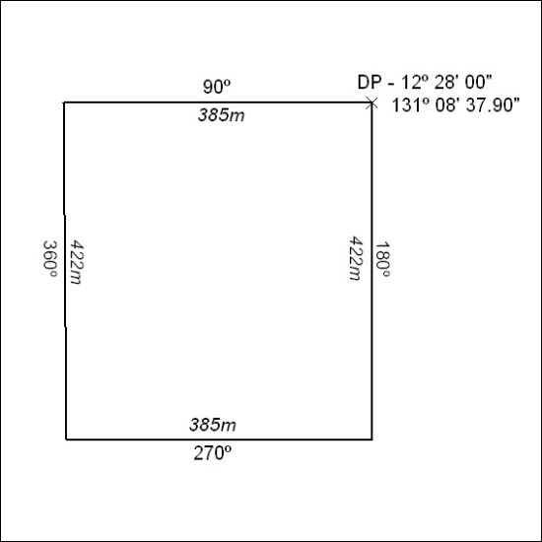

345/19

Mineral Titles Act 2010
NOTICE OF LAND CEASING TO BE A MINERAL TITLE AREA
Title Type and Number: | Mineral Lease (Northern) 1138
Area ceased on: | 30 June 2016
Area: | 2.00 Hectare
Locality: | MARANBOY
Name of Applicants(s)Holder(s): | 100% OUTBACK METALS PROPRIETARY LIMITED* [ACN. 126 797 573]
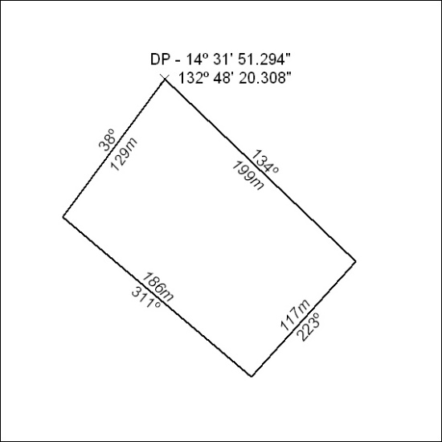

346/19

