Mineral Titles Act
NOTICE OF GRANT OF A MINERAL TITLE
Title Type and Number: | Exploration Licence 31869
Granted: | 30 November 2018, for a period of 6 Years
Area: | 250 Blocks, 797.79 km²
Locality: | MOUNT PEAKE
Name of Holder/s: | 100% INDEPENDENCE GROUP NL* [ACN. 092 786 304]
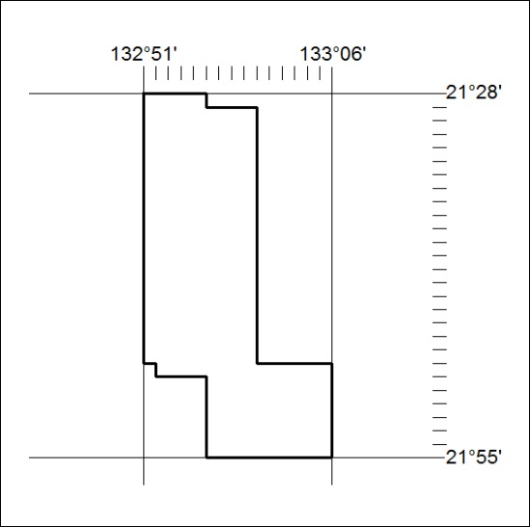
Area granted is indicated above. The titleholder is not permitted to exercise occupational rights on any land that is subject to a development title, or an application for a development title. Any land the subject of a Reserved Land gazettal under the Mineral Titles Act and all land vested in the Commonwealth of Australia is also excluded by description but not excised from the grant area.
554/18

Mineral Titles Act
NOTICE OF GRANT OF A MINERAL TITLE
Title Type and Number: | Exploration Licence 31871
Granted: | 30 November 2018, for a period of 6 Years
Area: | 137 Blocks, 438.73 km²
Locality: | CRAWFORD
Name of Holder/s: | 100% INDEPENDENCE GROUP NL* [ACN. 092 786 304]
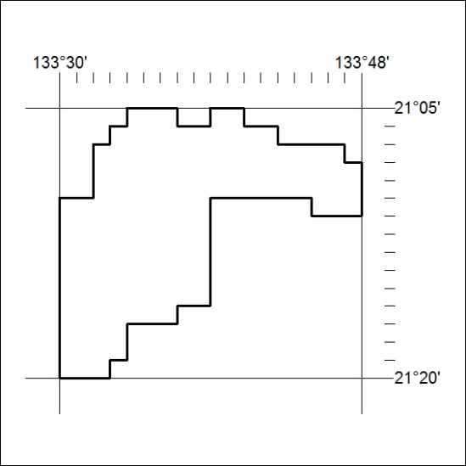
Area granted is indicated above. The titleholder is not permitted to exercise occupational rights on any land that is subject to a development title, or an application for a development title. Any land the subject of a Reserved Land gazettal under the Mineral Titles Act and all land vested in the Commonwealth of Australia is also excluded by description but not excised from the grant area.
555/18

Mineral Titles Act
NOTICE OF GRANT OF A MINERAL TITLE
Title Type and Number: | Exploration Licence 31872
Granted: | 04 December 2018, for a period of 6 Years
Area: | 236 Blocks, 695.40 km²
Locality: | CONICAL HILL
Name of Holder/s: | 100% INDEPENDENCE GROUP NL* [ACN. 092 786 304]
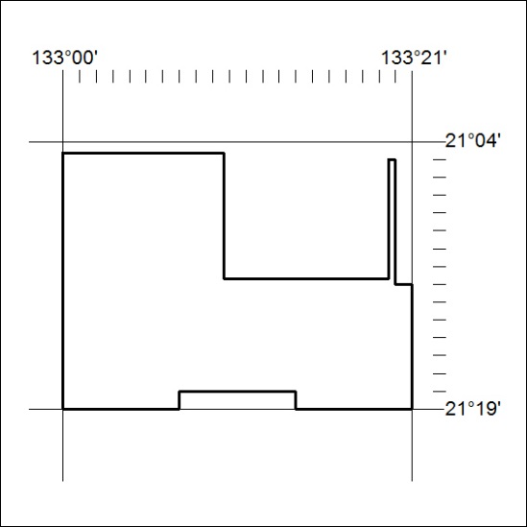
Area granted is indicated above. The titleholder is not permitted to exercise occupational rights on any land that is subject to a development title, or an application for a development title. Any land the subject of a Reserved Land gazettal under the Mineral Titles Act and all land vested in the Commonwealth of Australia is also excluded by description but not excised from the grant area.
556/18

Mineral Titles Act
NOTICE OF GRANT OF A MINERAL TITLE
Title Type and Number: | Exploration Licence 31874
Granted: | 30 November 2018, for a period of 6 Years
Area: | 117 Blocks, 374.08 km²
Locality: | WILLOWRA
Name of Holder/s: | 100% INDEPENDENCE GROUP NL* [ACN. 092 786 304]
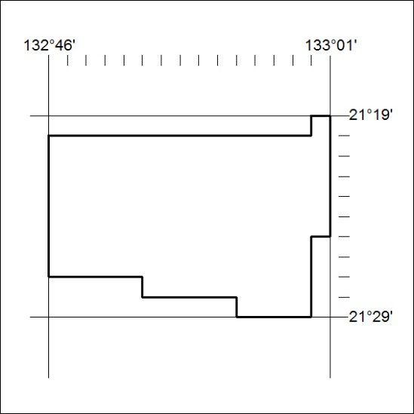
Area granted is indicated above. The titleholder is not permitted to exercise occupational rights on any land that is subject to a development title, or an application for a development title. Any land the subject of a Reserved Land gazettal under the Mineral Titles Act and all land vested in the Commonwealth of Australia is also excluded by description but not excised from the grant area.
557/18

Mineral Titles Act
NOTICE OF GRANT OF A MINERAL TITLE
Title Type and Number: | Exploration Licence 31889
Granted: | 30 November 2018, for a period of 6 Years
Area: | 240 Blocks, 719.13 km²
Locality: | WILLOWRA
Name of Holder/s: | 100% INDEPENDENCE GROUP NL* [ACN. 092 786 304]
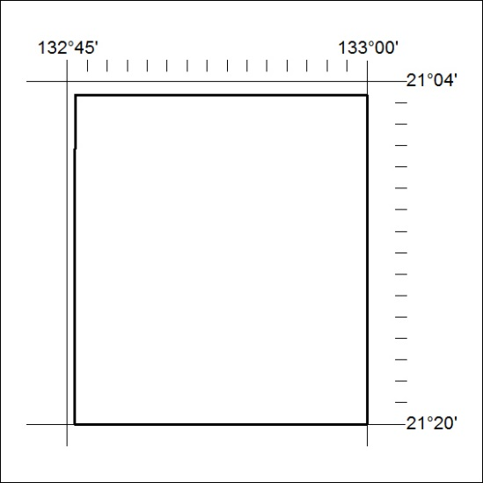
Area granted is indicated above. The titleholder is not permitted to exercise occupational rights on any land that is subject to a development title, or an application for a development title. Any land the subject of a Reserved Land gazettal under the Mineral Titles Act and all land vested in the Commonwealth of Australia is also excluded by description but not excised from the grant area.
558/18

