Mineral Titles Act
NOTICE OF LAND CEASING TO BE A MINERAL TITLE AREA
Title Type and Number: | Exploration Licence 28795
Area Ceased on: | 24 January 2018
Area: | 2 Blocks, 6.30 km²
Locality: | ANBURLA
Name of Applicant(s)/Holder(s): | 56.28% CROSSLAND NICKEL PTY LTD* [ACN. 099 477 915], 43.72% ESSENTIAL MINING RESOURCES PTY LTD [ACN. 601 655 725]
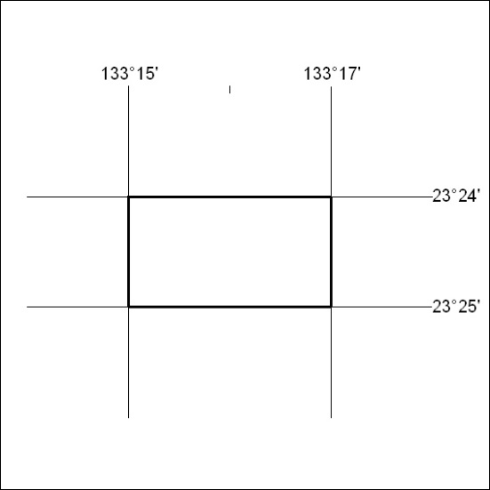

217/18

Mineral Titles Act
NOTICE OF LAND CEASING TO BE A MINERAL TITLE AREA
Title Type and Number: | Exploration Licence 28866
Area Ceased on: | 21 May 2018
Area: | 3 Blocks, 9.45 km²
Locality: | ANBURLA
Name of Applicant(s)/Holder(s): | 56.28% CROSSLAND NICKEL PTY LTD* [ACN. 099 477 915], 43.72% ESSENTIAL MINING RESOURCES PTY LTD [ACN. 601 655 725]
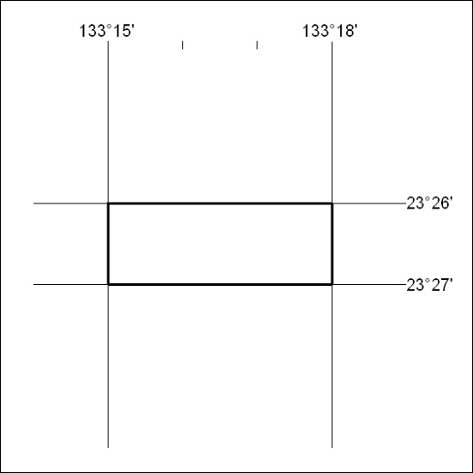

218/18

