Mineral Titles Act
NOTICE OF LAND CEASING TO BE A MINERAL TITLE AREA
Title Type and Number: | Exploration Licence 30040
Area Ceased on: | 04 May 2018
Area: | 20 Blocks, 56.11 km²
Locality: | DAVENPORT RANGE
Name of Applicant(s)/Holder(s): | 20% DUNNELL Kevin, 20% FALZON Angelo, 20% HALL Mary Anne, 20% HALL Thomas Raymond, 20% HOPPE Andrew Steven
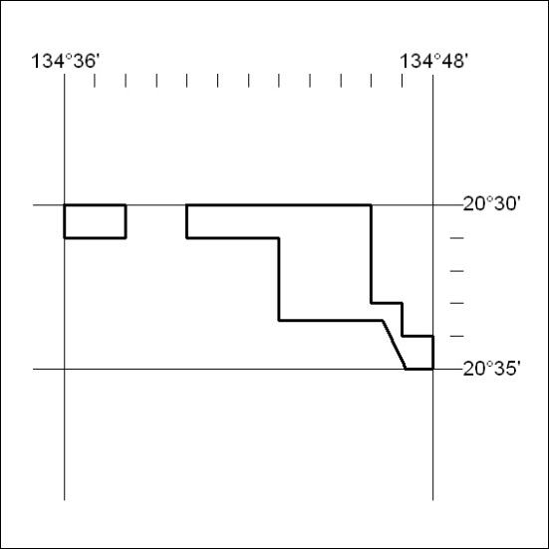

157/18

Mineral Titles Act
NOTICE OF LAND CEASING TO BE A MINERAL TITLE AREA
Title Type and Number: | Exploration Licence 30090
Area Ceased on: | 03 May 2018
Area: | 35 Blocks, 110.50 km²
Locality: | LAUGHLEN
Name of Applicant(s)/Holder(s): | 100% DAVENPORT RESOURCES LIMITED* [ACN. 153 414 852]
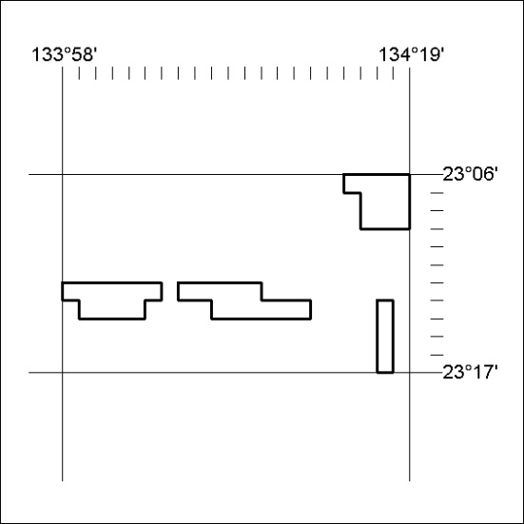

158/18

Mineral Titles Act
NOTICE OF LAND CEASING TO BE A MINERAL TITLE
Title Type and Number: | Mineral Lease (Northern) 419
Area ceased on: | 24 April 2018
Area: | 8.00 Hectare
Locality: | PINE CREEK
Name of Applicants(s)Holder(s): | 50% CASEY Geoffrey Edward, 50% CASEY Leonie Margaret
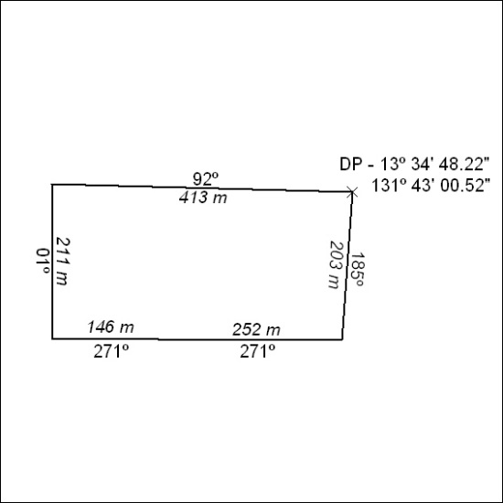
(Area now amalgamated into Mineral Lease 31677 under s102)

159/18

Mineral Titles Act
NOTICE OF LAND CEASING TO BE A MINERAL TITLE
Title Type and Number: | Mineral Lease (Northern) 420
Area ceased on: | 24 April 2018
Area: | 2.00 Hectare
Locality: | PINE CREEK
Name of Applicants(s)Holder(s): | 50% CASEY Geoffrey Edward, 50% CASEY Leonie Margaret
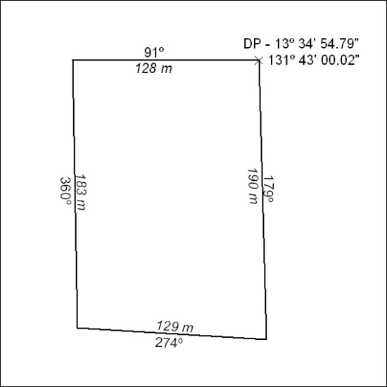
(Area now amalgamated into Mineral Lease 31677 under s102)

160/18

Mineral Titles Act
NOTICE OF LAND CEASING TO BE A MINERAL TITLE
Title Type and Number: | Mineral Lease (Northern) 421
Area ceased on: | 24 April 2018
Area: | 2.00 Hectare
Locality: | PINE CREEK
Name of Applicants(s)Holder(s): | 50% CASEY Leonie Margaret, 50% CASEY Geoffrey Edward
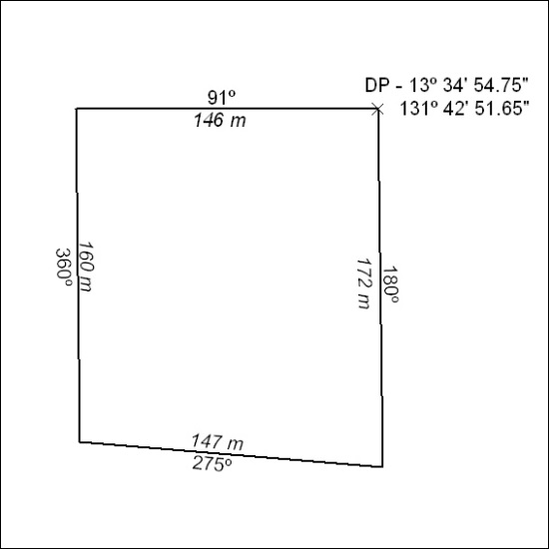
(Area now amalgamated into Mineral Lease 31677 under s102)

161/18

Mineral Titles Act
NOTICE OF LAND CEASING TO BE A MINERAL TITLE
Title Type and Number: | Mineral Lease (Northern) 422
Area ceased on: | 24 April 2018
Area: | 8.00 Hectare
Locality: | PINE CREEK
Name of Applicants(s)Holder(s): | 50% CASEY Geoffrey Edward, 50% CASEY Leonie Margaret
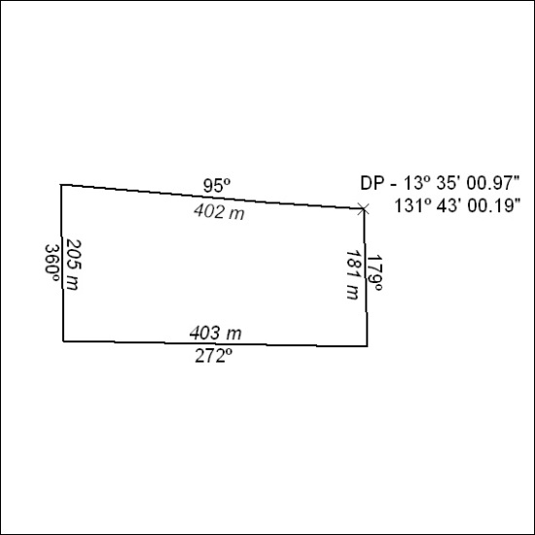
(Area now amalgamated into Mineral Lease 31677 under s102)

162/18

Mineral Titles Act
NOTICE OF LAND CEASING TO BE A MINERAL TITLE
Title Type and Number: | Mineral Lease (Northern) 455
Area ceased on: | 24 April 2018
Area: | 18.00 Hectare
Locality: | PINE CREEK
Name of Applicants(s)Holder(s): | 50% CASEY Leonie Margaret, 50% CASEY Geoffrey Edward
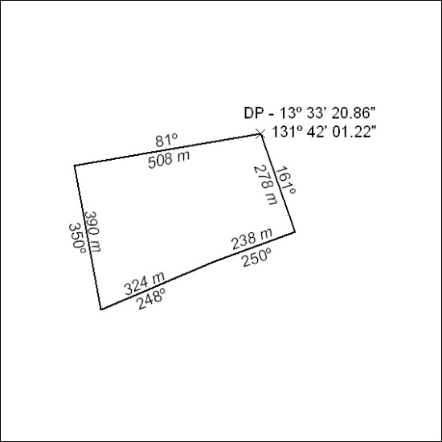
(Area now amalgamated into Mineral Lease 31678 under s102))

163/18

Mineral Titles Act
NOTICE OF LAND CEASING TO BE A MINERAL TITLE
Title Type and Number: | Mineral Lease (Northern) 456
Area ceased on: | 24 April 2018
Area: | 15.00 Hectare
Locality: | PINE CREEK
Name of Applicants(s)Holder(s): | 50% CASEY Geoffrey Edward, 50% CASEY Leonie Margaret
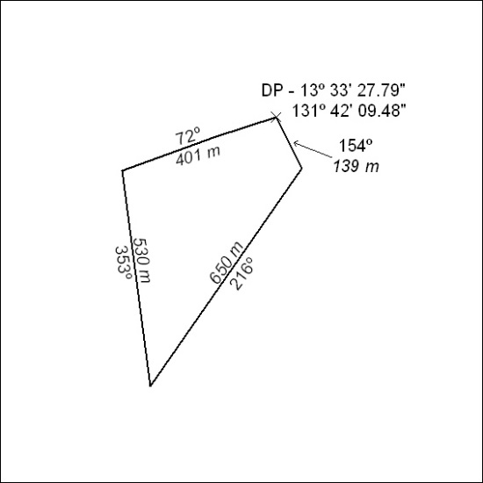
(Area now amalgamated into Mineral Lease 31678 under s102)

164/18

Mineral Titles Act
NOTICE OF LAND CEASING TO BE A MINERAL TITLE
Title Type and Number: | Mineral Lease (Northern) 572
Area ceased on: | 24 April 2018
Area: | 15.00 Hectare
Locality: | PINE CREEK
Name of Applicants(s)Holder(s): | 50% CASEY Leonie Margaret, 50% CASEY Geoffrey Edward
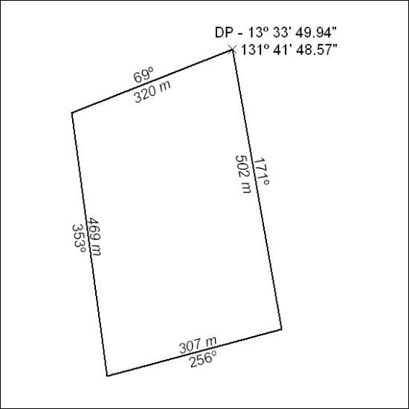
(Area now amalgamated into Mineral Lease 31678 under s102)

165/18

Mineral Titles Act
NOTICE OF LAND CEASING TO BE A MINERAL TITLE
Title Type and Number: | Mineral Lease (Northern) 573
Area ceased on: | 24 April 2018
Area: | 15.00 Hectare
Locality: | PINE CREEK
Name of Applicants(s)Holder(s): | 50% CASEY Geoffrey Edward, 50% CASEY Leonie Margaret
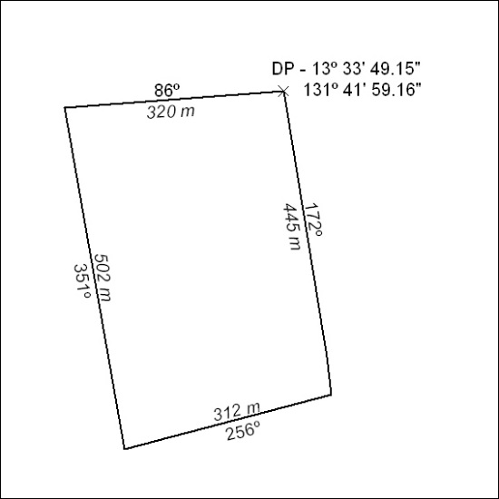
(Area now amalgamated into Mineral Lease 31678 under s102)

166/18

Mineral Titles Act
NOTICE OF LAND CEASING TO BE A MINERAL TITLE
Title Type and Number: | Mineral Lease (Northern) 759
Area ceased on: | 24 April 2018
Area: | 10.00 Hectare
Locality: | PINE CREEK
Name of Applicants(s)Holder(s): | 75% CASEY Leonie Margaret, 25% CASEY Geoffrey Edward
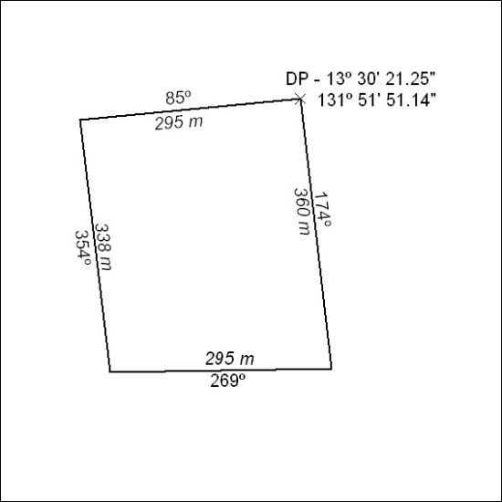
(Area now amalgamated into Mineral Lease 31679 under s102)

167/18

Mineral Titles Act
NOTICE OF LAND CEASING TO BE A MINERAL TITLE
Title Type and Number: | Mineral Lease (Northern) 760
Area ceased on: | 24 April 2018
Area: | 13.00 Hectare
Locality: | PINE CREEK
Name of Applicants(s)Holder(s): | 75% CASEY Leonie Margaret, 25% CASEY Geoffrey Edward
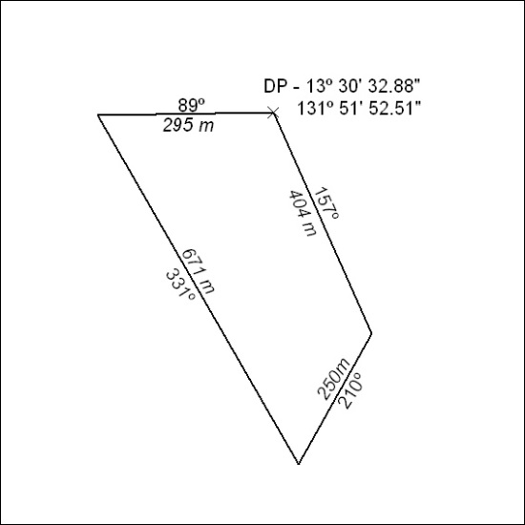
(Area now amalgamated into Mineral Lease 31679 under s102)

168/18

Mineral Titles Act
NOTICE OF LAND CEASING TO BE A MINERAL TITLE
Title Type and Number: | Mineral Lease (Northern) 767
Area ceased on: | 24 April 2018
Area: | 13.00 Hectare
Locality: | PINE CREEK
Name of Applicants(s)Holder(s): | 75% CASEY Leonie Margaret, 25% CASEY Geoffrey Edward
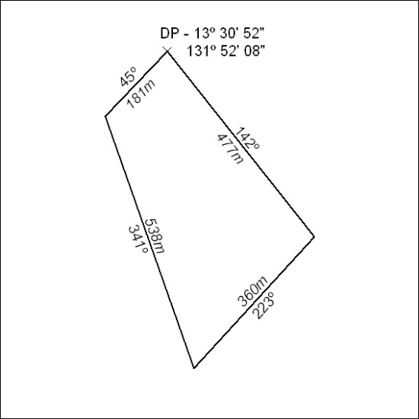
(Area now amalgamated into Mineral Lease 31679 under s102)

169/18

Mineral Titles Act
NOTICE OF LAND CEASING TO BE A MINERAL TITLE
Title Type and Number: | Mineral Lease (Northern) 768
Area ceased on: | 01 January 2017
Locality: | McKINLAY RIVER
Name of Applicants(s)Holder(s): | 75% CASEY Leonie Margaret, 25% CASEY Geoffrey Edward
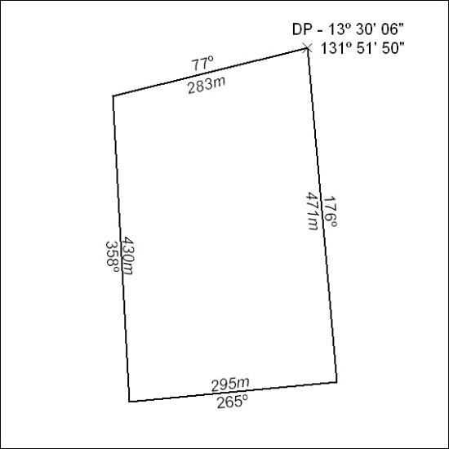
(Area now amalgamated into Mineral Lease 31679 under s102)

170/18

Mineral Titles Act
NOTICE OF LAND CEASING TO BE A MINERAL TITLE
Title Type and Number: | Mineral Lease (Northern) 769
Area ceased on: | 24 April 2018
Area: | 11.00 Hectare
Locality: | McKINLAY RIVER
Name of Applicants(s)Holder(s): | 75% CASEY Leonie Margaret, 25% CASEY Geoffrey Edward
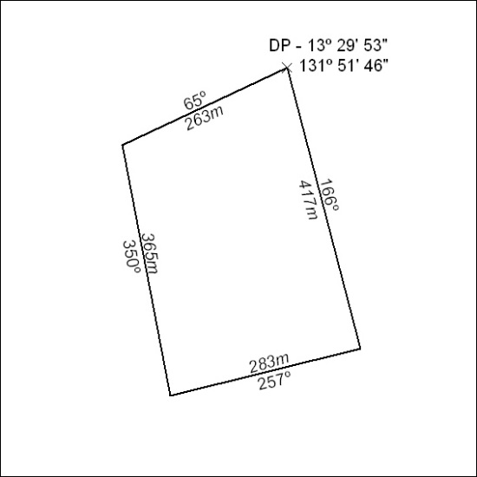
(Area now amalgamated into Mineral Lease 31679 under s102)

171/18

Mineral Titles Act
NOTICE OF LAND CEASING TO BE A MINERAL TITLE
Title Type and Number: | Mineral Lease (Northern) 770
Area ceased on: | 24 April 2018
Area: | 8.00 Hectare
Locality: | McKINLAY RIVER
Name of Applicants(s)Holder(s): | 75% CASEY Leonie Margaret, 25% CASEY Geoffrey Edward
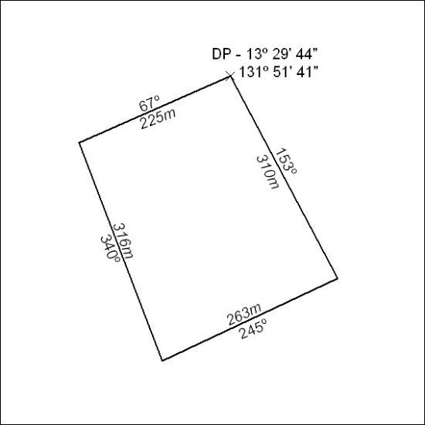
(Area now amalgamated into Mineral Lease 31679 under s102)

172/18

Mineral Titles Act
NOTICE OF LAND CEASING TO BE A MINERAL TITLE
Title Type and Number: | Mineral Lease (Northern) 771
Area ceased on: | 24 April 2018
Area: | 7.00 Hectare
Locality: | PINE CREEK
Name of Applicants(s)Holder(s): | 75% CASEY Leonie Margaret, 25% CASEY Geoffrey Edward
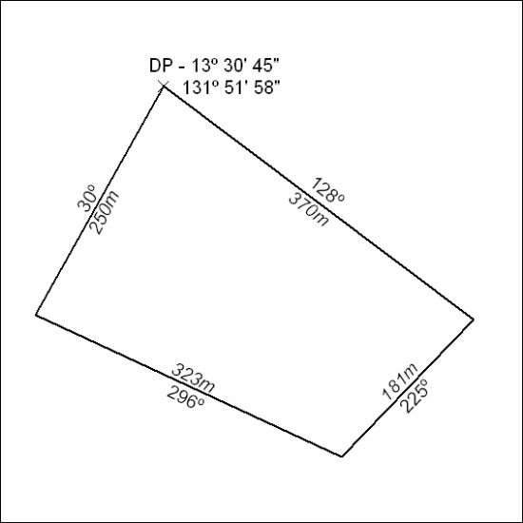
(Area now amalgamated into Mineral Lease 31679 under s102)

173/18

Mineral Titles Act
NOTICE OF LAND CEASING TO BE A MINERAL TITLE
Title Type and Number: | Mineral Lease (Northern) 964
Area ceased on: | 24 April 2018
Area: | 18.00 Hectare
Locality: | PINE CREEK
Name of Applicants(s)Holder(s): | 50% CASEY Leonie Margaret, 50% CASEY Geoffrey Edward
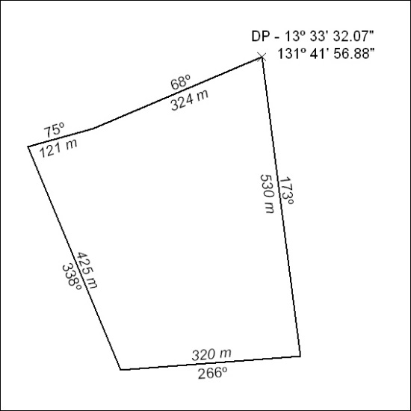
(Area now amalgamated into Mineral Lease 31678 under s102)

174/18

