Mineral Titles Act
NOTICE OF LAND CEASING TO BE A MINERAL TITLE
Title Type and Number: | Mineral Authority 29615
Area ceased on: | 01 May 2018
Area: | 28.00 Hectare
Locality: | KOOLPINYAH
Name of Applicants(s)Holder(s): | 100% INNOCENTE TRANSPORT PTY. LIMITED [ACN. 009 609 563]
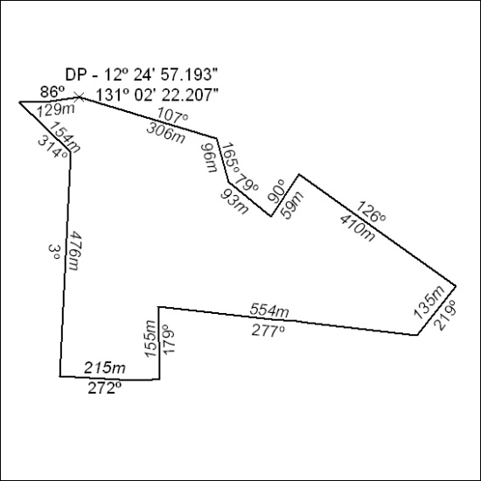

155/18

