Mineral Titles Act
NOTICE OF GRANT OF A MINERAL TITLE
Title Type and Number: | Exploration Licence 32936
Granted: | 02 September 2022, for a period of 6 Years
Area: | 216 Blocks, 676.34 km²
Locality: | PELLINORE
Name of Holder/s: | 100% ECOSTORAGE SOLUTIONS PTY LTD [ACN. 653 988 419]
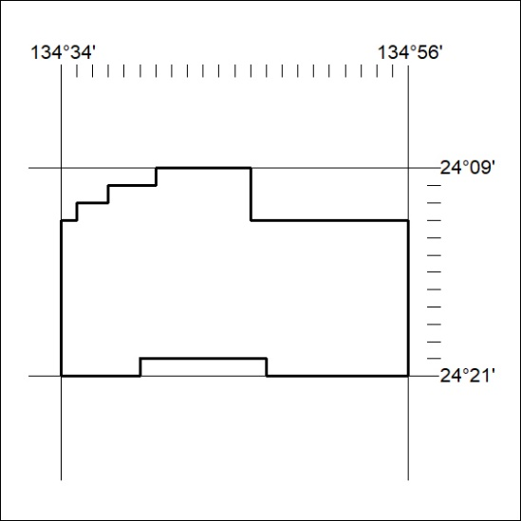
Area granted is indicated above. The titleholder is not permitted to exercise occupational rights on any land that is subject to a development title, or an application for a development title. Any land the subject of a Reserved Land gazettal under the Mineral Titles Act and all land vested in the Commonwealth of Australia is also excluded by description but not excised from the grant area.
318/22

Mineral Titles Act
NOTICE OF GRANT OF A MINERAL TITLE
Title Type and Number: | Exploration Licence 33101
Granted: | 02 September 2022, for a period of 6 Years
Area: | 38 Blocks, 108.82 km²
Locality: | SHORT RANGE
Name of Holder/s: | 100% HEAVY RARE EARTHS LIMITED* [ACN. 648 991 039]
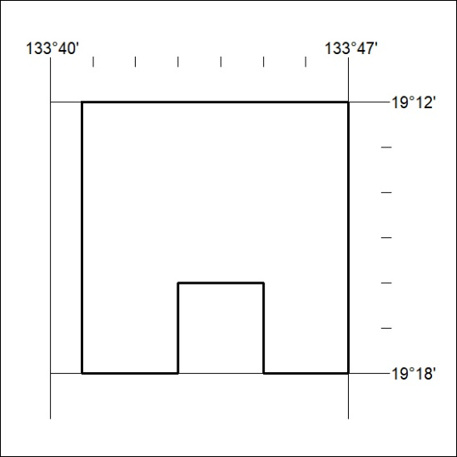
Area granted is indicated above. The titleholder is not permitted to exercise occupational rights on any land that is subject to a development title, or an application for a development title. Any land the subject of a Reserved Land gazettal under the Mineral Titles Act and all land vested in the Commonwealth of Australia is also excluded by description but not excised from the grant area.
319/22

Mineral Titles Act
NOTICE OF GRANT OF A MINERAL TITLE
Title Type and Number: | Exploration Licence 33108
Granted: | 02 September 2022, for a period of 6 Years
Area: | 250 Blocks, 828.20 km²
Locality: | MOROAK
Name of Holder/s: | 100% DALY TENEMENTS PTY LTD [ACN. 658 845 786]
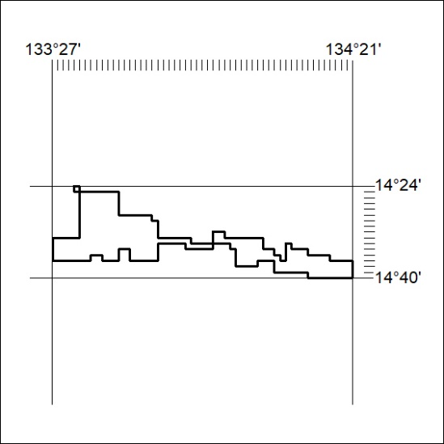
Area granted is indicated above. The titleholder is not permitted to exercise occupational rights on any land that is subject to a development title, or an application for a development title. Any land the subject of a Reserved Land gazettal under the Mineral Titles Act and all land vested in the Commonwealth of Australia is also excluded by description but not excised from the grant area.
320/22

