Mineral Titles Act 2010
NOTICE OF LAND CEASING TO BE A MINERAL TITLE APPLICATION AREA
Title Type and Number: | Extractive Mineral Permit 32264
Area ceased on: | 19 July 2022
Area: | 96.00 Hectare
Locality: | KOOLPINYAH
Name of Applicants(s)Holder(s): | 100% MOUSELLIS & SONS PTY. LTD. [ACN. 009 654 791]
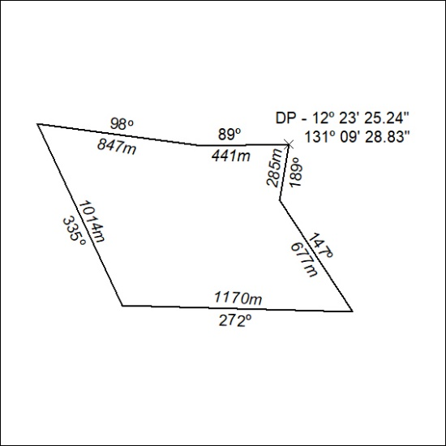

261/22

Mineral Titles Act 2010
NOTICE OF LAND CEASING TO BE A MINERAL TITLE APPLICATION AREA
Title Type and Number: | Extractive Mineral Permit 32265
Area ceased on: | 19 July 2022
Area: | 95.00 Hectare
Locality: | KOOLPINYAH
Name of Applicants(s)Holder(s): | 100% MOUSELLIS & SONS PTY. LTD. [ACN. 009 654 791]
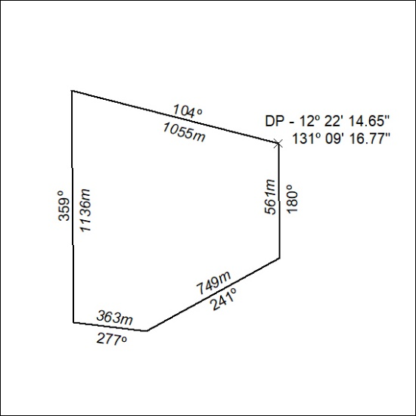

262/22

Mineral Titles Act 2010
NOTICE OF LAND CEASING TO BE A MINERAL TITLE APPLICATION AREA
Title Type and Number: | Extractive Mineral Permit 32266
Area ceased on: | 19 July 2022
Area: | 64.00 Hectare
Locality: | KOOLPINYAH
Name of Applicants(s)Holder(s): | 100% MOUSELLIS & SONS PTY. LTD. [ACN. 009 654 791]
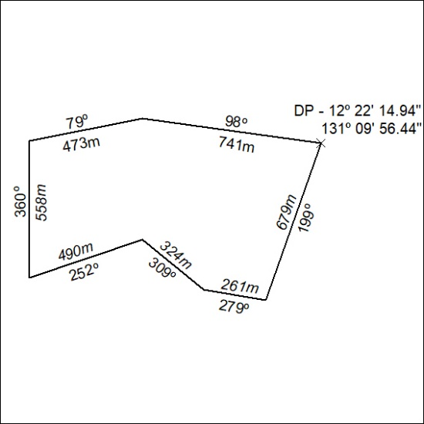

263/22

Mineral Titles Act 2010
NOTICE OF LAND CEASING TO BE A MINERAL TITLE APPLICATION AREA
Title Type and Number: | Extractive Mineral Permit 32268
Area ceased on: | 19 July 2022
Area: | 97.00 Hectare
Locality: | KOOLPINYAH
Name of Applicants(s)Holder(s): | 100% MOUSELLIS & SONS PTY. LTD. [ACN. 009 654 791]
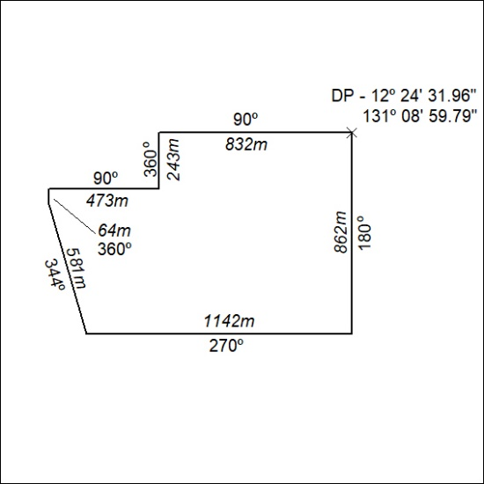

264/22

Mineral Titles Act 2010
NOTICE OF LAND CEASING TO BE A MINERAL TITLE APPLICATION AREA
Title Type and Number: | Extractive Mineral Permit 32269
Area ceased on: | 19 July 2022
Area: | 92.00 Hectare
Locality: | KOOLPINYAH
Name of Applicants(s)Holder(s): | 100% MOUSELLIS & SONS PTY. LTD. [ACN. 009 654 791]
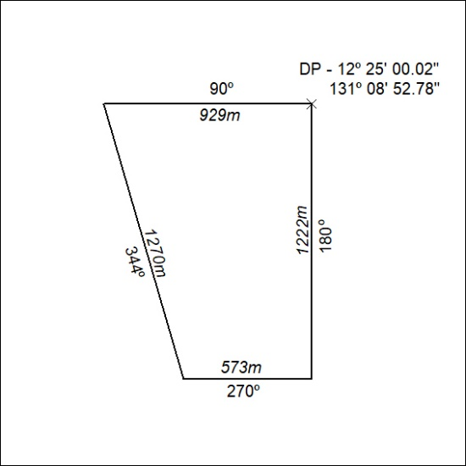

265/22

Mineral Titles Act 2010
NOTICE OF LAND CEASING TO BE A MINERAL TITLE APPLICATION AREA
Title Type and Number: | Extractive Mineral Permit 32270
Area ceased on: | 19 July 2022
Area: | 97.00 Hectare
Locality: | KOOLPINYAH
Name of Applicants(s)Holder(s): | 100% MOUSELLIS & SONS PTY. LTD. [ACN. 009 654 791]
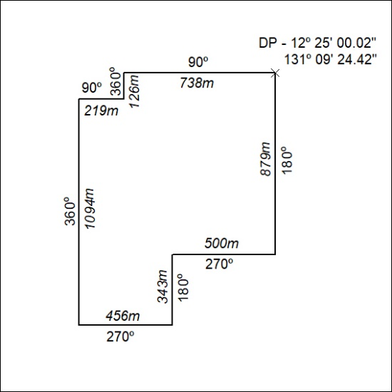

266/22

Mineral Titles Act 2010
NOTICE OF LAND CEASING TO BE A MINERAL TITLE APPLICATION AREA
Title Type and Number: | Extractive Mineral Permit 32271
Area ceased on: | 19 July 2022
Area: | 57.00 Hectare
Locality: | KOOLPINYAH
Name of Applicants(s)Holder(s): | 100% MOUSELLIS & SONS PTY. LTD. [ACN. 009 654 791]
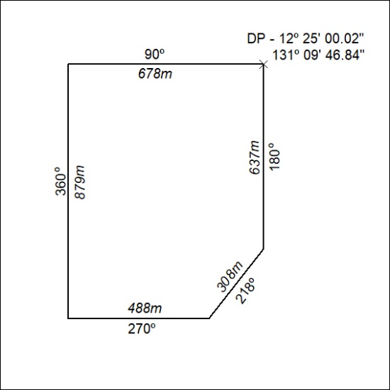

267/22

Mineral Titles Act 2010
NOTICE OF LAND CEASING TO BE A MINERAL TITLE APPLICATION AREA
Title Type and Number: | Extractive Mineral Permit 32707
Area ceased on: | 19 July 2022
Area: | 48.00 Hectare
Locality: | KOOLPINYAH
Name of Applicants(s)Holder(s): | 100% MOUSELLIS & SONS PTY. LTD. [ACN. 009 654 791]
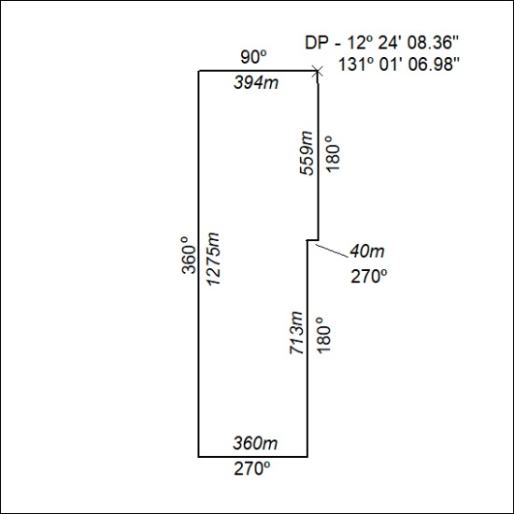

268/22

