Mineral Titles Act
NOTICE OF GRANT OF A MINERAL TITLE
Title Type and Number: | Exploration Licence 32956
Granted: | 15 June 2022, for a period of 6 Years
Area: | 130 Blocks, 399.26 km²
Locality: | TANAMI
Name of Holder/s: | 100% JARRAH NIA EXPLORATION PTY LTD [ACN. 654 419 986]
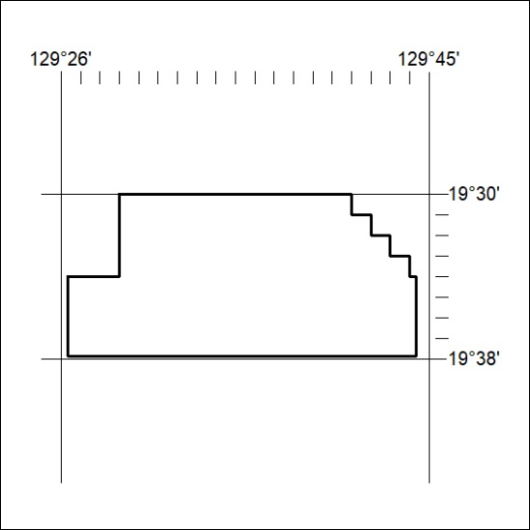
Area granted is indicated above. The titleholder is not permitted to exercise occupational rights on any land that is subject to a development title, or an application for a development title. Any land the subject of a Reserved Land gazettal under the Mineral Titles Act and all land vested in the Commonwealth of Australia is also excluded by description but not excised from the grant area.
196/22

Mineral Titles Act
NOTICE OF GRANT OF A MINERAL TITLE
Title Type and Number: | Exploration Licence 32957
Granted: | 15 June 2022, for a period of 6 Years
Area: | 117 Blocks, 370.81 km²
Locality: | BUSHY PARK
Name of Holder/s: | 100% JARRAH NIA EXPLORATION PTY LTD [ACN. 654 419 986]
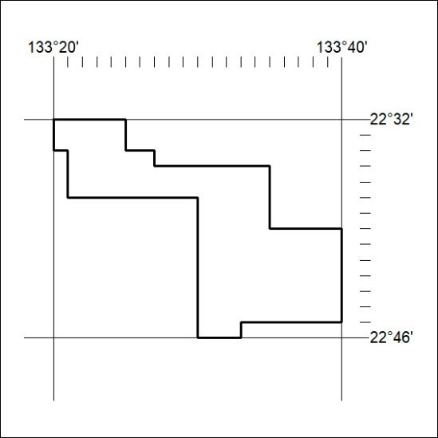
Area granted is indicated above. The titleholder is not permitted to exercise occupational rights on any land that is subject to a development title, or an application for a development title. Any land the subject of a Reserved Land gazettal under the Mineral Titles Act and all land vested in the Commonwealth of Australia is also excluded by description but not excised from the grant area.
197/22

