Mineral Titles Act 2010
NOTICE OF LAND CEASING TO BE A MINERAL TITLE AREA
Title Type and Number: | Exploration Licence 31524
Area Ceased on: | 21 January 2022
Area: | 9 Blocks, 28.39 km²
Locality: | RANFORD HILL
Name of Applicant(s)/Holder(s): | 100% ROCKWASH PTY LTD [ACN. 611 356 837]
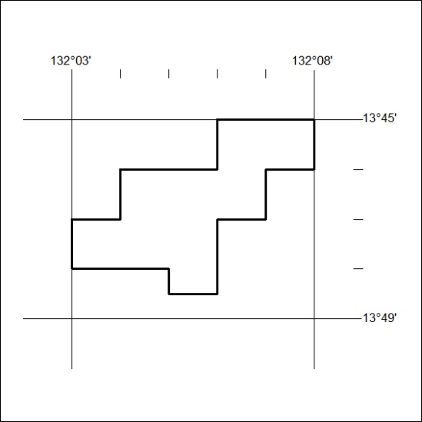

016/22

