Mineral Titles Act 2010
NOTICE OF LAND CEASING TO BE A MINERAL TITLE AREA
Title Type and Number: | Exploration Licence 29747
Area Ceased on: | 02 September 2021
Area: | 18 Blocks, 56.86 km²
Locality: | LEISLER
Name of Applicant(s)/Holder(s): | 100% CASTILE RESOURCES LTD* [ACN. 124 314 085]
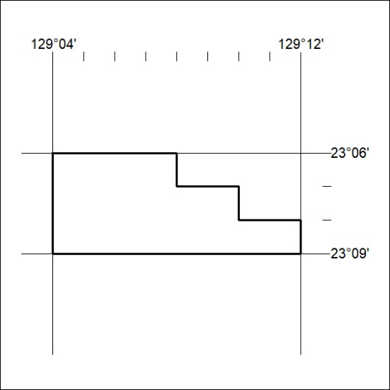

341/21

