|  |  |  |
| --- | --- | --- |
| **NT Agriculture, Forestry and Fishing Projects**  The map provides the location of major agriculture, forestry and fishing projects in the Northern Territory | * The Northern Territory has a land mass of 1 348 199 km2, the third largest Australian jurisdiction * The NT has a small and sparsely distributed population of 246 561 , accounting for about 1.0% of the Australian resident population * The NT civilian population (15+ years) is 190 079 persons, with a labour force of 132 531 persons, including 126 180 people employed * The NT is characterised by a young population, with a median age of 34 years compared to 37 years nationally * 30.3% of the resident NT population are Aboriginal and/or Torres Strait Islander * More than half of the NT’s population reside in the Greater Darwin region, the main hub of economic activity * The NT has considerable onshore and offshore energy resources, in addition to existing and prospective mineral, agriculture, aquaculture and horticulture projects. * The NT’s developing economic infrastructure connects regions and key markets through roads, ports, international airport, gas pipeline and Darwin to Adelaide railway * Economic output (GSP) in 2019-20 was $26.2 billion, a 5.3% increase from 2018-19 | **NT Mining and Energy Projects**  The map outlines the major mining and eneryg projects in the Northern Territory |
| * The NT’s five largest industries by output are mining; public administration and safety; health care and social assistance; construction; and education and training; comprising a combined 58% of total NT GSP * The Defence presence (air force, army, and navy) in the region plays a significant role * Tourism activity is an expanding sector with significant assets such as the world-famous Kakadu National Park, Uluru, Katherine Gorge; and other national parks |
| * The NT is an open, trade-oriented economy * Key exports include LNG, live animals, and mineral ores and concentrates * About 77% of NT exports go to Japan, China, Taiwan, and the Republic of Korea * Key imports include refined petroleum, road vehicles, and machinery and equipment * The NT’s major import partners are Malaysia, Japan, and Singapore |

Greater Darwin includes Darwin city, Darwin suburbs, Palmerston, Litchfield. It has an area of 3164 square kilometres, a population of 147231, number of businesses are 11025, and key industries are retail/wholesale; and manufacturing.
Daly-Tiwi-West Arnhem has an area of 112251 square kilometres, a population of 17909, number of businesses are 361, and key industries are agriculture/fishing; and mining; 
East Arnhem has an area of 33596 square kilometres, population of 14565, number of businesses are 266, and key industries are agriculture/fishing; mining; and tourism; 
Barkly has an area of 303295 square kilometres, population of 6142, number of businesses are 213, and key industries are agriculture, tourism; and government services.
Alice Springs has an area of 569566 square kilometres, population is 39391, number of businesses is 2139, and key industries agriculture, tourism; cattle; and mining.
Katherine, also called Big Rivers, has an area of 326327 square kilometres, population is 20905, number of businesses are 943, and key industries are agriculture, tourism, cattle; fishing; and mining.
Regions are classified according to the Australian Statistical Geography Standard Statistical Area level 3

Please read in outline view for best navigational experience.

# Introduction

The Territory’s economy, while relatively small compared to other Australian jurisdictions, is vibrant and has an abundance of mineral and energy resources. Its close proximity to Asia, the fastest growing region of the global economy, and a renewed focus of developing northern Australia, provide many potential business opportunities for Territory businesses.

# Gross state product (GSP)

The NT’s 10-year average annual economic (GSP) growth rate (2009-10 to 2019-20) was 2.5%. In 2019-20, NT GSP (inflation adjusted) increased by 5.3% to $26.2 billion (Chart 1), driven by a strong rise in exports (primarily LNG), partially offset by a fall in business investment, and consumption. In 2019-20, total investment in the NT was valued at $4.5 billion, a decrease of 19.7% compared to 2018-19.

Private investment is the largest component of total investment, about 70% ($3.2 billion). Private investment decreased by 20.2% over 2019-20 (Chart 2). This decrease was largely driven by a 41.1% fall in non-dwelling construction activities (business investment). In the NT economy, large projects have a considerable impact on investment and generate high levels of economic growth, but also cause large fluctuations in investment.

Nationally, Gross Domestic Product (GDP) decreased by 0.3% in 2019-20, reflecting the impacts of COVID and the lockdowns measures that were implemented. NT GSP accounts for 1.3% of Australian GDP.

**Chart 1: State and Territory Real GSP 2019-20**

Australian gross domestic product in 2018-19 was $1.9 trillion
Northern Territory gross state product was $26 billion
Queensland gross state product was $364 billion
New South Wales gross state product was $625 billion
Australian Capital Territory gross state product was $41 billion
Victoria gross state product was $459 billion
Tasmania gross state product was $32 billion
South Australia gross state product was $108 billion
Western Australia gross state product was $292 billion
Source is Australian Burea of Statistics Catalogue Number 5220.0

*Source: ABS Cat. No. 5220.0*

**Chart 2: NT investment components growth**

NT investment is forecast to increase in the outer years driven by private investment

*Source: ABS Cat. No. 5220.0, DTF*

**Chart 3: GSP vs SFD Growth**

The Department of Treasury and Finance forecast subdued economic growth in the Northern Territory in the foreward estimates.

*Source: ABS Cat. No. 5220.0, DTF*

Private business investment ($2.5 billion), the key driver of investment ($4.5 billion), comprised about 78% of the total private investment ($3.2 billion) and 54% of the total investment in 2019-20.

NT economic growth is estimated to increase by 4.7% in 2020-21, by 2.3% in 2021-22, and by 3.1% in 2022-23 (Chart 3) (Department of Treasury and Finance Budget 2021-22). This is largely due to rebounding consumption expenditure and private investment associated with a number of major projects including the Barossa Project, the Darwin ship lift and marine industry project, and Darwin City Deal (including the CDU CBD campus). Deloitte Access Economics forecasts the NT economy to grow by 1.9% in 2020-21 and by 3.5% in 2021‑22. National GDP declined by 0.3% in 2019‑20 but is estimated to rebound by 1.25% in 2020-21 and forecast to increase by 4.25% in 2021-22 (Australian Government 2021-22 Budget).

# State final product (SFD)

SFD, a measure of the value of spending in the local economy by households, government and businesses on goods and services and capital investment, and does not include the value of international exports, net interstate trade or changes in inventories.

In the March quarter 2021, NT SFD, total domestic expenditure within the local economy, decreased by 1.9%. In the year to March 2021 (Chart 4), NT SFD increased by 1.2% (Chart 5) to $24.2 billion (seasonally adjusted and inflation adjusted). For the same period in the previous year, SFD was $23.9 billion (Chart 6). Consumption (public and private consumption), the largest component of SFD, comprised 81.1% of domestic demand.

**Chart 4: State final demand, year on year % change**

NT state final demand increased by 1.2 per cent in 2019-20

*Source: ABS Cat. No. 5206.0*

**Chart 5: NT SFD, inflation adjusted**

SFD growth is driven by changes in investment, which has been declining for the past two years

*Source: ABS Cat. No. 5220.0, DTF*

**Chart 6: State final demand components**

State final demand is forecast to be subdued over the outer years

*Source: ABS Cat. No. 5206.0, DTF*

In 2020-21 and 2021-22, SFD growth is expected to increase as the economy recovers from the effects of COVID, driven by growth in private sector investment and private consumption.

| **NT SFD component** | **Proportion of SFD in the year to March 2021** | | |
| --- | --- | --- | --- |
|  | **March 2021** | **March 2020** | **Annual change** |
| Private consumption | 44.9% | 44.8% | Increase |
| Public consumption | 36.0% | 35.1% | Increase |
| Private investment | 14.0% | 13.8% | Decrease |
| Public investment | 5.1% | 6.3% | Decrease |

# International goods trade

In the year to May 2021, the value of NT goods exported fell to $9.7 billion (Chart 7). This represents a 21.4% decrease on the same time last year, which is attributed to less export activity to Japan, China, and Taiwan.

Over the same period, the value of goods imported has fallen by 24.9% to $1.1 billion, primarily due to a large fall in petroleum imports from Singapore, and aircraft from Switzerland.

The NT’s trade surplus sits at $8.6 billion in the year to May 2021.

The NT contributed about 2.5% of Australia’s goods exports, and around 0.3% of imports in the year to May 2021.

A significant proportion of imports to the NT come from other Australian jurisdictions and is treated as the balancing item in the GSP accounts.

**Chart 7: NT International Trade**

Northern Territory exports are forecast to increase strongly in 2020-21 and imports are forecast to moderate, hence yielding a strengthening balance of trade. This follows a period of falling exports and imports.

*Source: ABS Cat. No. 5368.0*

**Chart 8: NT International Goods Trade**

A very large portion of trade is with Asia, primarily Japan, China, Korea and Taiwan.

*Source: ABS Cat. No. 5368.0*

Regional breakdowns:  
Asia includes Southern and Central Asia, Middle East, North East Asia, and South East Asia  
Europe includes North-West Europe and Southern and Eastern Europe  
Americas includes North America, South America, Central America and the Caribbean  
Other (a) includes Africa (North Africa, Central and West Africa, and Southern and East Africa) and Oceania (Antarctica and Pacific Island countries and territories)

Major NT imports from overseas are refined petroleum, road vehicles, and machinery and equipment.

The NT’s major exports to overseas are LNG, live animals, and mineral ores and concentrates.

Key NT trading partners are Japan, China and Taiwan (Chart 8), which accounts for more than 60% of total NT international trade.

The majority of NT exports are destined for North and South East Asia (Japan and China are key export partners) while the main import partners in the year to May 2021 were Malaysia, Japan, and Singapore.

# International services trade

In 2019-20, NT international services exports decreased by 8.3% to $693 million. Over the same period, NT international services imports decreased by 22.9% to $487 million. NT net international services trade increased by 66.1% to a surplus of $206 million.

The decreases in both NT international services exports and imports were driven by falling travel services. Travel services exports decreased by 12.3% to $484 million and travel services imports decreased by 25.2% to $318 million.

# Population

As at December 2020, the NT’s resident population was 246 561, an increase of 0.5% in annual terms (Chart 9). Natural increase and net overseas migration added to the population while net interstate migration detracted from population growth. Population growth has been affected by COVID, with border closures and restrictions for overseas travellers. The population of Australia in December 2020 was 25 694 393 people. The NT population comprised 1.0% of the national population. The estimated resident Aboriginal and Torres Strait Islander population of the NT in June 2016 was 74 546 persons,

**Chart 9: Northern Territory Population**

Northern Territory population growth has moderated over the past three years, after a period of strong growth. The Northern Territory population has increased from about 232581 in 2011 to about 246000 in 2020.

*Source: ABS Cat. No. 3101.0*

**Chart 10: NT Age Distribution 2020**

Northern Territory is characterised by a young population with the largest number of people in the 25 to 34 age group. The Northern Territory population pyramid is typical of a developed nation population age structure where the majority of people are aged in the 25 to 50 year age groups.

*Source: ABS Cat. No. 3101.0*

59.9% of the Northern Territory population is in Greater Darwin
16% of the Northern Territory population is in Alice Springs
2.5% of the Northern Territory population is in Barkly
7.2% of the Northern Territory population is in Daly-Tiwi-West Arnhem
5.9% of the Northern Territory population is in East Arnhem
8.5% of the Northern Territory population is in Katherine**Chart 11: NT Regional Population, June 2020**

*Source: ABS Cat. No. 3218.0*

comprising around 30.3% of the NT resident population. Around 49.5% of the Indigenous population were females. Nationally, the Indigenous population accounts for 3.3% of the total population.

The NT population is relatively young (Chart 10) (median age of 34 years compared to 37 years nationally) with a higher male-to-female sex ratio 109.9 males per 100 females compared to 98.4 males per 100 females nationally.

In June 2021, the NT working age population (15+ years) was 190 079 persons, up 0.4% over the year, and accounted for about 77% of the total population. Nationally, the civilian population was 81% of the population.

Around 59.8% of the NT population is located in the Greater Darwin area (Darwin City, Darwin suburbs, Litchfield and Palmerston) with Central Australia (Alice Springs region) accounting for a further 16.0% and the Katherine region accounting for 8.5% of the total population (Chart 11).

# Labour market

The NT labour market has softened over the past six months, with falling resident employment and a lower participation rate. The number of unemployed persons and the unemployment rate has come down, but this may reflect fewer active job seekers.

In June 2021, the NT unemployment rate increased to 4.8% (seasonally adjusted) and has decreased by 0.8 percentage points over the year (Chart 12), and has the third lowest unemployment rate of all Australian jurisdictions. Nationally, the unemployment rate was 4.9% (seasonally adjusted).

Employment levels have decreased to 126 180 persons employed across the NT as at June 2021. This represents a 1.8% decrease when compared to June 2020.

The year on year change in resident employment declined by 1.6% (Chart 13), while national employment levels increased by 0.6% over the same period.

**Chart 12: NT Participation and Unemployment Rate**

Northern Territory employment rate has remained relativley steady while the participation rate has been trending downwards.

*Source: ABS Cat. No. 6202.0*

**Chart 13: NT Total Employed and Growth Rate**

Northern Territory employment has been steadily declining. Employment growth is volatile and is dependent on major projects in the Northern Territory, with the Inpex gas plant construction the latest major project to drive employment growth.

*Source: ABS Cat. No. 6202.0*

The NT underemployment rate was the lowest of all jurisdictions at 5.0% of total employed persons in June 2021, compared to 7.9% nationally. This signifies that there are more employed people in the NT working their desired number of hours.

The NT underemployment rate has been falling since peaking in April 2020 when social distancing measures were in place.

The NT underutilisation rate (unemployment rate + underemployment rate) was 9.8% of the total employed persons in June 2021 (Chart 14). Similar, to the underemployment rate, this rate has trended down since peaking at 17.2% in May 2020.

The NT participation rate has been trending down over the year but remains second highest of all jurisdictions at 69.7%. This represents a 2.2 percentage point decrease in annual terms. The national participation rate was 66.2% in the same period.

Non-resident labour (including fly-in-fly-out workers) is an important component of the NT labour market statistics. Although difficult to measure, Census 2016 estimated it to be about 8700 workers in June 2016. Similarly, members of the Australian Defence Force are also not included in the labour force statistics, but Australian Defence Force data estimated it to be about 4393 permanent defence force personnel as at June 2020 (Department of Treasury and Finance).

Employment levels in the NT are estimated to fall by 0.6% in 2020-21 before recovering to 1.8% growth in 2021-22 and increasing by 1.7% in 2022-23 (Department of Treasury and Finance Budget 2021-22). The forecast rebound in NT resident employment reflects the expected lifting of international border restrictions, which supports the labour intensive tourism sector, and new investment for major public and private sector projects.

Regional statistics show the unemployment rate increased in all NT regions, except for Greater Darwin in the March quarter 2021. Daly-Tiwi-West Arnhem reported the highest unemployment rate of 9.4% in the quarter,

**Chart 14: Labour underutilisation rate**

Labour underutilisation rate has decreased after peaking in 2020

*Source: ABS Cat. No. 6202.0*

**Chart 15: NT Total Employment by Industry, May 2021**

In the year to May 2021, employment by industry in the Northern Territory is as follows:
Public administration and safety is 15700
Health care and social assistance is 15200
Construction is 8000
Education and training is 9400
Retail trade is 8800
Accommodation and food services is 6400
Professional, scientific and technical services is 5600
Other services is 5300
Transport, postal and warehousing is 4600
Administrative and support services is 4100
Mining is 1700
Arts and recreation services is 3100
Manufacturing is 2800
Electricity, gas, water, and waste services is 1400
Wholesale trade is 2100
Rental, hiring and real estate services is 1800
Financial and insurance services is 1100
Agriculture, forestry and fishing is 1700
Information, media and telecommunications is 1100

*Source: ABS Cat. No. 6291.0.55.003*

while Alice Springs reported the lowest unemployment of 4.3%.

As at June 2021 the number of youth employed (aged 15-24 years) in the NT decreased to 14 131, which represents a 1.5% year on year decline. At the national level, youth employment decreased to 1 918 393 persons, representing a 1.1% year on year decrease.

NT employment by industry sector data (annual moving average at May 2021) shows that Health care and social assistance is the largest employer employing about 17.3% (Chart 15) of the total employed, ahead of Public administration and safety (16.9%).

Other large industry employers include Education and training (9.5%), Retail trade (8.6%) and Construction (7.9%). The Mining industry on the other hand employs around 2.3% of the NT workforce.

Year to date to May 2021, there were 1226 apprentice and trainee commencements in the Territory, an increase of 35.0% compared to the same period in the previous year. Over the same period, there were 331 apprentice and trainee completions, an increase of 40.3% compared to the same time last year.

# Prices

The consumer price index (CPI) increased by 1.0% in the June quarter 2021.

Over the year to June 2021, the Darwin CPI increased by 6.1% (Chart 16). Over this period, all categories recorded increases except ‘Housing’ (down by 1.9%), ‘Communication’ (down by 1.2%), and ‘Financial and insurance services’ (down by 0.5%) (Chart 17). ‘Furnishings, household equipment and services’ reported the largest annual increase over the year (up by 17.3%). Nationally, the annual CPI increased by 3.8%.

The Reserve Bank of Australia’s (RBA) measure of the national annual underlying inflation (core inflation) increased by 1.7% (Average of Weighted Median and Trimmed Mean) in the June quarter 2021, lower than the RBA’s target inflation range of 2-3%.

**Chart 16: Inflation Aggregates, annual change, June quarter 2021**

Darwin city inflation has been trending down since 2013 and even went into deflation for a short period in 2016. Australian inflation has also been very weak since 2013. Currently Northern Territory inflation is below the Reserve Bank's target band of two to three per cent, but Australian inflation is at 1.3%. *Source: ABS Cat. No. 6401.0*

**Chart 17: Darwin CPI Components, June quarter 2021**

In the June quarter 2021, consumer price index components that experienced increases were; alcohol and tobacco; transportation; clothing & footwear; and recreation & culture. All other categories experienced decreases.

*Source: ABS Cat. No. 6401.0*

# Residential property prices

The NT property market has started the year with increases in sales volumes, median prices and rents, and decreases in vacancy rates. The stronger property market has been driven by record low interest rates, as well as government incentives such as the HomeBuilder Grant and the BuildBonus Grant.

The June quarter 2021 Real Estate Institute of the Northern Territory (REINT) data on median prices for a 3 bedroom house ranged from $302 500 in Tennant Creek to $755 000 in Inner Darwin (Chart 18). Median 2 bedroom residential unit prices ranged from $232 000 in Darwin North to $430 000 in Inner Darwin.

REINT reported the median rent price for a 3 bedroom house ranged from $470 in Katherine to $700 in Inner Darwin. Median 2 bedroom residential unit rents ranged from $365 in Katherine to $475 in Inner Darwin (Chart 19).

| **Location** | **Median House price** | **Median Unit/ Townhouse price** |
| --- | --- | --- |
| Darwin Overall | $580 000 | $396 500 |
| Inner Darwin | $755 000 | $430 000 |
| Palmerston | $518 000 | $307 000 |
| Katherine | $395 000 | $239 000 |
| Tennant Creek | $302 500 | n.a |
| Alice Springs | $497 000 | $333 500 |

The property price index (PPI - established house price and attached house price) produced by ABS for Australian capital cities, show that for the March quarter 2021, Darwin PPI increased by 4.7%, while nationally the PPI increased by 5.4%. **Chart 18:** **House and Unit Purchase Price, June quarter**

House prices in Darwin have gradually decreased between June 2017 and June 2020, from around $500000 to about $450000. House prices have moderated over the last 12 months.
Unit prices in Darwin have gradually decreased between June 2017 and June 2020, from around $480000 to about $300000.
Palmerston house prices gradually decreased between June 2016 and June 2019, from around $480000 to about $420000. 
Palmerston unit prices have gradually decreased between June 2016 and June 2019, from around $385000 to about $220000.

*Source: REINT*

**Chart 19: House and Unit Weekly Rental Price, June quarter**

House prices in Darwin have gradually increased between June 2017 and June 2020, from around $585000 to about $700000. House prices have moderated over the last 12 months.
Unit prices in Darwin have gradually decreased between June 2017 and June 2020, from around $445000 to about $425000.
Palmerston house prices have been relatively stable between June 2017 and June 2020, at around $440000.
Palmerston unit prices have been relatively stable between June 2017 and June 2020, at around $325000.

*Source: REINT*

# Income

The average weekly earnings and wage price index measures are different but related concepts. Average weekly earnings captures the current average value of wages and salaries paid to employees. Wage price index measures changes in wages and salaries paid to employees for a unit of labour where the quality and quantity of labour are not considered. The Wage Price Index is designed to measure inflationary pressures on wages and salaries.

Average weekly earnings have generally increased over time, however the rate of growth has fluctuated.

In annual terms, NT average weekly full time adult ordinary earnings (AWFTOE), which excludes bonuses, increased by 1.1% in November 2020 to $1703, compared to the national increase of 3.2% to $1711 (Chart 20).

NT average weekly full time adult total earnings (AWFTE), which includes bonuses, increased by 0.2% over the year to November 2020 to $1777, compared to a 2.7% increase nationally to $1767 (Chart 21).

The NT has the fourth highest AWFTE among Australian jurisdictions, behind ACT ($1919), WA ($1908), and NSW ($1815).

Over the year, the AWFTE for males in the NT increased by 0.4% to $1914 and for females it increased by 1.1% to $1626. A substantial difference between male and female wage levels exists - both in the NT and at the national level.

In annual terms to March 2021, the WPI increased by 1.8% in the NT. Nationally, the growth in the WPI was 1.5% over the same period (Chart 23).

**Chart 20: Average Weekly Ordinary Earnings**

Average weekly earnings in the Northern Territory have increased faster than nationally, and are significantly higher than the national average. Since November 2018, average weekly earnings in the Northern Territory have increased to about $1776 a week, while nationally average weekly earnings are about $1767.

*Source: ABS Cat. No. 6302*

**Chart 21: Average Weekly Total Earnings**

Average weekly earnings in the Northern Territory have increased faster than nationally, and are significantly higher than the national average. Since November 2018, average weekly earnings in the Northern Territory have increased to about $1776 a week, while nationally average weekly earnings are about $1767.

*Source: ABS Cat. No. 6302*

**Chart 22: NT Average Weekly Earnings**

NT average weekly earnings excluding bonuses has been tracking below average weekly earnings including bonuses 

*Source: ABS Cat. No. 6302*

# Business confidence

The Department of Industry, Tourism and Trade (DITT) conducts its own quarterly business confidence survey with a significantly higher sample size than the Sensis® Business Index (SBI), and includes results by region and industry.

In the June 2021 DITT quarterly survey, business confidence was +84% (Chart 24), with confidence by region ranging from +83% in Greater Darwin to +62% in Katherine (Big Rivers). Business confidence is at a record high, after touching a record low in the June quarter 2020.

Average annual NT business confidence increased to +64% in 2020-21 compared to +41% in 2019-20 (Chart 25). Business confidence is at its highest annual average level on record, which followed the lowest level on record in 2019-20.

Overall 62% of businesses report business performance is better this year compared to the previous year. Over the past year, the proportion of businesses reporting better business conditions has been trending up and is at a record high level, while the proportion of businesses reporting worse business conditions has been trending downwards and is at a record low level (Chart 26).

In the June quarter 2021, key reasons for businesses feeling confident include strong customer relations, strong market position, and business opportunities. Key reasons why businesses were worried included a lack of suitably skilled workers, increasing business costs, and government red tape.

**Chart 23: Wage Price Index, year on year % change**

The wage price index has moderated gradually in the Northern Territory and nationally since 2008. Growth both in the Northern Territory and nationally is at very low levels, about 1.8 per cent and 1.4 per cent respectively.

*Source: ABS Cat. No. 6345.0*

**Chart 24: NT Business Confidence**

NT business confidence has been trending up over the past couple of quarter. Business confidence is at a record high, after touching a record low in the June quarter 2020,  mainly due to an increase in businesses that are confident and Net Balance in future prospects.

*Source: DITT Business Confidence Survey*

**Chart 25: NT Business Confidence, financial year average**

NT business confidence has been trending up over the past couple of quarter. Business confidence is at a record high, after touching a record low in the June quarter 2020,  mainly due to an increase in businesses that are confident and Net Balance in future prospects.

*Source: DITT Business Confidence Survey*

# Count of NT businesses

The Northern Territory (NT) had 15 072 actively trading businesses at June 2020, comprising 0.62% of total actively trading businesses in Australia. In June 2019 there were 14 769 businesses operating (Chart 27).

The highest number of operating businesses was in New South Wales followed by Victoria, Queensland, Western Australia, South Australia, Tasmania, the Australian Capital Territory and the NT.

In 2019-20, the entry rate for businesses in the NT was 14.9%, slightly higher than the national average of 14.5%. In 2019-20, the exit rate for NT was 12.4%, lower than the entry rate and resulting in an increase in the number of overall businesses. Nationally, the exit rate was 12.5%.

In June 2016, the NT had 14 289 operating businesses and of these 87.3% were still operating in June 2017, 77.3% survived to June 2018, 70.3% were still operating in June 2019 and 64.6% survived to June 2020. Similarly, at the national level, 65.1% of the businesses operating in June 2016 survived to June 2020.

Australian Bureau of Statistics (ABS) defines business size by level of employment as follows:

* Small business: 0-19 employees
* Medium business: 20-199 employees
* Large business: 200+ employees.

The majority of actively trading businesses in the NT are small. In June 2020, 95.9% were small businesses, 3.7% were medium businesses and 0.3% were large businesses (Chart 28). Nationally, 97.5% of the businesses were small.

**Chart 26: NT Business Performance**

62% of Territory businesses noted that their business performance was better last year compared to this year. This represents an decrease in expected business performance which had been trending downwards over recent years.

*Source: DITT Business Confidence Survey*

**Chart 27: Number and Growth of NT Businesses**

The number of actively trading businesses in the Northern Territory increased in 
2019-20 to 15072 , 2018-19 equals to 14776, 2017-18 equalsto 14479, and 2016-17 equals to 14442

*Source: ABS Cat. No. 8165.0*

**Chart 28: NT Business size, June 2020**

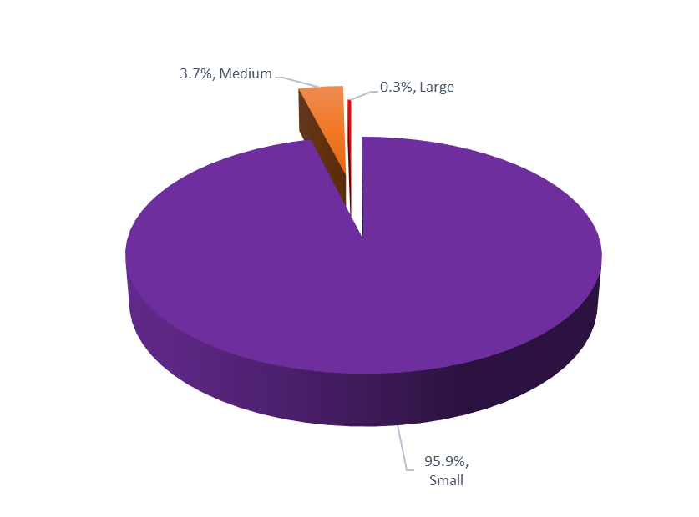

*Source: ABS Cat. No. 8165.0*

Of the small businesses in the NT, 63.2% were non-employing businesses, 23.3% had 1-4 employees and 13.5% had between 5-19 employees

In June 2020, the ‘Construction” industry had the highest number of businesses operating in the NT with 18.8% of total businesses (Chart 29).

This was followed by ‘Rental, hiring and real estate services’ (12.6%); ‘Professional, scientific and technical services’ (9.6%); ‘Transport, postal and warehousing’ (8.8%); ‘Retail trade’ (6.2%) and ‘Finance and insurance services’ (6.1%).

The majority of businesses in the NT are in the ‘services sector’ (all industries except ‘Agriculture, forestry and fishing’; ‘Mining’; ‘Manufacturing’; ‘Electricity, water, gas and waste services’; and ‘Construction’). In June 2020, the ‘services sector’ had 71.5% of all NT businesses.

At the national level, ‘Construction’ industry had the highest number of businesses (16.4%) followed by ‘Professional, scientific and technical services’ (12.5%), ‘Rental, hiring and real estate services’ (10.9%), and ‘Financial & insurance services (9.0%).

The majority of the businesses in the Territory are located in the Greater Darwin region (Darwin City, Darwin Suburbs, Litchfield and Palmerston) (Chart 30).

In June 2020, 74.1% of all businesses in the NT were located in the Greater Darwin region. The Alice Springs region had the second highest number of businesses (14.0%), the Katherine region had 6.4%, Daly-Tiwi-West Arnhem had 2.4%, East Arnhem had 1.7%, and the Barkly region had 1.3%. Business locations of about 1.0% of the businesses were ‘currently unknown’.

**Chart 29: NT Business by Industry, June 2020**

In 2019-20, proportion of businesses by industry to total businesses in the Northern Territory is as follows:
Construction is 18.8 per cent
Rental, hiring and real estate services is 12.6 per cent
Professional, scientific and technical services is 9.6 per cent
Transport, postal and warehousing is 8.8 per cent
Retail trade is 6.2 per cent
Financial and insurance services is 6.1 per cent
Agriculture, forestry and fishing is 6 per cent
Other services is 5.9 per cent
Health care and social assistance is 5.7 per cent
Accommodation and food services is 5.1 per cent
Administrative and support services is 5 per cent
Manufacturing is 3.1 per cent
Wholesale trade is 2.1 per cent
Education and training is 1.3 per cent
Arts and recreation services is 1.4 per cent
Education and Training is 1.2 per cent
Information, media and telecommunications is 0.7 per cent
Mining is 0.6 per cent
Public administration and safety is 0.4 per cent 
Electricity, gas, water, and waste services is 0.3 per cent


*Source: ABS Cat. No. 8165.0*

**Chart 30: Business Location, June 2020**

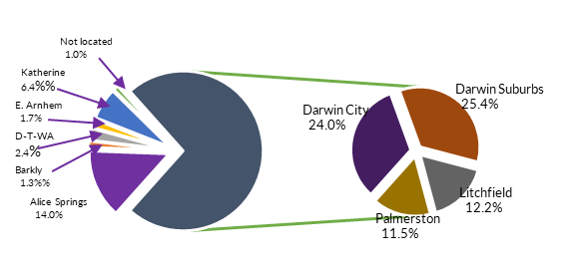

*Source: ABS Cat. No. 8165.0*

At June 2020, the NT had 25.2% of businesses operating in the ‘zero to <$50k’ turnover range. About 12.8% of the businesses were operating in the ‘$50k to <$100k’ range, 17.6% in the ‘$100k to <$200k’ range, 18.5% were in the ‘$200k to <$500k’ range, 17.0% in the ‘$500k to <$2m’ range, 5.4% in the ‘$2m to <$5m range, 1.8% in the $5m to <$10m range, and 1.7% in the $10m+ range.

# Key industry sectors

The structure of the NT economy is different to the national economy with greater contributions to production in the NT from Construction, Mining, Public administration and safety, Education and training, and Health care and social assistance industries (Chart 31).

These five sectors together make up 58.0% of the total of industry sector contributions to the NT’s GSP in 2019-20 with the combined value of their contribution to the NT economy being about $15.2 billion.

| **Industry** **sector** | **Value Added 2019-20** | **Proportion of NT GSP** |
| --- | --- | --- |
| Mining | $7.5 billion | 28.8% |
| Public administration and safety | $3.1 billion | 11.7% |
| Heath care & social assistance | $1.9 billion | 7.5% |
| Construction | $1.5 billion | 5.6% |
| Education and training | $1.2 billion | 4.5% |

**Chart 31: Sector Contribution to Output, NT and Australia 2019-20**

In 2019-20, gross state product contribution by industry is as follows:
Construction is 5.6 per cent in the Northern Territory and 7.0 per cent nationally
Mining is 28.8 per cent in the Northern Territory and 10.4 per cent nationally
Public administration and safety is 11.7 per cent in the Northern Territory and 8.6 per cent nationally
Health care and social assistance is 7.5 per cent in the Northern Territory and 7.4 per cent nationally
Transport, postal and warehousing is 2.9 per cent in the Northern Territory and 4.8 per cent nationally
Rental, hiring and real estate services is 1.4 per cent in the Northern Territory and 2.0 per cent nationally
Education and training is 4.5 per cent in the Northern Territory and 7.0 per cent nationally
Professional, scientific and technical services is 3.7 per cent in the Northern Territory and 5.5 per cent nationally
Manufacturing is 3.8 per cent in the Northern Territory and 5.6 per cent nationally
Retail trade is 2.6 per cent in the Northern Territory and 4.3 per cent nationally
Administrative and support services is 1.7 per cent in the Northern Territory and 2.4 per cent nationally
Financial and insurance services is 2.4 per cent in the Northern Territory and 3.6 per cent nationally
Electricity, gas, water, and waste services is 1.8 per cent in the Northern Territory and 2.8 per cent nationally
Agriculture, forestry and fishing is 2.5 per cent in the Northern Territory and 4.0 per cent nationally
Accommodation and food services is 2.2 per cent in the Northern Territory and 3.6 per cent nationally
Wholesale trade is 1.6 per cent in the Northern Territory and 2.0 per cent nationally
Other services is 1.6 per cent in the Northern Territory and 2.2 per cent nationally
Arts and recreation services is 1.1 per cent in the Northern Territory and 1.7 per cent nationally
Information, media and telecommunications is 0.4 per cent in the Northern Territory and 0.8 per cent nationally


*Source: ABS; Cat. No. 5220.0*

# Mining and energy sector

The Mining and energy sector increased by 39.7% to $7.5 billion (gross value-added) in 2019-20, and comprised 28.8% of NT GVA (Chart 32).

The main minerals produced and processed in the NT are bauxite, gold, manganese and zinc/lead concentrate. Key energy commodities are oil, natural gas, and LNG.

Although the sector is the largest contributor to NT GSP it employs around 2.3% of the resident employment, as it is capital intensive and a portion of its FIFO workers are residents of other jurisdictions.

The value of Mining and energy increased strongly in 2019-20 as LNG production commenced at INPEX’s LNG plant.

# Construction sector

In 2019-20, the Construction sector contributed $1.4 billion to NT GSP (Chart 33), with an industry share of total output of 5.6%. The construction industry accounts for 7.9% of the NT’s resident employment.

The value of the Construction sector is now below historical levels largely due to the completion of major construction projects such as INPEX LNG gas project.

In the year to March 2021, construction work done increased by 16.1% to $2.2 billion. Engineering work done increased by 20.4% to $1.4 billion, residential construction increased by 9.7% to $346 million and non‑residential construction increased by 9.6% to $480 million (Chart 34).

**Chart 32: Mining, GVA, Inflation Adjusted**

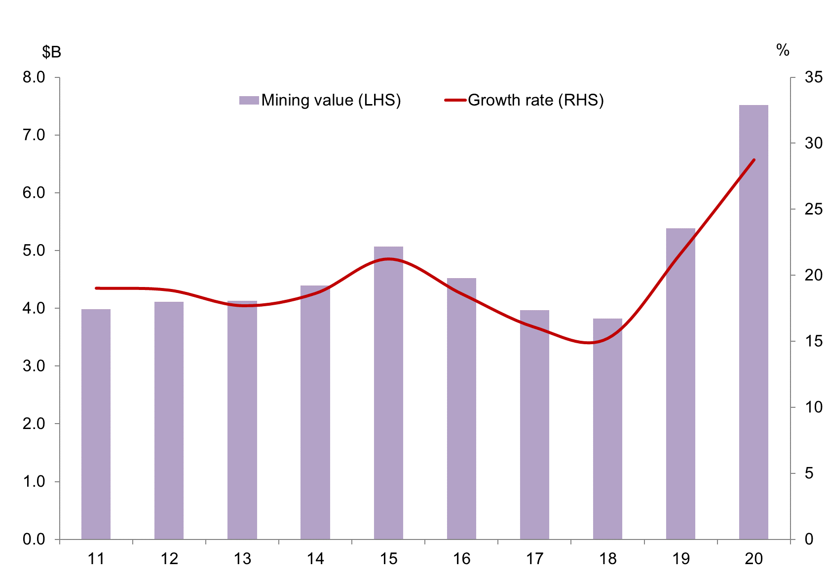

*Source: ABS Cat. No. 5220.0*

**Chart 33: Construction, GVA, Inflation Adjusted**

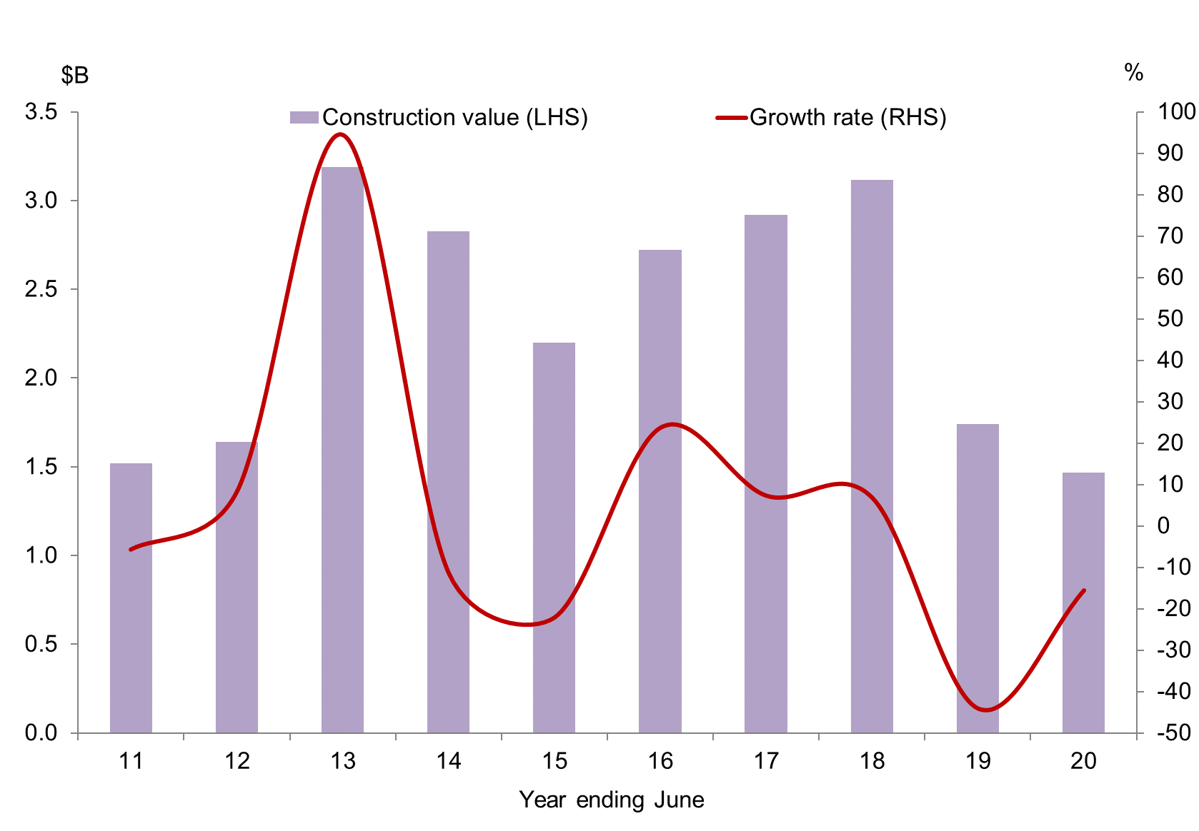

*Source: ABS Cat. No. 5220.0*

**Chart 34: NT Construction Activity**

Construction activity in the Northern Territory has moderated from record high levels, driven by a slowdown in engineering activity. Residential and non residential activity has moderated slightly over the past two years, but is significantly more stable than engineering construction.

*Source: ABS Cat. No. 8755.0*Manufacturing sector

In 2019-20, the Manufacturing sector was valued at $982 million (Chart 35) and accounted for 3.8% of the NT’s GSP.

Manufacturing in the NT consists mainly of small scale production of various products for export and domestic consumption.

This sector employs around 3600 people, 2.6% of the NT’s total resident employment in the year to May 2021.

# Retail sector

The Retail trade sector value (gross value added) decreased by 0.9% in 2019-20 to $690 million (Chart 36). The sector contributes around 2.6% to NT GSP and 8.6% to total NT resident employment in the year to May 2021.

Nationally, retail turnover in 2019-20 contributed about 4.1% of the national GDP and the sector fell by 0.5% in the same period.

The retail turnover (sales) in the NT in the year to May 2021 was $3.6 billion, a year on year increase of 11.9%.

Food retailing is the largest single component contributing 3.4 percentage points to total NT growth in the year, followed by Other retailing (12.8 percentage points), and Clothing, footwear and personal accessory (1.2 percentage points).

The growth in NT retail turnover is expected to be subdued in the short term, largely reflecting softening population growth in the NT.

The Wholesale trade sector contributed $422 million or about 1.6% of the NT GSP.

**Chart 35: Manufacturing, GVA, Inflation Adjusted**

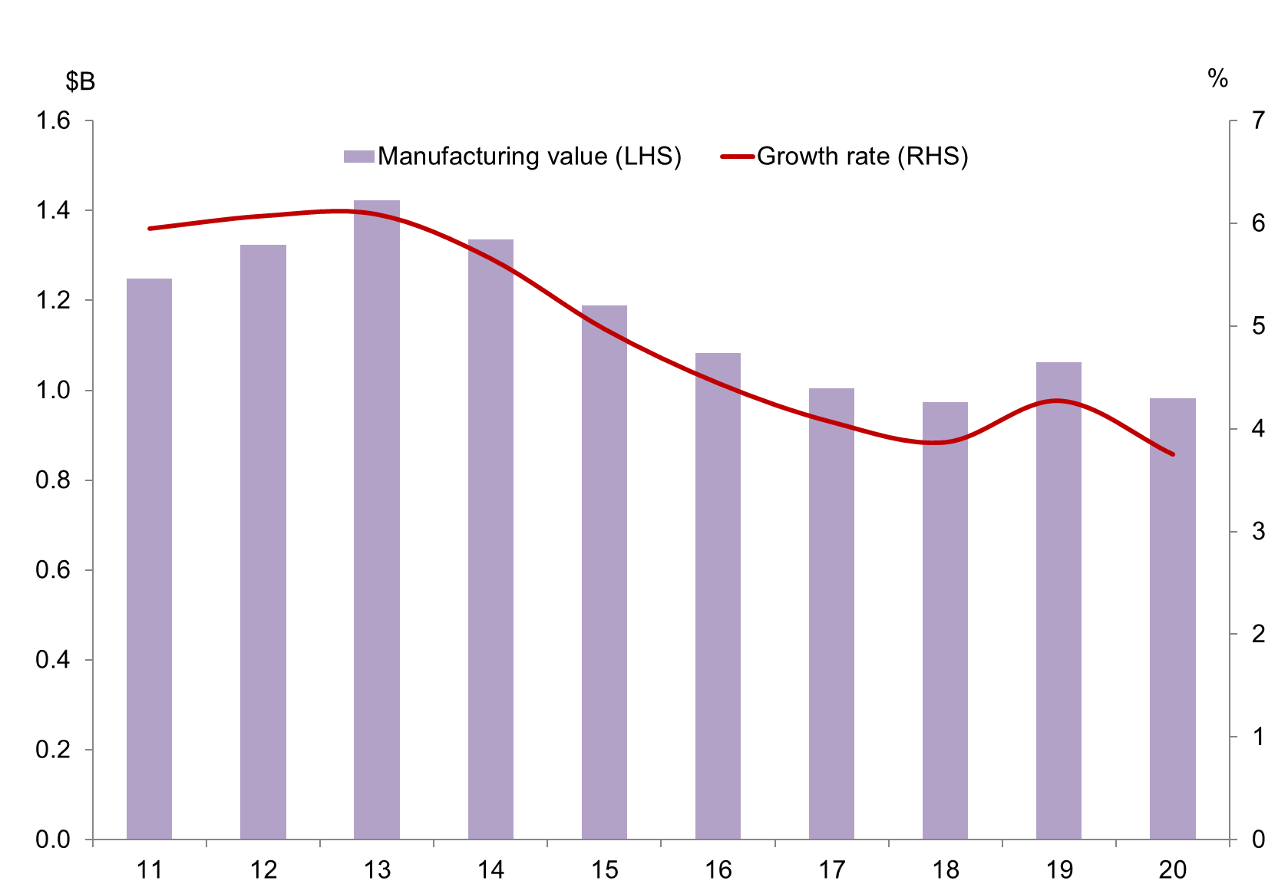

*Source: ABS Cat. No. 5220.0*

**Chart 36: Retail trade, GVA, inflation adjusted**

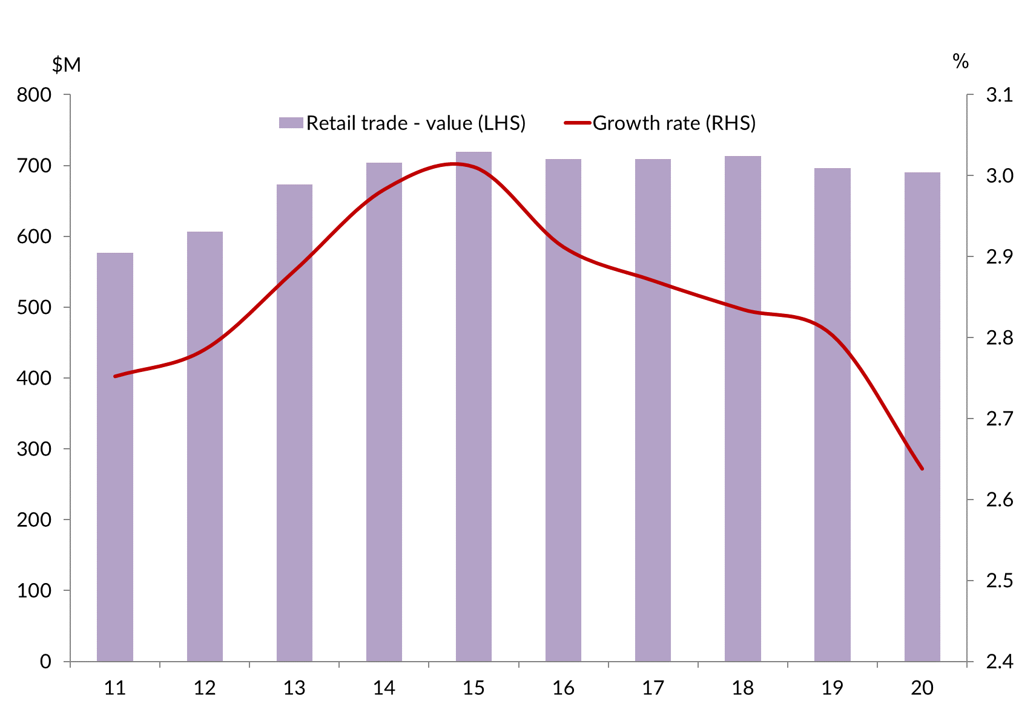

*Source: ABS Cat. No. 5220.0*

# Agriculture, forestry and fishing

Key agricultural commodities include livestock, horticulture produce and fisheries.

The key livestock commodities of the NT include cattle, buffaloes and crocodiles. In the horticultural sector, the main commodities include fruit (mangos, melons, and bananas), Asian vegetables, and plant nursery products. The fishing sector includes commercial, recreational and traditional indigenous fishing. The commercial fishing sector includes wild catch fish (such as barramundi, snapper, and shark), crustaceans (mainly prawns and mud crabs) and aquaculture (pearls). Forestry includes sandalwood and African Mahogany production.

Agriculture, fishing and forestry contributed $649 million (inflation adjusted) (Chart 37), about 2.5% to the value of NT GSP in 2019-20.

Cattle production is the largest component of agriculture, forestry and fishing. The key markets for NT cattle are interstate markets (for further growing or slaughter) and live exports overseas (mainly Indonesia). In the short term, the value of this industry is expected to increase, driven by growth in the value of live cattle exports under the free trade agreement signed in March 2019 between Australia and Indonesia. This will be partly offset by competition from Indian buffalo meat and disruptions in the cattle supply chain from severe Queensland floods.

Horticultural production is expected to improve with favourable outlooks for barramundi and prawn production, and recovering production of bananas and

**Chart 37: Agriculture, Forestry and Fishing: NT GVA, Inflation Adjusted**

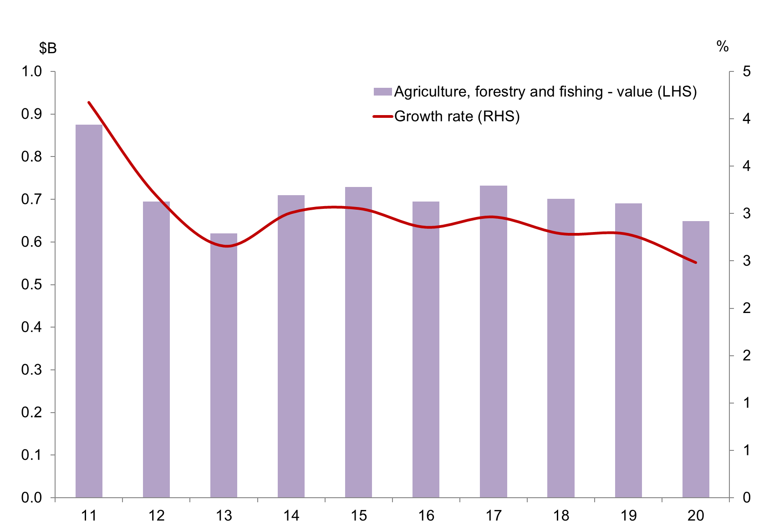

*Source: ABS Cat. No. 5220.0*

melons. The horticultural products are mainly destined for interstate markets.

Fisheries production in the NT has strong potential in the coming years with the expansion of aquaculture production, e.g. Seafarms’ $1.45 billion Sea Dragon Project.

# Tourism

The Tourism sector is distributed across a number of Australian and New Zealand Standard Industrial Classification (ANZSIC) industry sectors. The largest industry sectors that directly contribute to tourism gross value added (GVA) in the NT include Accommodation and food services; Transport, postal and warehousing, and Recreation and culture.

In the year to March 2021, visitor expenditure in the NT was $873 million and accounted for 3.3% of NT gross value added (Tourism NT) (Chart 38).

Over the same period, 899 000 people visited the NT, down 54% on the previous year’s visitor numbers, largely due to COVID impacting the number of domestic and international visitors.

Tourism employs around 9.5% of the NT employment.

**Chart 38: Share of Tourism in Gross Value Added, 2019-20**

In 2019-20, tourism share of gross value added in the Northern Territory is second highest in the nation behind Tasmania. Western Australia had the lowest share of gross value added and gross state product in 2019-20

*Source: Tourism Research Australia, 2019-20*

# Goods-producing and service-producing sectors

In categorising goods and services, dwelling growth is excluded.

The GVA of goods-producing sectors (Agriculture, forestry and fishing, Mining, Manufacturing, Electricity, gas and water, Construction) was $11.1 billion in 2019‑20, about 48.3% of all industries.

Service producing sectors’ output (“things you cannot drop on your foot”) was valued at $11.9 billion, contributing 47.5% of all industries NT GVA (ownership of dwellings is excluded from the service-producing sectors).

Business services (those industries that provide non-distribution services to other companies) have grown strongly since 2012 and contributed $2.5 billion (9.7%) of NT GSP in 2019-20. Since 2012, business services have grown, on average, by 1.6%. There are however, variations in growth in individual business service sectors (Chart 39).

‘Professional, scientific and technical services’ has shown the strongest growth between 2011-12 and 2019-20, up 40.3% over the period. ‘Information, media and telecommunications’ showed the next strongest growth over the period, up by 29.5%. ‘Administrative and support services’ showed the weakest growth over the period, up by 9.7%.

**Chart 39: Business Services Output**

Business service industries have grown strongly over the past six years, particularly professional, scientific and technical services; and information, media and telecommunications. In 2011 and 2012, most of these business service industries declined before recovering and increasing strongly in the subsequent years.

*Source: ABS Cat. No. 5220.0*

# Regional labour markets, population and income

| **Region1** | **Labour force March Qtr 2020** | **Unemployment March Qtr 2020** | **Unemployment rate (%) March Qtr 2020** | **Population 2019-20** | **Median weekly household income 2016 ($)1** |
| --- | --- | --- | --- | --- | --- |
| Greater Darwin | 83 256 | 5064 | 6.7 | 147 231 | 2183 |
| Darwin city | 18 470 | 851 | 4.8 | 27 542 | 2320 |
| Darwin suburbs | 31 888 | 2030 | 7.1 | 55 508 | 2075 |
| Litchfield | 14 609 | 651 | 4.8 | 25 164 | 2219 |
| Palmerston | 18 289 | 1532 | 10.1 | 39 017 | 2199 |
| Alice Springs | 17 326 | 742 | 4.3 | 39 391 | 1715 |
| Barkly | 2876 | 189 | 6.6 | 6 142 | 1366 |
| Daly-Tiwi-West Arnhem | 7390 | 615 | 9.4 | 17 909 | 1134 |
| East Arnhem | 6079 | 418 | 6.7 | 14 565 | 1944 |
| Katherine | 10 562 | 556 | 7.3 | 20 905 | 1485 |

*Source: ABS Cat. No. 3218.0, Commonwealth Department of Employment (Small Area Labour Market* *March Quarter 2021), and Census 2016 on Population and Housing*

1. Statistical Area Level 3 (SA3)

# Enquiries

Economic Analysis and Advice, Department of Industry, Tourism and Trade

Email: Economicinnovation.ITT@nt.gov.au

# Disclaimer

The Northern Territory of Australia gives no warranty of assurance, and makes no representation as to the accuracy of any information or advice contained in this publication, or that it is suitable for your intended use. You should not rely upon information in this publication for the purpose of making any serious business or investment decisions without obtaining independent, professional advice in relation to your particular situation.