Mineral Titles Act
NOTICE OF GRANT OF A MINERAL TITLE
Title Type and Number: | Exploration Licence 32450
Granted: | 21 May 2021, for a period of 6 Years
Area: | 249 Blocks, 816.12 km²
Locality: | KILGOUR
Name of Holder/s: | 100% MINERALS PTY LTD [ACN. 641 565 139]
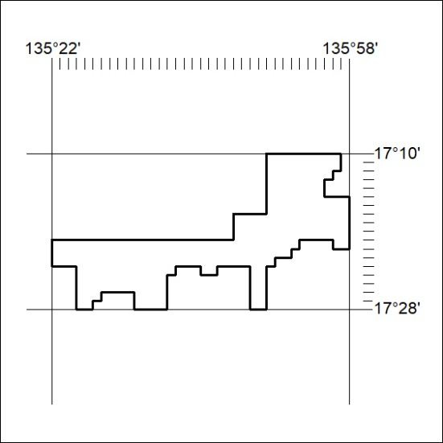
Area granted is indicated above. The titleholder is not permitted to exercise occupational rights on any land that is subject to a development title, or an application for a development title. Any land the subject of a Reserved Land gazettal under the Mineral Titles Act and all land vested in the Commonwealth of Australia is also excluded by description but not excised from the grant area.
171/21

Mineral Titles Act
NOTICE OF GRANT OF A MINERAL TITLE
Title Type and Number: | Exploration Licence 32451
Granted: | 21 May 2021, for a period of 6 Years
Area: | 249 Blocks, 816.26 km²
Locality: | LANCEWOOD
Name of Holder/s: | 100% MINERALS PTY LTD [ACN. 641 565 139]
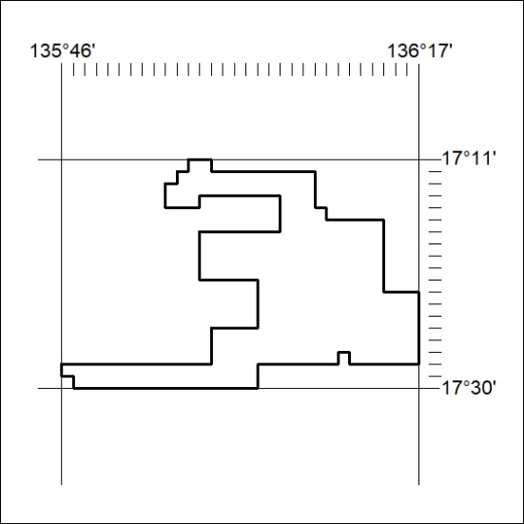
Area granted is indicated above. The titleholder is not permitted to exercise occupational rights on any land that is subject to a development title, or an application for a development title. Any land the subject of a Reserved Land gazettal under the Mineral Titles Act and all land vested in the Commonwealth of Australia is also excluded by description but not excised from the grant area.
172/21

Mineral Titles Act
NOTICE OF GRANT OF A MINERAL TITLE
Title Type and Number: | Exploration Licence 32452
Granted: | 21 May 2021, for a period of 6 Years
Area: | 249 Blocks, 816.22 km²
Locality: | LANCEWOOD
Name of Holder/s: | 100% MINERALS PTY LTD [ACN. 641 565 139]
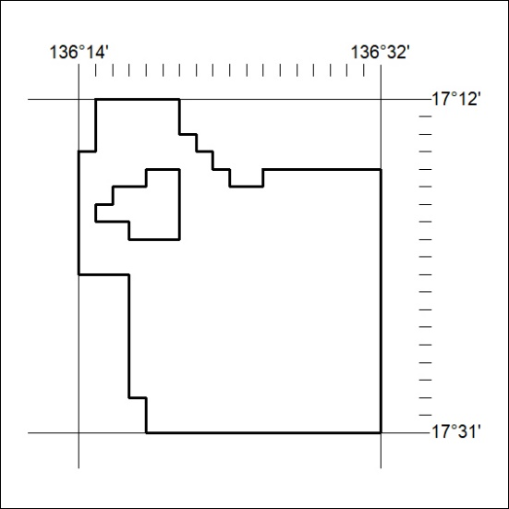
Area granted is indicated above. The titleholder is not permitted to exercise occupational rights on any land that is subject to a development title, or an application for a development title. Any land the subject of a Reserved Land gazettal under the Mineral Titles Act and all land vested in the Commonwealth of Australia is also excluded by description but not excised from the grant area.
173/21

Mineral Titles Act
NOTICE OF GRANT OF A MINERAL TITLE
Title Type and Number: | Exploration Licence 32453
Granted: | 21 May 2021, for a period of 6 Years
Area: | 249 Blocks, 816.19 km²
Locality: | SURPRISE CREEK
Name of Holder/s: | 100% MINERALS PTY LTD [ACN. 641 565 139]
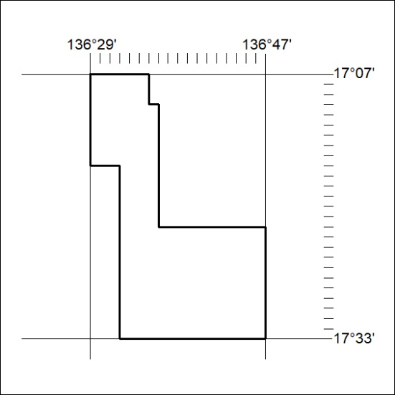
Area granted is indicated above. The titleholder is not permitted to exercise occupational rights on any land that is subject to a development title, or an application for a development title. Any land the subject of a Reserved Land gazettal under the Mineral Titles Act and all land vested in the Commonwealth of Australia is also excluded by description but not excised from the grant area.
174/21

Mineral Titles Act
NOTICE OF GRANT OF A MINERAL TITLE
Title Type and Number: | Exploration Licence 32454
Granted: | 21 May 2021, for a period of 6 Years
Area: | 249 Blocks, 816.30 km²
Locality: | SURPRISE CREEK
Name of Holder/s: | 100% MINERALS PTY LTD [ACN. 641 565 139]
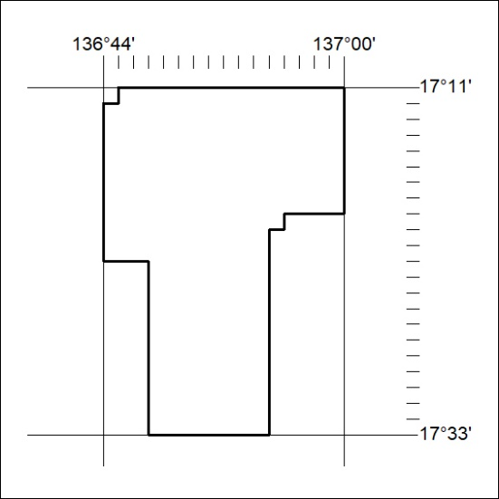
Area granted is indicated above. The titleholder is not permitted to exercise occupational rights on any land that is subject to a development title, or an application for a development title. Any land the subject of a Reserved Land gazettal under the Mineral Titles Act and all land vested in the Commonwealth of Australia is also excluded by description but not excised from the grant area.
175/21

Mineral Titles Act
NOTICE OF GRANT OF A MINERAL TITLE
Title Type and Number: | Exploration Licence 32455
Granted: | 21 May 2021, for a period of 6 Years
Area: | 249 Blocks, 814.89 km²
Locality: | PUZZLE
Name of Holder/s: | 100% MINERALS PTY LTD [ACN. 641 565 139]
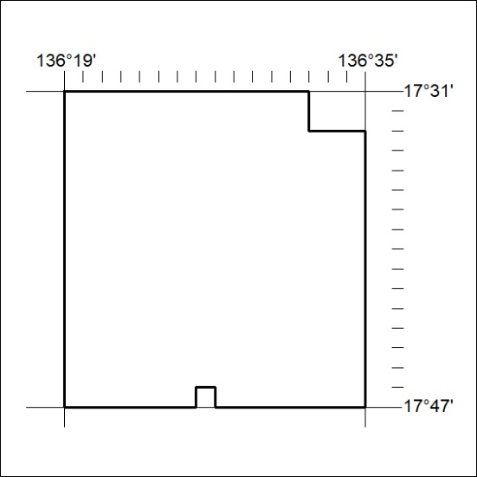
Area granted is indicated above. The titleholder is not permitted to exercise occupational rights on any land that is subject to a development title, or an application for a development title. Any land the subject of a Reserved Land gazettal under the Mineral Titles Act and all land vested in the Commonwealth of Australia is also excluded by description but not excised from the grant area.
176/21

Mineral Titles Act
NOTICE OF GRANT OF A MINERAL TITLE
Title Type and Number: | Exploration Licence 32456
Granted: | 21 May 2021, for a period of 6 Years
Area: | 249 Blocks, 814.71 km²
Locality: | COANJULA
Name of Holder/s: | 100% MINERALS PTY LTD [ACN. 641 565 139]
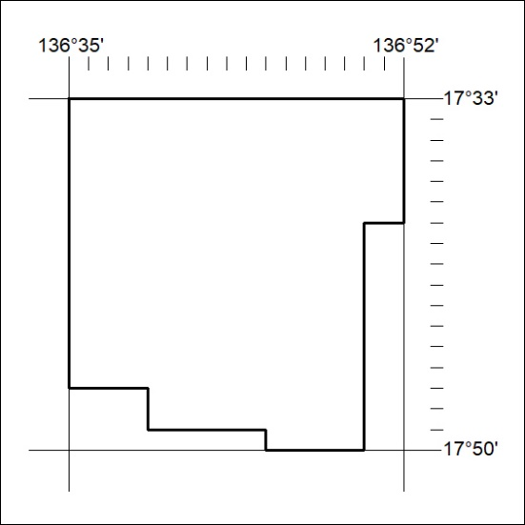
Area granted is indicated above. The titleholder is not permitted to exercise occupational rights on any land that is subject to a development title, or an application for a development title. Any land the subject of a Reserved Land gazettal under the Mineral Titles Act and all land vested in the Commonwealth of Australia is also excluded by description but not excised from the grant area.
177/21

Mineral Titles Act
NOTICE OF GRANT OF A MINERAL TITLE
Title Type and Number: | Exploration Licence 32472
Granted: | 21 May 2021, for a period of 6 Years
Area: | 249 Blocks, 802.94 km²
Locality: | BLOODWOOD CREEK
Name of Holder/s: | 100% MINERALS PTY LTD [ACN. 641 565 139]
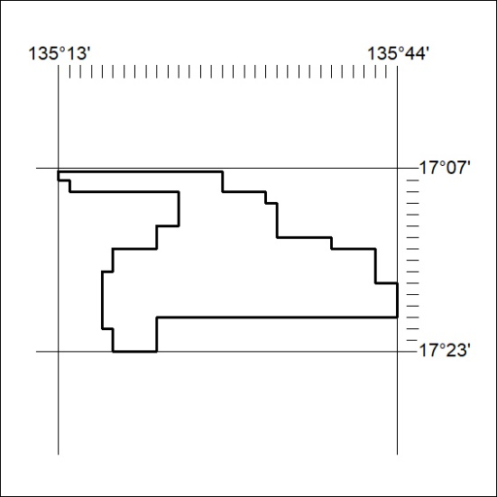
Area granted is indicated above. The titleholder is not permitted to exercise occupational rights on any land that is subject to a development title, or an application for a development title. Any land the subject of a Reserved Land gazettal under the Mineral Titles Act and all land vested in the Commonwealth of Australia is also excluded by description but not excised from the grant area.
178/21

Mineral Titles Act
NOTICE OF GRANT OF A MINERAL TITLE
Title Type and Number: | Exploration Licence 32473
Granted: | 21 May 2021, for a period of 6 Years
Area: | 249 Blocks, 815.68 km²
Locality: | CALVERT HILLS
Name of Holder/s: | 100% MINERALS PTY LTD [ACN. 641 565 139]
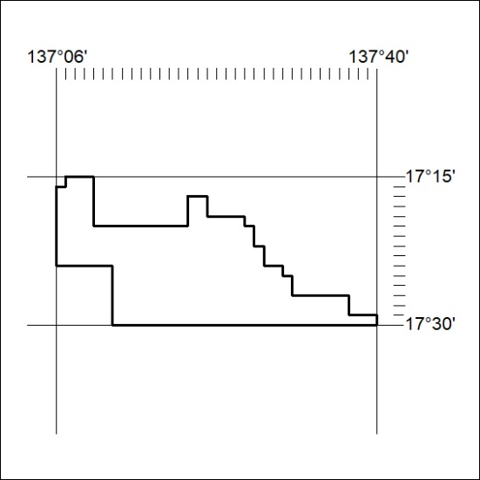
Area granted is indicated above. The titleholder is not permitted to exercise occupational rights on any land that is subject to a development title, or an application for a development title. Any land the subject of a Reserved Land gazettal under the Mineral Titles Act and all land vested in the Commonwealth of Australia is also excluded by description but not excised from the grant area.
179/21

Mineral Titles Act
NOTICE OF GRANT OF A MINERAL TITLE
Title Type and Number: | Exploration Licence 32474
Granted: | 21 May 2021, for a period of 6 Years
Area: | 249 Blocks, 795.01 km²
Locality: | CALVERT HILLS
Name of Holder/s: | 100% MINERALS PTY LTD [ACN. 641 565 139]
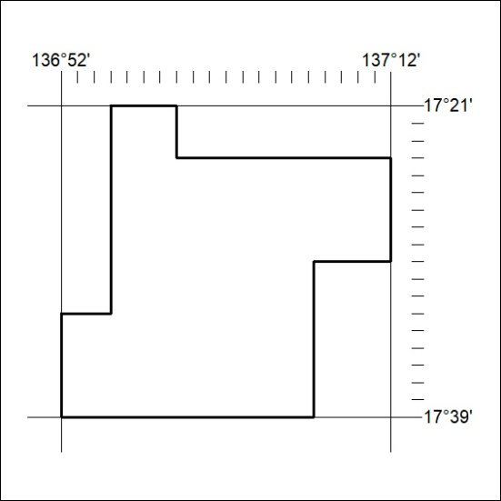
Area granted is indicated above. The titleholder is not permitted to exercise occupational rights on any land that is subject to a development title, or an application for a development title. Any land the subject of a Reserved Land gazettal under the Mineral Titles Act and all land vested in the Commonwealth of Australia is also excluded by description but not excised from the grant area.
180/21

