Mineral Titles Act 2010
NOTICE OF LAND CEASING TO BE A MINERAL TITLE APPLICATION AREA
Title Type and Number: | Exploration Licence 32245
Area Ceased on: | 28 April 2021
Area: | 36 Blocks, 113.89 km²
Locality: | SHORT RANGE
Name of Applicant(s)/Holder(s): | 100% RIO TINTO EXPLORATION PTY LIMITED [ACN. 000 057 125]
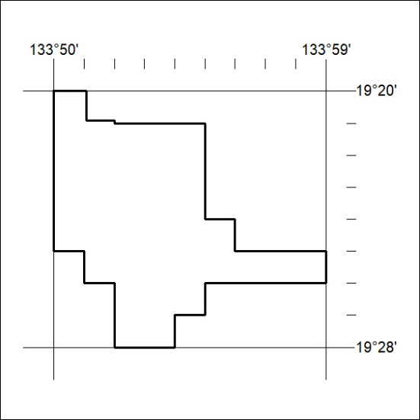
120/21

Mineral Titles Act
NOTICE OF GRANT OF A MINERAL TITLE
Title Type and Number: | Exploration Licence 32230
Granted: | 30 April 2021, for a period of 6 Years
Area: | 111 Blocks, 351.77 km²
Locality: | KELLY
Name of Holder/s: | 100% RIO TINTO EXPLORATION PTY LIMITED [ACN. 000 057 125]
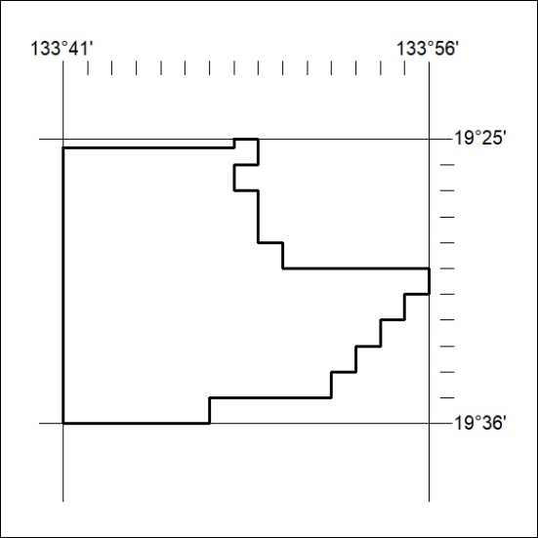
Area granted is indicated above. The titleholder is not permitted to exercise occupational rights on any land that is subject to a development title, or an application for a development title. Any land the subject of a Reserved Land gazettal under the Mineral Titles Act and all land vested in the Commonwealth of Australia is also excluded by description but not excised from the grant area.
121/21

Mineral Titles Act
NOTICE OF GRANT OF A MINERAL TITLE
Title Type and Number: | Exploration Licence 32231
Granted: | 30 April 2021, for a period of 6 Years
Area: | 58 Blocks, 184.85 km²
Locality: | KELLY
Name of Holder/s: | 100% RIO TINTO EXPLORATION PTY LIMITED [ACN. 000 057 125]
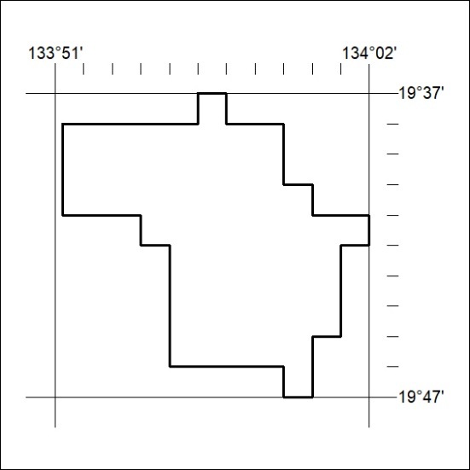
Area granted is indicated above. The titleholder is not permitted to exercise occupational rights on any land that is subject to a development title, or an application for a development title. Any land the subject of a Reserved Land gazettal under the Mineral Titles Act and all land vested in the Commonwealth of Australia is also excluded by description but not excised from the grant area.
122/21

Mineral Titles Act
NOTICE OF GRANT OF A MINERAL TITLE
Title Type and Number: | Exploration Licence 32232
Granted: | 30 April 2021, for a period of 6 Years
Area: | 11 Blocks, 35.59 km²
Locality: | KELLY
Name of Holder/s: | 100% RIO TINTO EXPLORATION PTY LIMITED [ACN. 000 057 125]
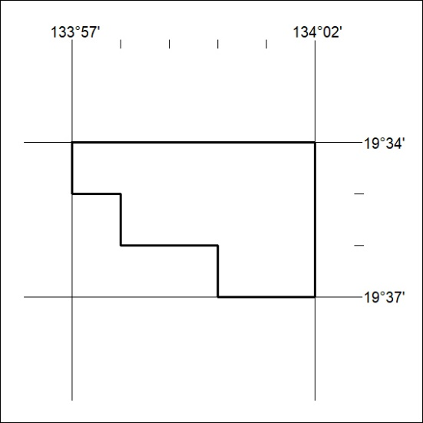
Area granted is indicated above. The titleholder is not permitted to exercise occupational rights on any land that is subject to a development title, or an application for a development title. Any land the subject of a Reserved Land gazettal under the Mineral Titles Act and all land vested in the Commonwealth of Australia is also excluded by description but not excised from the grant area.
123/21

Mineral Titles Act
NOTICE OF GRANT OF A MINERAL TITLE
Title Type and Number: | Exploration Licence 32233
Granted: | 30 April 2021, for a period of 6 Years
Area: | 6 Blocks, 19.43 km²
Locality: | FLYNN
Name of Holder/s: | 100% RIO TINTO EXPLORATION PTY LIMITED [ACN. 000 057 125]
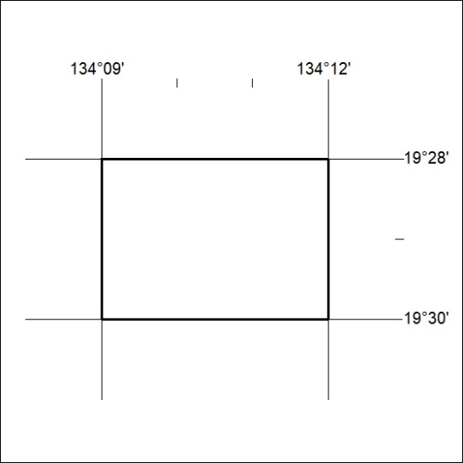
Area granted is indicated above. The titleholder is not permitted to exercise occupational rights on any land that is subject to a development title, or an application for a development title. Any land the subject of a Reserved Land gazettal under the Mineral Titles Act and all land vested in the Commonwealth of Australia is also excluded by description but not excised from the grant area.
124/21

Mineral Titles Act
NOTICE OF GRANT OF A MINERAL TITLE
Title Type and Number: | Exploration Licence 32234
Granted: | 30 April 2021, for a period of 6 Years
Area: | 5 Blocks, 16.20 km²
Locality: | FLYNN
Name of Holder/s: | 100% RIO TINTO EXPLORATION PTY LIMITED [ACN. 000 057 125]
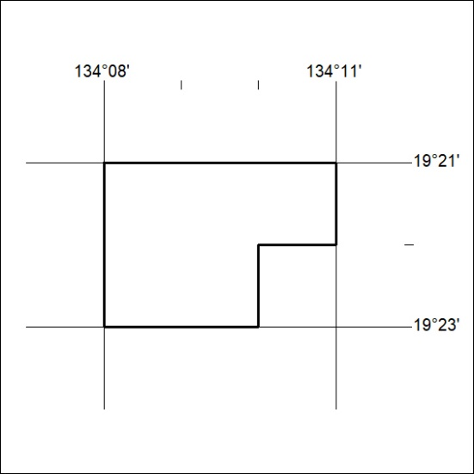
Area granted is indicated above. The titleholder is not permitted to exercise occupational rights on any land that is subject to a development title, or an application for a development title. Any land the subject of a Reserved Land gazettal under the Mineral Titles Act and all land vested in the Commonwealth of Australia is also excluded by description but not excised from the grant area.
125/21

Mineral Titles Act
NOTICE OF GRANT OF A MINERAL TITLE
Title Type and Number: | Exploration Licence 32246
Granted: | 30 April 2021, for a period of 6 Years
Area: | 67 Blocks, 217.12 km²
Locality: | FLYNN
Name of Holder/s: | 100% RIO TINTO EXPLORATION PTY LIMITED [ACN. 000 057 125]
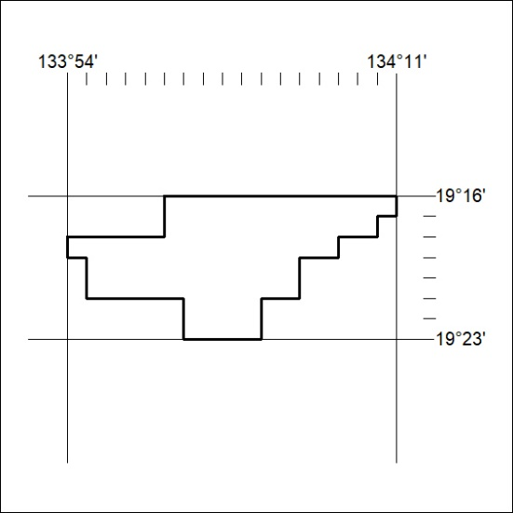
Area granted is indicated above. The titleholder is not permitted to exercise occupational rights on any land that is subject to a development title, or an application for a development title. Any land the subject of a Reserved Land gazettal under the Mineral Titles Act and all land vested in the Commonwealth of Australia is also excluded by description but not excised from the grant area.
126/21

Mineral Titles Act
NOTICE OF GRANT OF A MINERAL TITLE
Title Type and Number: | Exploration Licence 32447
Granted: | 04 May 2021, for a period of 6 Years
Area: | 25 Blocks, 79.08 km²
Locality: | DNEIPER
Name of Holder/s: | 50% WALLACE Brian Richard, 50% WALLACE Raymond Cedric
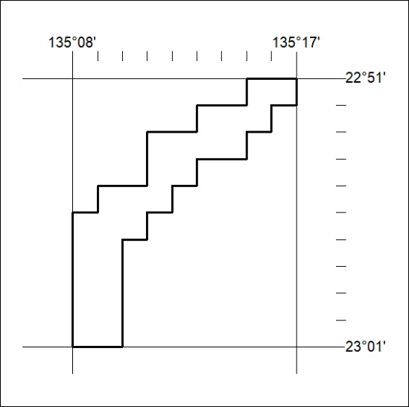
Area granted is indicated above. The titleholder is not permitted to exercise occupational rights on any land that is subject to a development title, or an application for a development title. Any land the subject of a Reserved Land gazettal under the Mineral Titles Act and all land vested in the Commonwealth of Australia is also excluded by description but not excised from the grant area.
127/21

