Mineral Titles Act 2010
NOTICE OF LAND CEASING TO BE A MINERAL TITLE AREA
Title Type and Number: | Extractive Mineral Permit 29250
Area ceased on: | 05 July 2019
Area: | 51.00 Hectare
Locality: | ADAM
Name of Applicants(s)Holder(s): | 100% BIRCH Alan James
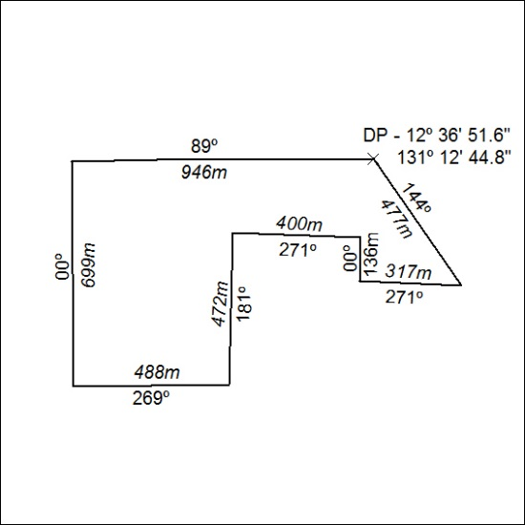

284/19

Mineral Titles Act 2010
NOTICE OF LAND CEASING TO BE A MINERAL TITLE APPLICATION AREA
Title Type and Number: | Exploration Licence 31785
Area Ceased on: | 04 July 2019
Area: | 141 Blocks, 394.59 km²
Locality: | LIMBLA
Name of Applicant(s)/Holder(s): | 100% GEMPART (NT) PTY LTD* [ACN. 081 859 896]
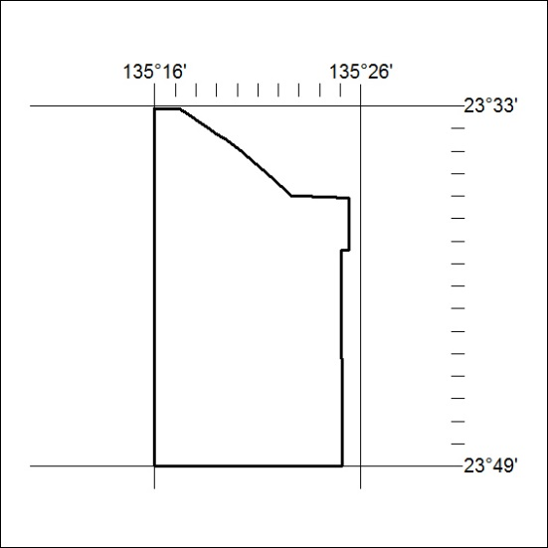

285/19

