Mineral Titles Act
NOTICE OF LAND CEASING TO BE A MINERAL TITLE AREA
Title Type and Number: | Exploration Licence 28967
Area Ceased on: | 03 July 2018
Area: | 14 Blocks, 44.29 km²
Locality: | NAPPERBY
Name of Applicant(s)/Holder(s): | 100% AUSTRALIA MINING & GEMSTONE CO. PTY LTD [ACN. 114 395 247]
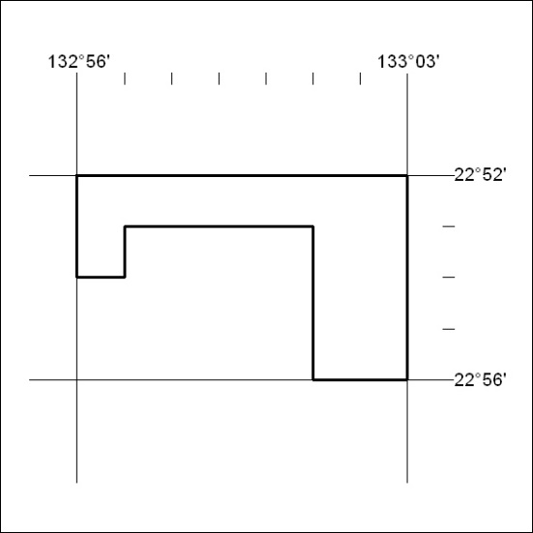

282/18

Mineral Titles Act
NOTICE OF GRANT OF A MINERAL TITLE
Title Type and Number: | Exploration Licence 31687
Granted: | 02 July 2018, for a period of 6 Years
Area: | 46 Blocks, 148.88 km²
Locality: | BATTEN
Name of Holder/s: | 100% MMG EXPLORATION PTY LTD* [ACN. 119 136 659]
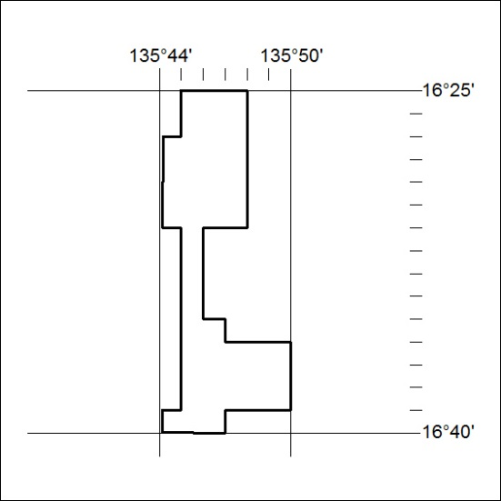
Area granted is indicated above. The titleholder is not permitted to exercise occupational rights on any land that is subject to a development title, or an application for a development title. Any land the subject of a Reserved Land gazettal under the Mineral Titles Act and all land vested in the Commonwealth of Australia is also excluded by description but not excised from the grant area.

283/18

Mineral Titles Act
NOTICE OF GRANT OF A MINERAL TITLE
Title Type and Number: | Exploration Licence 31688
Granted: | 02 July 2018, for a period of 6 Years
Area: | 134 Blocks, 440.68 km²
Locality: | GLYDE
Name of Holder/s: | 100% MMG EXPLORATION PTY LTD* [ACN. 119 136 659]
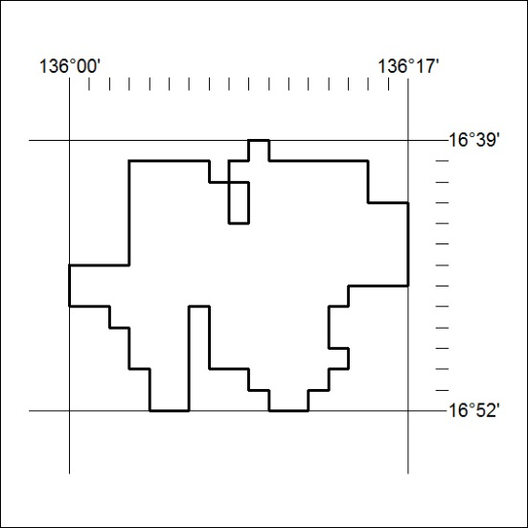
Area granted is indicated above. The titleholder is not permitted to exercise occupational rights on any land that is subject to a development title, or an application for a development title. Any land the subject of a Reserved Land gazettal under the Mineral Titles Act and all land vested in the Commonwealth of Australia is also excluded by description but not excised from the grant area.

284/18

Mineral Titles Act
NOTICE OF GRANT OF A MINERAL TITLE
Title Type and Number: | Exploration Licence 31689
Granted: | 02 July 2018, for a period of 6 Years
Area: | 170 Blocks, 559.66 km²
Locality: | GLYDE
Name of Holder/s: | 100% MMG EXPLORATION PTY LTD* [ACN. 119 136 659]
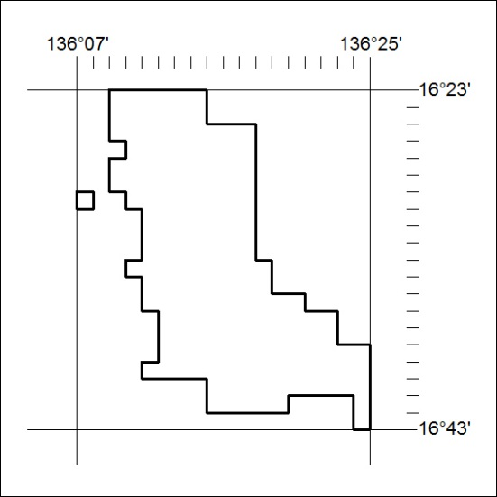
Area granted is indicated above. The titleholder is not permitted to exercise occupational rights on any land that is subject to a development title, or an application for a development title. Any land the subject of a Reserved Land gazettal under the Mineral Titles Act and all land vested in the Commonwealth of Australia is also excluded by description but not excised from the grant area.
285/18

Mineral Titles Act
NOTICE OF GRANT OF A MINERAL TITLE
Title Type and Number: | Exploration Licence 31690
Granted: | 02 July 2018, for a period of 6 Years
Area: | 55 Blocks, 180.69 km²
Locality: | GLYDE
Name of Holder/s: | 100% MMG EXPLORATION PTY LTD* [ACN. 119 136 659]
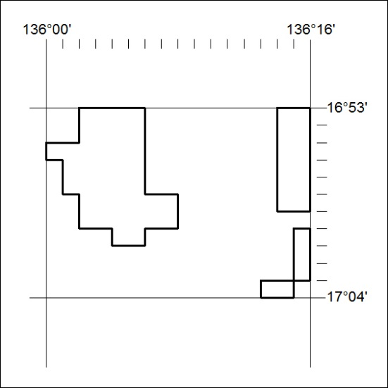
Area granted is indicated above. The titleholder is not permitted to exercise occupational rights on any land that is subject to a development title, or an application for a development title. Any land the subject of a Reserved Land gazettal under the Mineral Titles Act and all land vested in the Commonwealth of Australia is also excluded by description but not excised from the grant area.
286/18

Mineral Titles Act
NOTICE OF GRANT OF A MINERAL TITLE
Title Type and Number: | Exploration Licence 31691
Granted: | 02 July 2018, for a period of 6 Years
Area: | 185 Blocks, 607.23 km²
Locality: | LANCEWOOD
Name of Holder/s: | 100% MMG EXPLORATION PTY LTD* [ACN. 119 136 659]
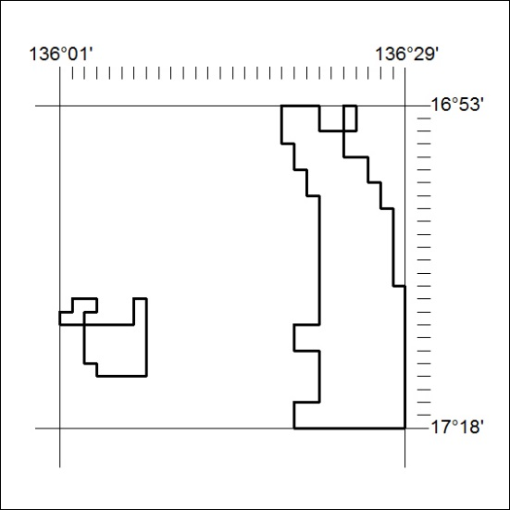
Area granted is indicated above. The titleholder is not permitted to exercise occupational rights on any land that is subject to a development title, or an application for a development title. Any land the subject of a Reserved Land gazettal under the Mineral Titles Act and all land vested in the Commonwealth of Australia is also excluded by description but not excised from the grant area.
287/18

